Taylor Cadwallader, Jared Callupe Lopez
GAM200
Team: Luminosity
Game: KnightLight

Design Guide

Concept/Theme/Setting

High Concept: KnightLight is a tile-based platformer with tile-based lighting where you use your flashlight to find your way out of the Underground.

Theme: Light and Darkness

Setting: You play as a knight made of light that has been banished to the darkness, by getting thrown into the Underground. The Underground is an abandoned environment inhabited by various enemy creatures and shrouded in darkness. The enemy creatures are shadows with the intention of destroying all forms of light.

Characters/Dialogue/Emotional Design

Character: The idea is that the player character is a knight made of light that has been banished to the darkness, by getting thrown into the Underground. The enemy characters are shadow creatures with the intention of destroying all forms of light.

Dialogue: No dialogue is planned to be added to the game.

Emotional Design: There are plans to include collectible light creatures waiting to be rescued by the knight. These can be obtained from chests hidden in every room, creating both discovery engagement and an emotional attachment to the player.

Core Mechanic and Components

Core Mechanic: The core mechanic of KnightLight is the knight’s flashlight. The flashlight is used to allow the player to see enemies in the darkness as well as see the environment itself. The flashlight is also used to destroy enemies and activate lamps by focusing and supercharging the flashlight. When the flashlight is supercharging for a specified time interval, it overheats and causes the player to lose a life. Player life is shown with an aura around the player that emits a non-lethal light that shrinks in size depending on the player’s health.

Components: The flashlight uses various SFX; focusing and unfocusing the light, supercharging and canceling the supercharge, as well as when the flashlight starts overheating and when the flashlight overheats. There will also be a few animations implemented to give the player an excellent understanding of everything that is happening mechanically with the flashlight, such as; when the flashlight is supercharged and when it’s not, and when the flashlight starts to overheat and successfully overheats. When the flashlight overheats and the player loses a life, the SFX that plays when the player loses a life will also play, as well as an animation for the player's aura itself that was specifically made for when the flashlight overheats. The player sprite itself also plays a blinking animation to show invincible frames, and the color of the player sprite gets darker and darker the lower their health is to additionally signify their current health. A subtle particle effect for the flashlight and aura may also be seen as more of an idle thing to help showcase the environment's setting.

Research: Most of the general ideas of the Core Mechanic and its Components were originally thought of together as a team at the beginning of the semester. However, over time we have come up with several realizations and formed many more ideas from the design meetings, as well as various games brought to our attention in our free time and feedback received from our M2 presentation. The games are as follows; Luigi’s Mansion 3, Kirby and the Forgotten Land, Subsonic, and Shadeshift. All of which are towards the bottom of the document where they are broken down and showcased in the References section.

Controls, Camera and HUD

Controls:
Walking - ‘A’&’D’ keys
Jumping - ‘W’ key
Falling through platforms - ‘S’ key

Aiming flashlight - Mouse Cursor
Focusing flashlight - Hold Right-Click
Supercharge flashlight - Hold Left-Click

Camera: Dynamic camera that follows the player with an offset that moves with the direction the flashlight is facing, with an interpolant in the X-position greater than the Y-position interpolant.

HUD: The only HUD element we have is when you collect coin/s, a coin counter fades in on the top right and plays a small animation per coin collected, and when the player hasn’t collected a coin for however long, the coin counter fades back out. When the player opens the pause menu, the coin counter will be displayed in the menu itself as well for the player to see their coins whenever they want to.

Gameplay Spaces and Environments

Gameplay Spaces: The gameplay spaces consist of multiple rooms containing small sections where the main objective is to trigger the exit door and continue to the next section, ultimately escaping and progressing to the next room. Each section contains a different challenge that requires the player to use their flashlight to defeat enemies and open doors, getting progressively more challenging as the game goes on. Between each section, there will be a healing lamp working as a checkpoint which the player can trigger to activate its healing effect, working like a checkpoint and safe zone. In addition, all ceilings have been modified to prevent the player from hitting their head, allowing smoother movement around the map. As well as, the removal of some precision platforming elements such as long precise jumps across cliffs, or high jumps that barely make it to high jump throughs.

Environments: The environment represents the Underground, a big dark cave filled with shadow enemies, using black and white colors. All environment walls use rocky tiles that produce the effect of extending infinitely. Decorations and background elements the player cannot interact with have lower opacity. Jump-through platforms use chained hanging platform tiles as well as bridge tiles with the non-collidable parts having lower opacity, too.
The monochromatic color scheme is contrasted by the use of blue and orange colors to signify the different types of lamps, also.

Level/Pacing

Level: There will be rooms containing challenges with trigger lamps at the end of them that can open the next door. The game will increase in difficulty as the levels go on with more hazards, more challenging platforming, and harder to find lamps in later rooms.

Pacing: There will be healing lamps as safe points between rooms. Unexpected encounters like dropping enemies that will surprise the player will be included to increase engagement.

User Experience

Tools: Various sound effects for all elements related to gameplay, including those already mentioned in detail in components. Ambience sfx will be implemented, as well. Since lighting is a crucial part of the main mechanic, all light sources, including the flashlight and lamps, emit particles to simulate dust in the environment. Additionally, enemies will also emit particles when exposed to the super charged light to simulate the burning/disintegrating effect. Camera shake could potentially be implemented to enhance the feel of the player getting hit, when the player character steps into the Underground for the first time, or when the player falls from a great height.

Main Engagement Type: Discovery engagement as we allow the player to go around the environment finding hidden exits which allow them to progress even further.

Game Systems

Health/Energy System: Signified by an aura around the player. When an enemy hits the player or the player’s flashlight overheats by focusing it for too long, the player loses a life/energy which then shrinks the aura. The player cannot die from overheating the light.

Coin Collectibles: Collectibles that serve as a small reward and are also placed around the level to guide the player.

Chest Collectibles: The chest will contain a large amount of coins, as well as a collectible little guy. There will be one hidden chest in every room which will require the player to backtrack, find a hidden path, or perform certain actions.

Persona

- Name: Charles

- Relationship status: It’s complicated
- Career: Full-time streamer

Back story: Charles has been playing games since his dad introduced him to the NES at the age of 3, his favorite game being Metroid. Growing up, all he’s ever wanted to do is play games. Luckily now that he’s a moderately successful streamer, he can now play games for a living. He’s recently played Limbo, recommended by a viewer, and enjoys the aesthetic. He tries his best to stay up to date with indie game releases, but mainly relies on his viewers for games to play. He struggles with precision in games, especially in shooters and platformers. But he enjoys exploration, finding secrets and 100%ing games.

Defining quote: “I absolutely love games that offer rich exploration and hidden secrets. The thrill of uncovering every nook and cranny and achieving 100% completion is what truly excites me in gaming!”

Demographics
- Age: 23
- Sex: Male
- Education level: Community college

Game experience: Plays indie PC games 36 h/wk

Preferences -
Favorite games:
- Limbo
- Hollow Knight

Ideal experience:
- Prefers to learn by experimenting without a long tutorial
- Game makes you think, but isn’t super complicated
- Game has exploration elements
- Game doesn’t have long boring texts related to lore
- Game has replayability

Motivations:
- Hidden secrets
- A lot of level content
- Big areas to explore

Frustrations:
- Complicated UI
- Goals that are too explicit or evident
- Precision aiming or platforming
- Long idle sections

References

Hollow Knight (https://www.hollowknight.com)
The metroidvania-like level design with simple platforming sections, but with enemies scattered throughout different rooms, inspired the general level design and enemy distribution of our game. The game was played for research and notes were taken regarding its level design by recognizing patterns in it. Some of the more important findings were the following:

- Backtracking: various sections that require the player to come back to previous rooms once they have unlocked something. In our game’s case, this will be done on a smaller scale since we do not support large scale levels like Hollow Knight.
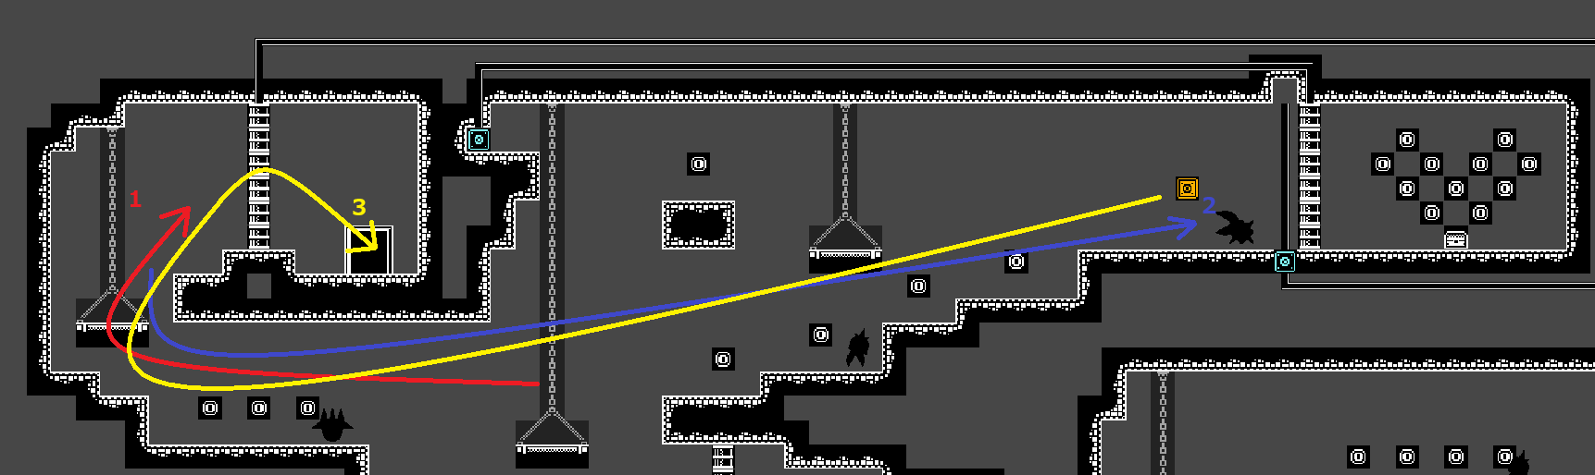
Small-scale backtracking section

- Precise jumps: Jumps that are just barely possible as their height is equal to the player’s jump height. Since we do not want platforming that’s too precise on our game, the highest jumps we’ll implement in the game will be one tile lower than the maximum jump height.
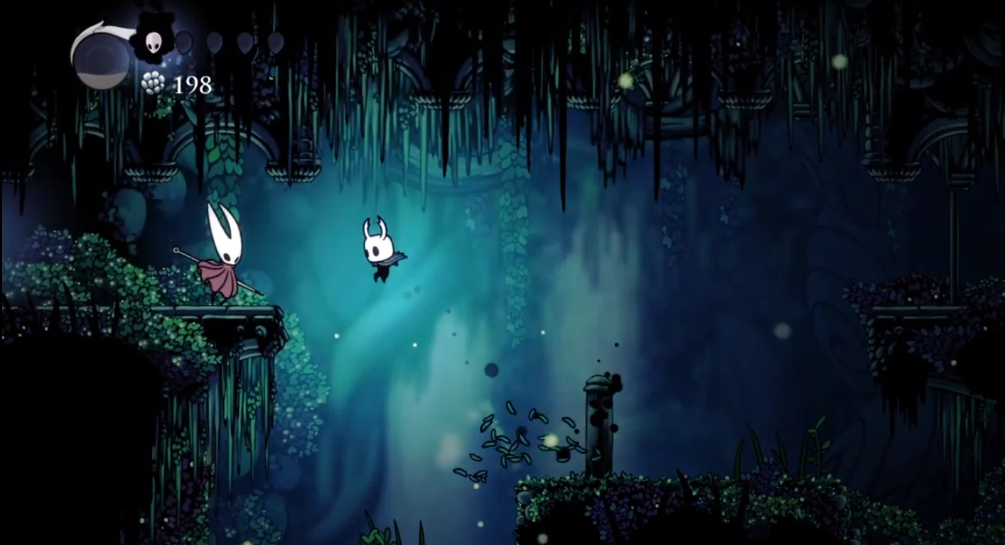
Barely impossible single jump (without any abilities)
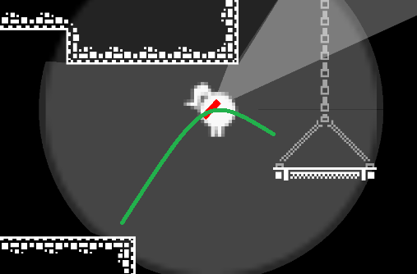
Jump lower than the max height jump

- Foreshadowing entrances: Entrances to rooms that are usually located in high places foreshadowing future exits that lead to the current room. Our game will follow a similar approach with looping by making the player return to previous locations in a not too linear way.
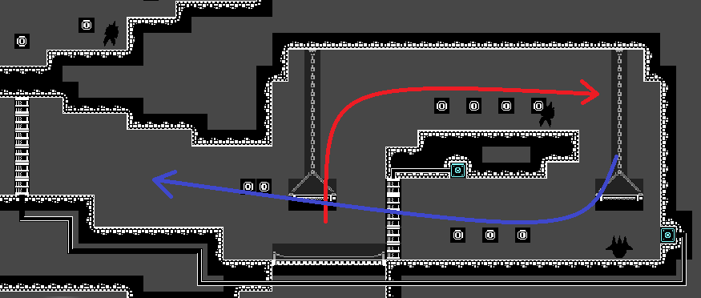
Looping section

- Multiple exits: Some rooms do not have one single exit or way to progress to the next room(s). Most rooms branch into different rooms and hallways that connect with each other. Our game does not necessarily present the player with many exits but they are usually presented by two paths with one blocked by a door.
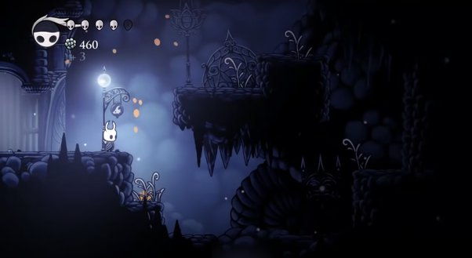
Multiple paths the player may explore.
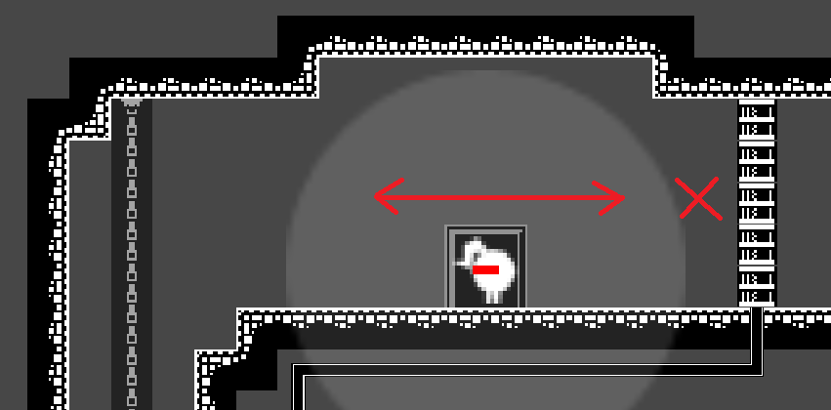
Right path blocked by a door

- Spiked floors lips: Floors full of spikes have a small lip on the sides. We presume their purpose is to stop the player from jumping off directly to the spikes and getting damaged. In our game, these ledges will benefit the player and help them not fall on the spikes since they’re only visible when they’re being focused at by the flashlight, as they will allow the light to travel to the lower ground where the spikes are arranged and not be blocked by a sharp end.
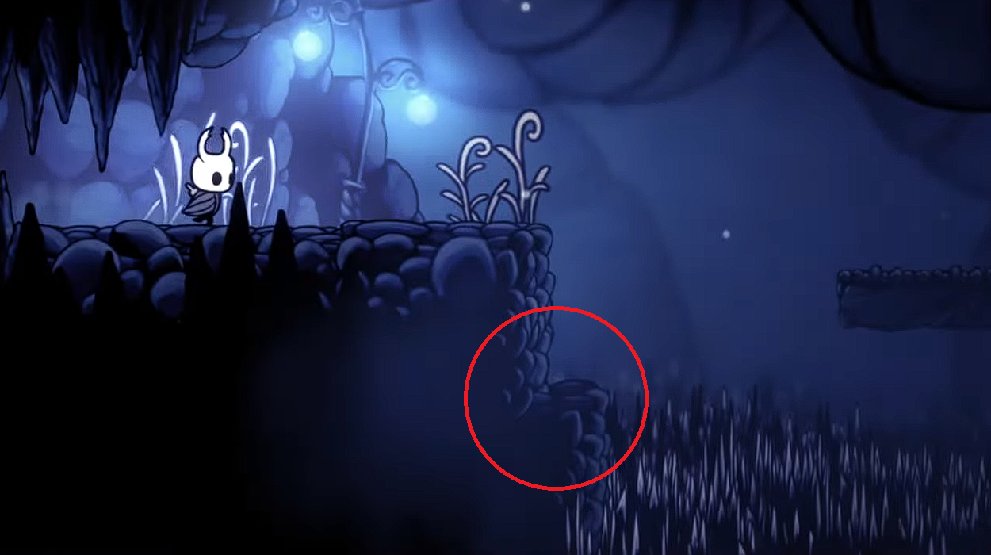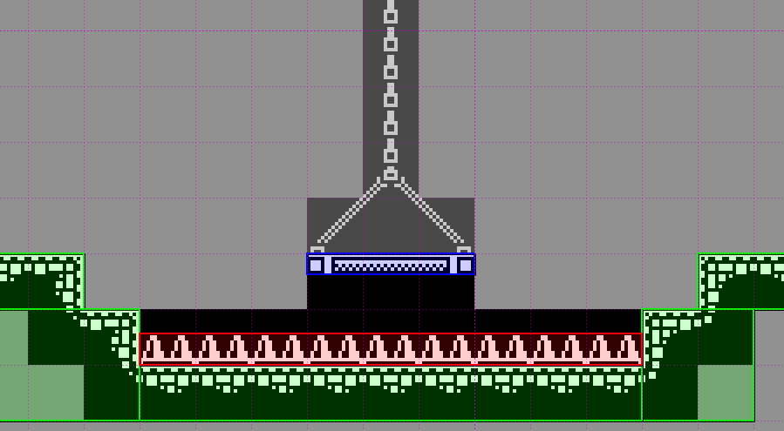
Spike floor lips

Luigi’s Mansion 3 (https://luigismansion.nintendo.com)
The game’s dark environment inspired one of the key factors when designing our atmosphere and tone. The main principle we followed from this game is making sure the lighting is dark enough to create a gloomy and bleak environment but not too dark that it handicaps the player. Translated into our game, hazards remain hidden in the dark until they are revealed by the player’s light.
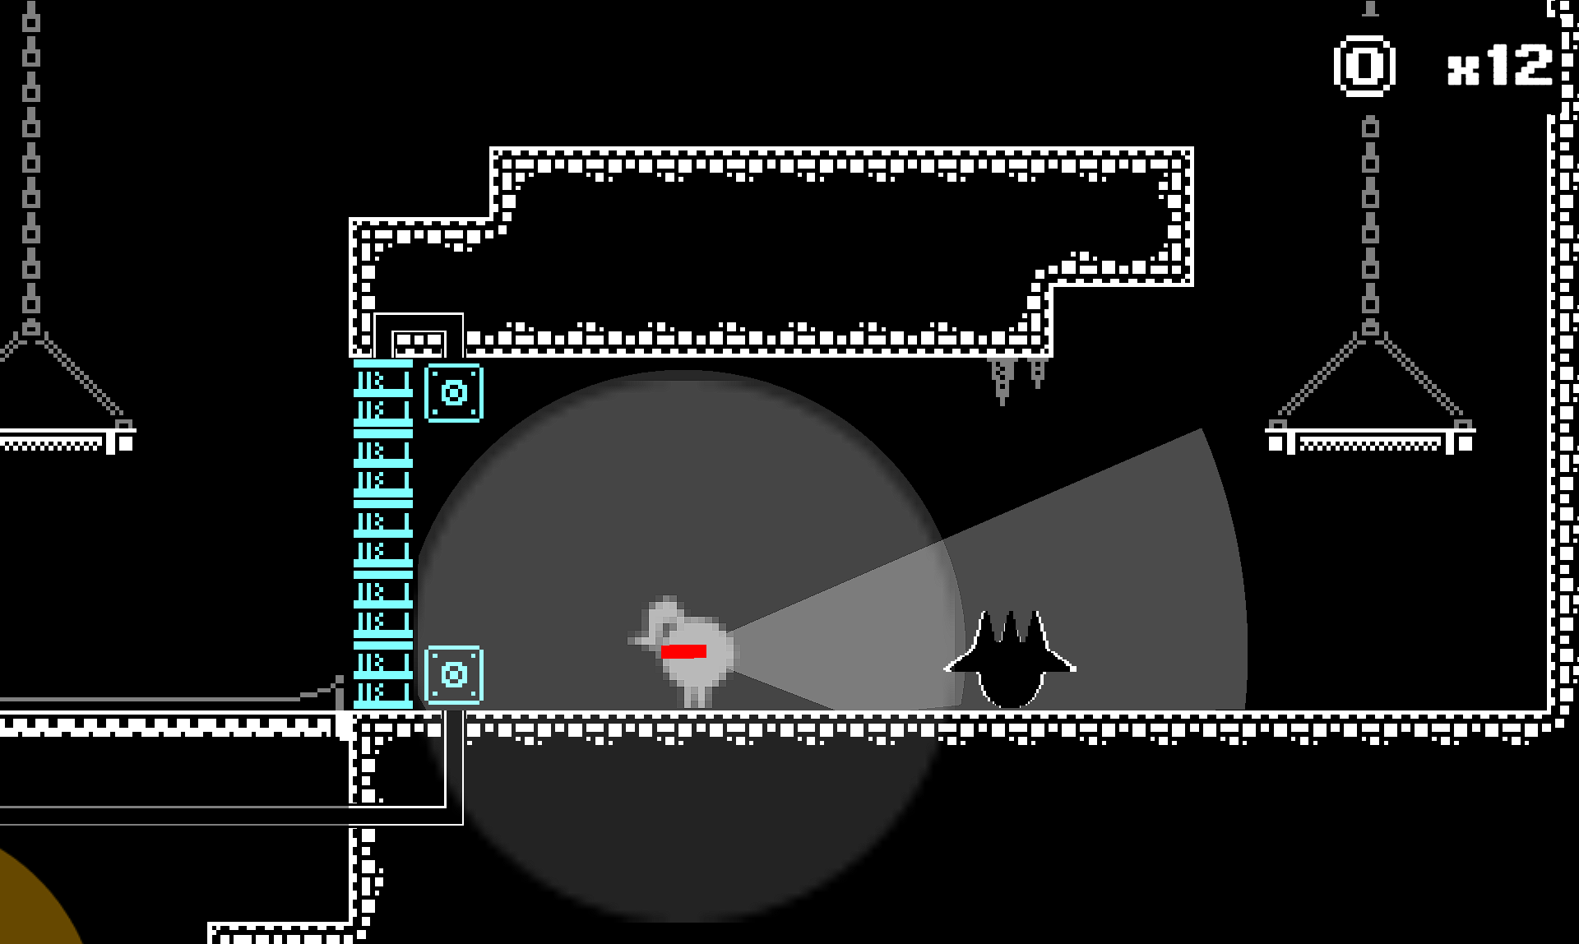
Game environment
The safe points between rooms was another great inspiration taken from this game. The game uses lit rooms to signify safety, inspired by old horror games, allowing the player to take a break before going back into action. Similarly, our game combines this with our main mechanic, having to light a healing lamp to trigger its healing effect in a small safe room.
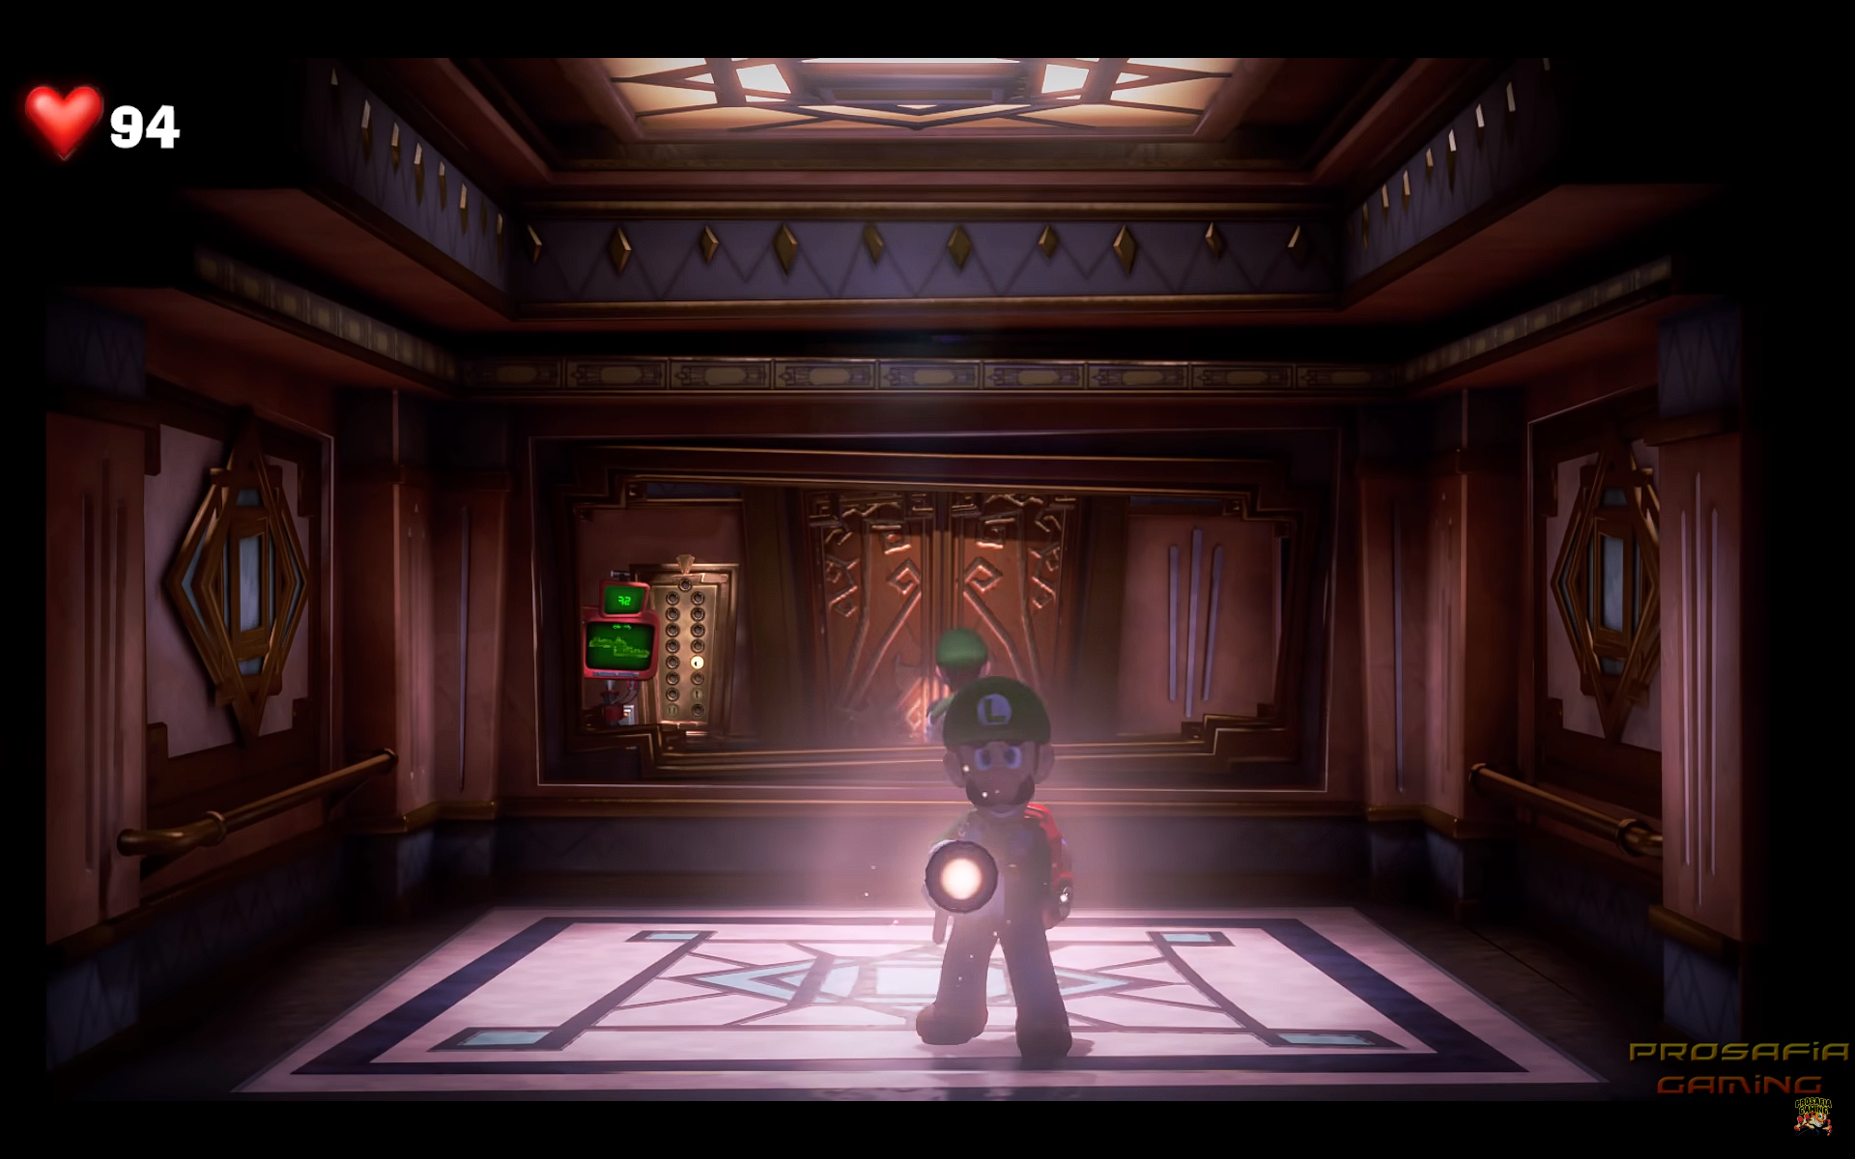
Lit elevator room used to travel between floors

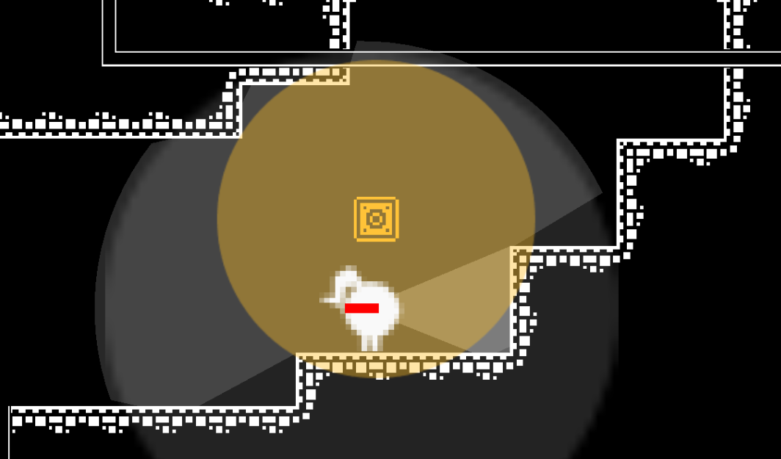
Safe room with healing lamp between sections

Luigi’s Strobulb ability also inspired our game’s main mechanic. Having a flashlight on at all times, allowing the player to see what’s in front of them in the direction they’re aiming at in a dark environment, having a way to guide themselves in the dark. And it can also be triggered to activate its ability. However, that’s where the similarities end since our game’s flashlight doesn’t stun enemies making them vulnerable like in Luigi’s Mansion 3. Instead, our flashlight “super charges” slowly transferring its light to the target whether it be a lamp triggering its effect, or an enemy in which case it will slowly start growing, as long as the super charged light keeps targeting them, until they get too big and end up exploding. This flashlight uses energy over time until it overheats.

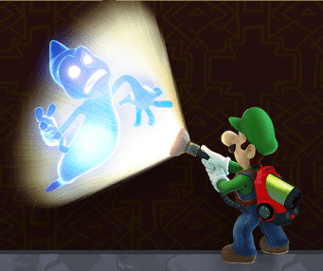
Luigi’s Strobulb ability stuns enemies
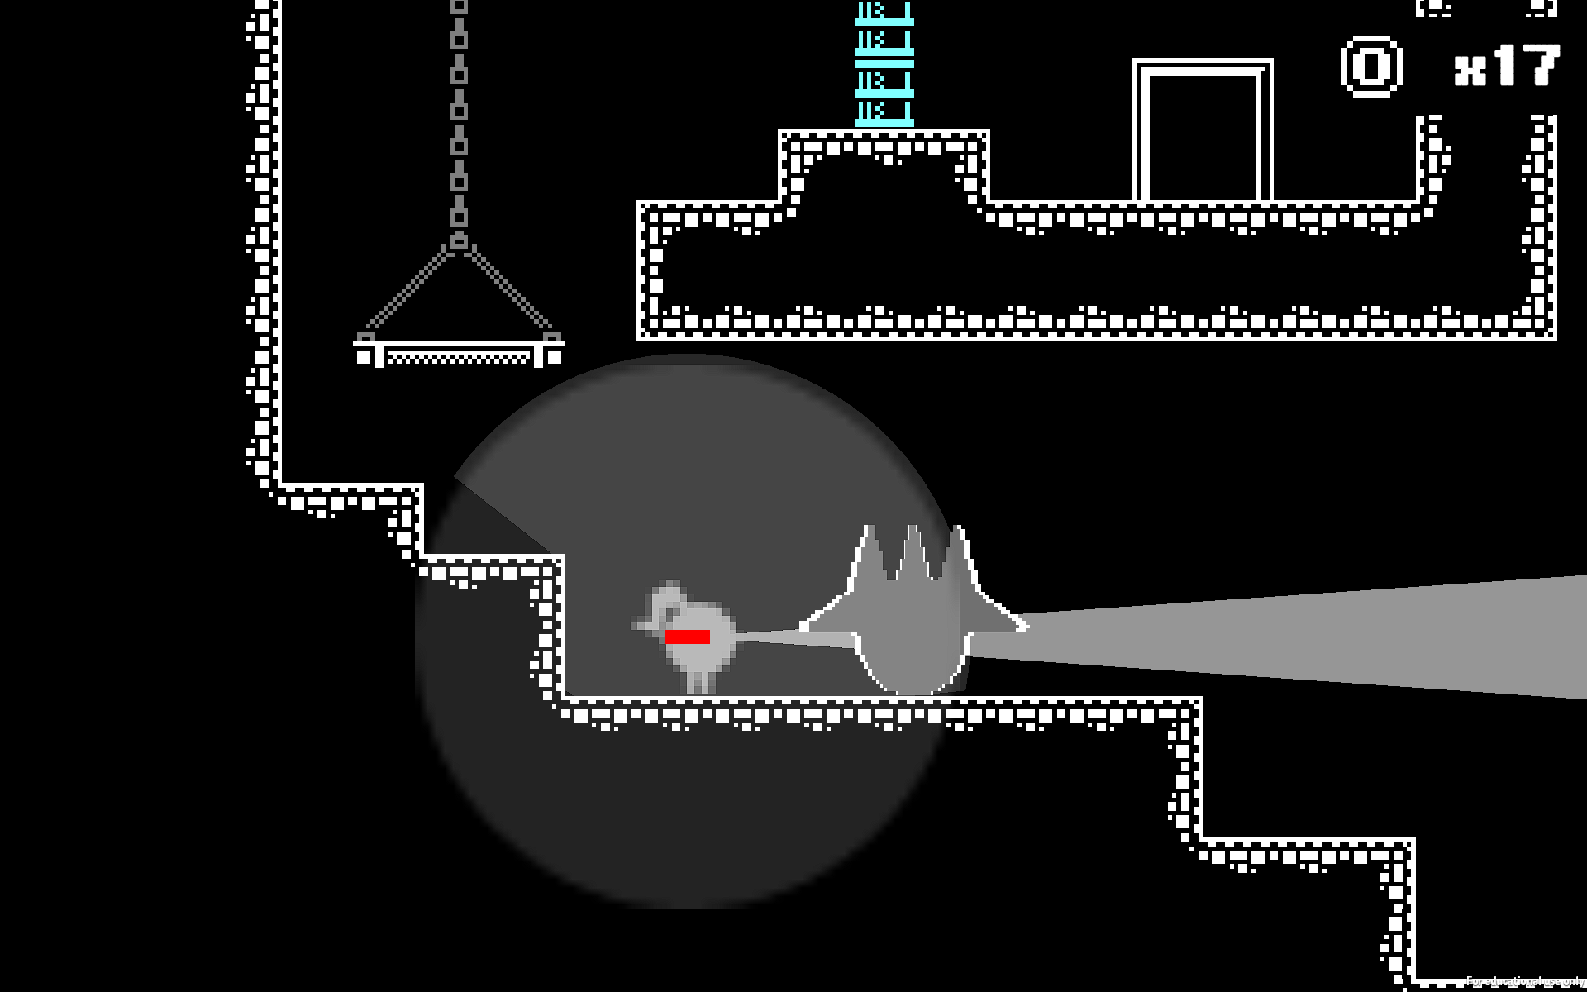
Enemy getting hit by the flashlight

A video that helped us understand Luigi’s Mansion design: https://www.youtube.com/watch?v=7qXeejLPc0c

Kirby and the Forgotten Land (https://kirbyandtheforgottenland.nintendo.com)
The enemy encounters in the dark sections with the lightbulb ability in this game inspired our own game’s encounters. Enemies in these sections will only attack Kirby when he’s emitting light with the lightbulb. Similarly, our game features enemies that will only trigger their defining mechanic (e.g. chasing the player or running away from them).
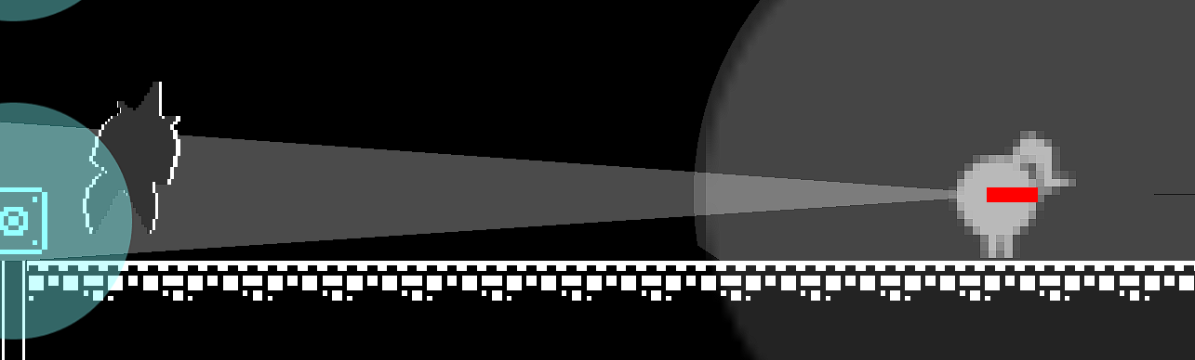
‘Coward’ enemy escaping as soon as they get hit by the player’s super charge

In addition, enemies in this game are not fully visible in the dark and become more visible when Kirby uses the lightbulb or gets closer. In our game, enemies’ shadows are visible when walking in front of collectibles or decoration tiles because of their black sprites rendering on top of them. But when the player focuses them with their flashlight, their white outline becomes visible, allowing the player to see their shape more clearly.
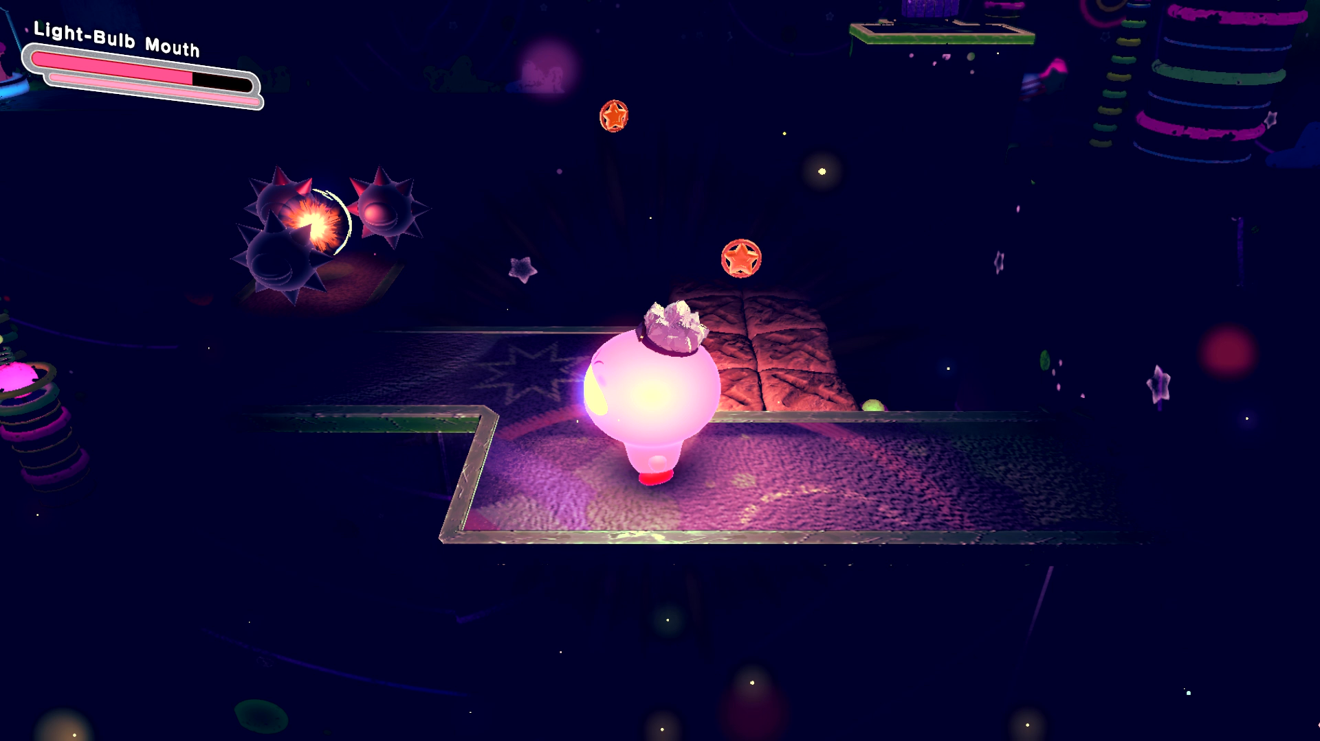
Dark section featuring lightbulb Kirby, some enemies can be see in the background

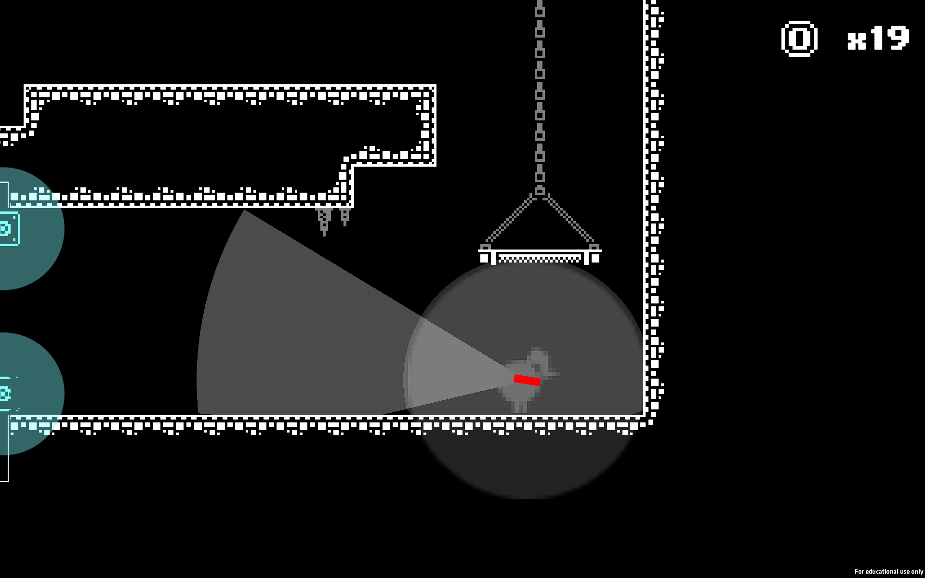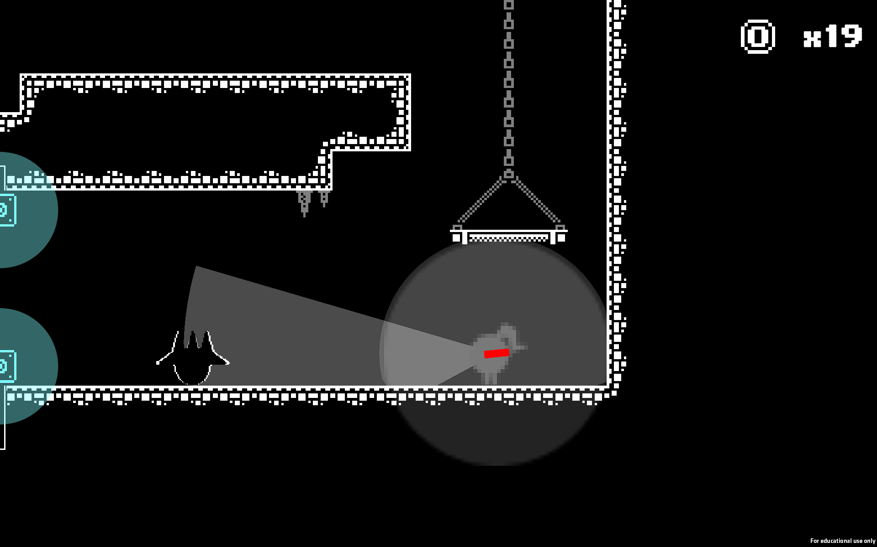
Enemy’s outline appearing when it gets touched by the player’s light

Subsonic (https://games.digipen.edu/games/subsonic)
A DigiPen game that, while completely different to our current game, has helped us see how different mechanics could work in the environment. First, the soundwave’s and enemies’ field of view are signified by raycasts that go around them and stop casting when they collide with walls. Based on this, our game’s prototype features a similar working aura around the player that doesn’t go through walls. In the same way, the player’s flashlight gets interrupted by environment collisions excluding jump-through platforms from which you can aim your flashlight through its floor, similar to how the soundwaves in Subsonic go through lasers.
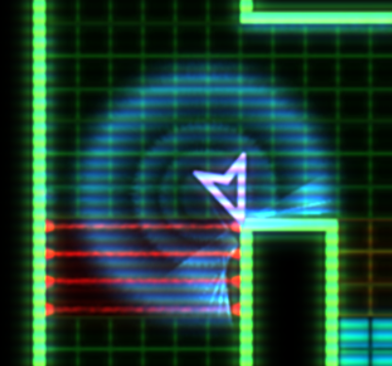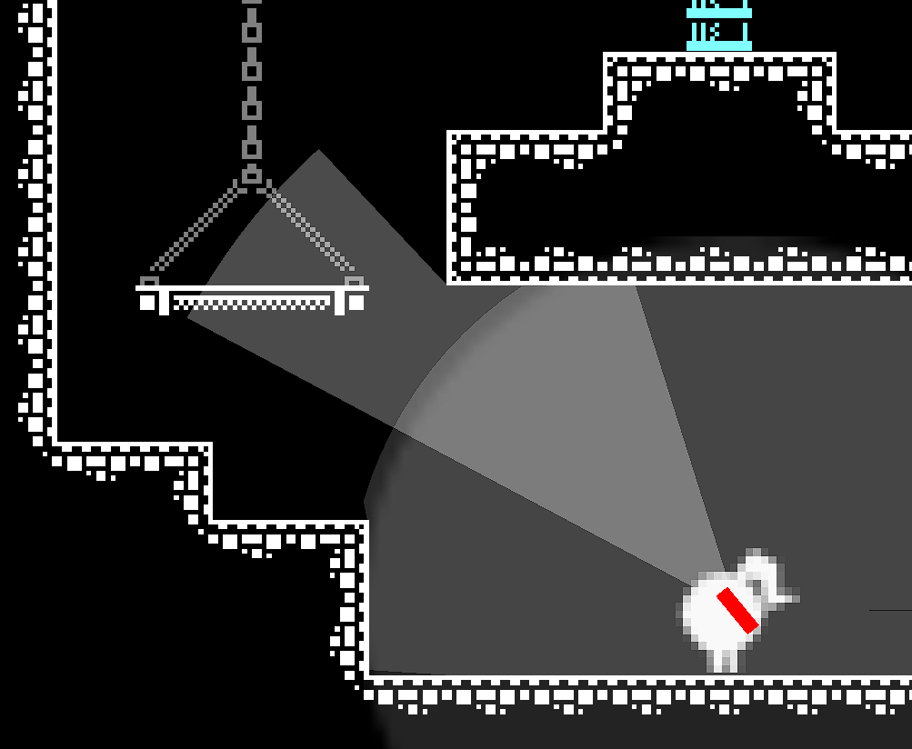
Soundwaves going through lasers but not through walls, while flashlight goes through jump-through platforms but not the environment

Additionally, some secrets are hidden behind walls or behind invisible tiles in the dark. In our game, some level sections will feature hidden rooms with collectibles, reinforcing our main engagement type, discovery.
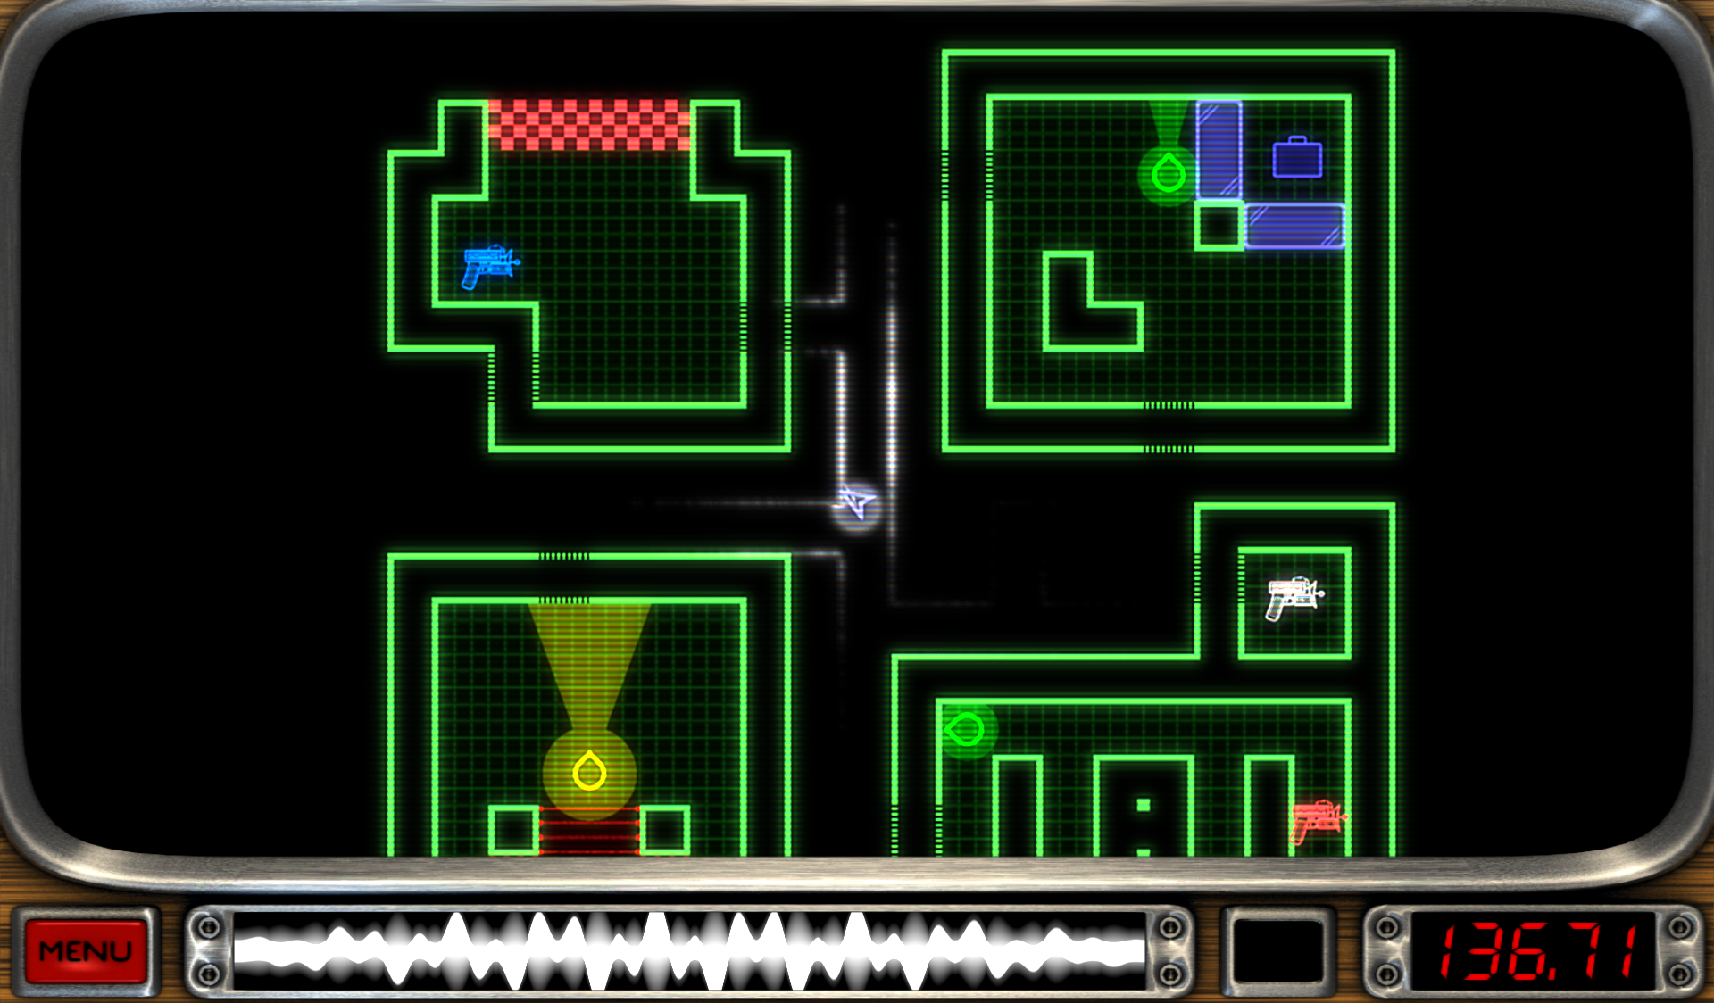
Dark vents you can move in

Finally, an additional element we would like to eventually add to the game is the wave signifier used to indicate how charged the shot is. In the case of our game, we would like to implement a more diegetic version of this effect to indicate how long the super charge has been used for and when the flashlight is about to overheat.
Wave signifier in HUD

Shadeshift (https://lunasii.itch.io/shadeshift)
Even though we found this game after prototyping the main menu and the game’s main mechanic, it still helped us polish these aspects and further improve them. The game’s main menu features the player character with their flashlight able to be controlled by the position of the player’s mouse, creating a more diegetic way of navigating the menus.. The second half of the game’s title can be revealed by aiming at it with the flashlight, foreshadowing the game’s main mechanic. The level select menu has the same effect but this time the player character isn’t present. Instead, there’s a light originating from outside the screen. In our game, the main menu has a floating flashlight that follows the mouse, but when ‘Play’ is pressed, the player character is dropped into the underground for a more diegetic approach.

This game also contains elements hidden in the dark which is an idea that popped up while brainstorming. The implementation of dark platforms that can only be seen when the flashlight is focusing them due to the raycasts getting interrupted by their colliders.
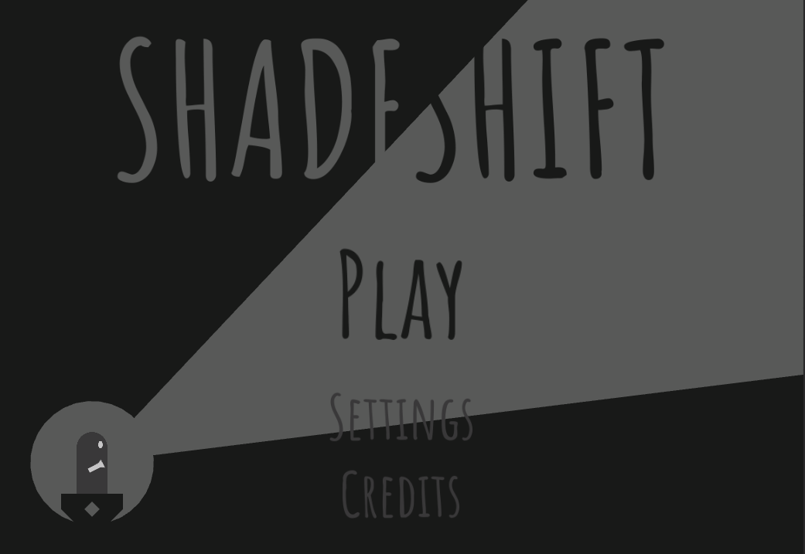
Shadeshift main menu

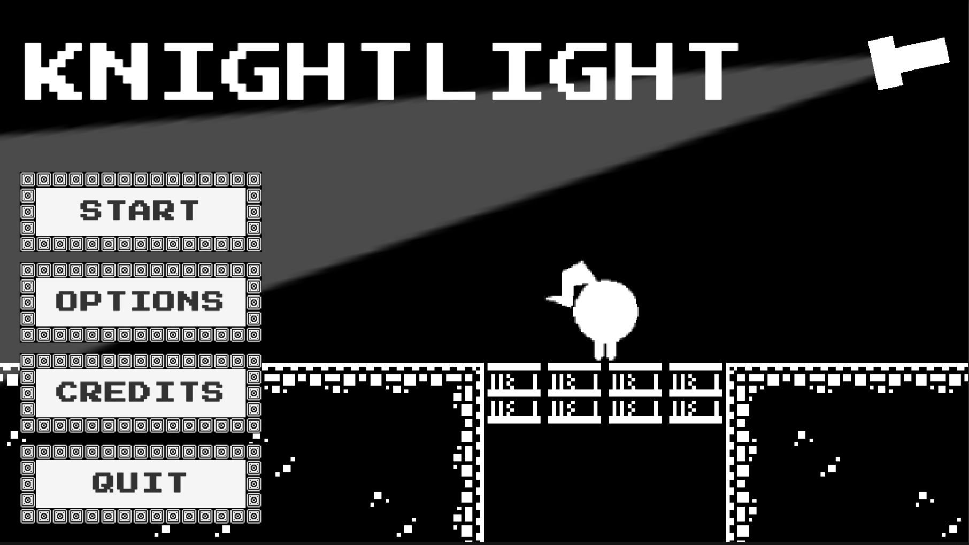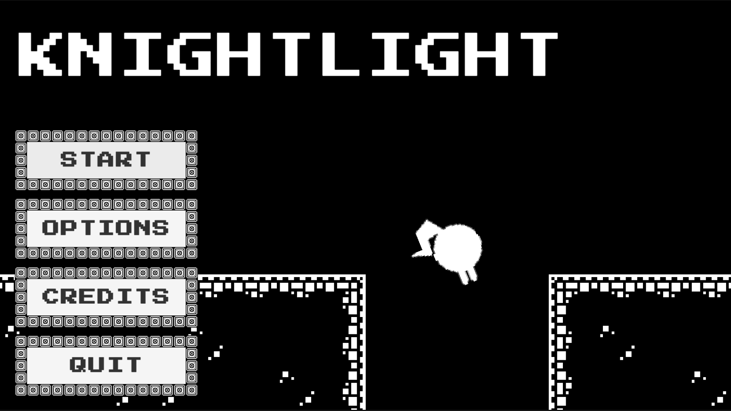
Main menu prototype and player character getting dropped

