Jared Callupe Lopez
GAM250
Team Luminosity
Game KnightLight
Playtest Report 5
Full Game Playtest
Subject
All of KnightLight’s three levels.

Executive Summary
After testing our game’s second level in the custom engine, the designers received feedback that lead them to completely redesign about 2/3 of the second level. Since level 3 was also in the works, the designers have decided that because they needed to playtest both the reworked level 2 and the new level 3, they will be testing the entirety of the game (level 1, 2, and 3) to first time users. In order to accomplish this, multiple other designers were invited to playtest the game. The reason for having other designers play through the game was to receive more technical feedback of our game, and help our designers identify flaws in their designs.
This build consisted of all three levels, which introduced different mechanics in each. In level 1, player movement and flashbang, as well as the light and door mechanics. In level 2, the vent mechanic was showcased, ending with the introduction of the knight armor. Finally, in level 3, the synergy between the knight and light players is put to test with the switch ability that allows the light player to jump out of the armor and recall back to it whenever. In addition, this level also introduces the launch ability in the second half, allowing the knight to throw the light player to higher places.
Some of the main findings while playtesting were the following: checkpoints require better signifiers as some players missed the interaction prompt multiple times and didn’t know why you had to interact with them until they unlocked the knight armor. As well as the signiflyers having no purpose other than guidance and didn’t feel rewarding to the player, a designer suggested adding fireworks when collecting all of them. Another finding was that while guidance is required throughout the whole game, it is even more important around checkpoints since players tend to get lost after being respawned. In addition to this, multiple playtesters had problems trying to remember the keybinds and they would end up performing the wrong action in multiple instances. All of the conclusions made, and feedback collected were used to form recommendations that will help our designers further improve their design.
Not to mention some of the bugs that players ran into such as the compute shader bug which crashed the game, or bugs with the player like making the screen dark when respawning after dying as light. As well as multiple physics bugs that made the player clip through colliders, get stuck in corners, or even completely disappear on some vent colliders.

Purpose
“What changes should we make to our game’s overall mechanics and level design?”
The purpose of this playtest was to find potential changes that could be implemented to the game’s different mechanics such as flashbang, lamp and doors, vents, knight armor, and launch. As well as the tutorialization and challenge implementation of these different mechanics in our level design. After receiving feedback regarding our second level in our last playtest, we decided to completely rework about 2/3 of the second level, making more use of this level’s mechanic, the vents, and creating more challenges around them. In addition to this, we also had planned to playtest our third level for this playtest, which showcased the armor mechanic and the launch upgrade. Since we had to playtest both the reworked level 2, and the new level 3, we decided it was a good idea to playtest all three levels to first time users to see how new players play through the entirety of our game. This playtest focuses on player behavior when presented with the different mechanics, as well as level design aspects such as exploration, puzzle solving, backtracking, not to mention psychological concepts like cognitive maps and heuristics.

Additional Playtesting
In addition to all our game mechanics and level design, some UX elements were analyzed, too. Elements like the colors of different light sources, collectibles, vent travel duration, flashbang cooldown, keybinds, launch force, etc. In addition to this, some questions were asked during the feedback and debriefing sections of the playtest. Questions like whether the gameplay length seemed reasonable to them, or regarding the way the different levels were structured and the pacing of the introduction of different mechanics. Not to mention that notes were taken regarding any bugs or unintended behaviors in the build.

The Build
Just like the more recent playtests, the build used for this playtest was the current Release build of the game. The build consists of six different scenes: the main menu, credits, level 1, level 2, level 3, and the win screen. The main menu presents no changes from the last playtest build’s main menu, other than some buttons used for debugging save files.
The credits menu is a different scene as it was being worked on by a programmer. It shows our team members’ names and roles, and it allows the player to scroll up and down to show more credits. It is currently being worked on to further improve the UX.
The credits menu is the same scene being worked on by a programmer. It’s been updated to show all team members and their contributions, professors and advisors, copyright information, and credits for art and audio assets. The player is able to scroll through this list using the ‘W’ and ‘S’ keys and return to the main menu using ‘Esc’.
Regarding the different levels, level 1 went through some minor changes since our playtest showcasing this level, while level 2 changed almost completely due to the rework. In addition, level 3 was already designed on paper and was implemented in Tiled and imported to the engine. All of these levels are connected through level transitions at the end and/or beginning of each, allowing the player to travel through them and backtrack to a previous level if they wish. Up next, we’ll explain all modified sections and new features added to these levels.
Regarding level 1, not many changes were made, and it keeps the same structure as it did since it was last playtested. Some of the changes made were the addition of more checkpoints in the first half of the level, the addition of a hanging platform at the end of the first half, the addition of proximity prompts and sprites that show the player the controls, as well as the modifications of the small lamp challenges in the second half of the level, making the three lamp sections different from each other. Finally, the ending vent was changed to a long hallway that leads and connects to the start of level 2.
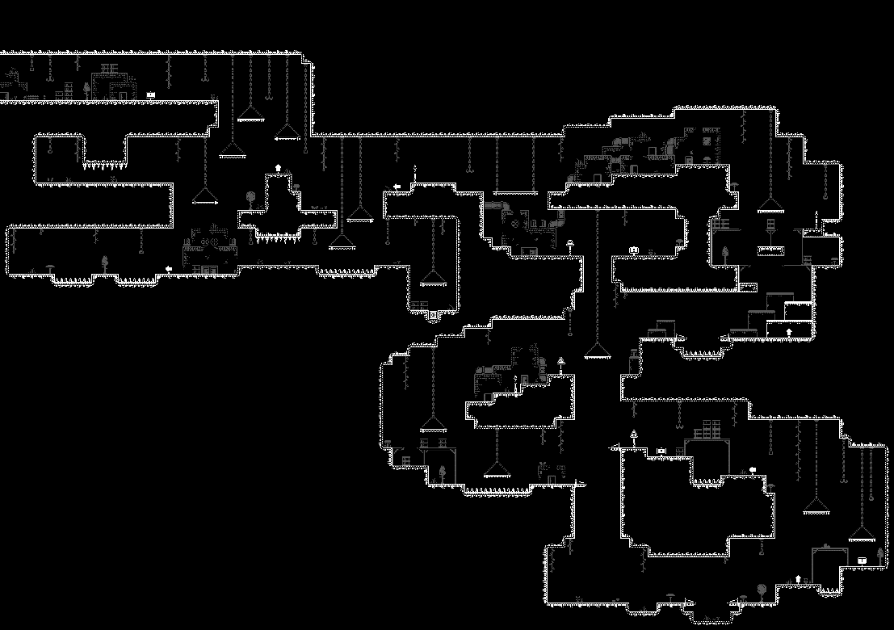
Level 1 Tilemap
Regarding level 2, most of the first part was kept intact, except for the starting room as it had to be extended in order to connect it to the end of level 1, as well as the room that surrounds the player with vents to make them squigglier and have a more elaborate aesthetic. In the second half, the idea of multiple floors that go around a tower was kept. However, after going through our last playtest feedback, the challenges underused the mechanic introduced, and players felt like not much happened in it compared to the last level. In order to fix this, we decided to showcase different applications of the vents such as going through doors or avoiding hazards. Then, we’d introduce a more complex puzzle, in this case, a maze, which requires a door to open the ending. At the end of the level, the player ends up in a room with the knight armor in the middle, and two vents that lead one step up making them useless in gameplay. However, the true purpose of these vents is to show the player that the knight cannot go through vents compared to the light, forcing the knight to jump over them. Finally, the player goes through the transition to level 3.
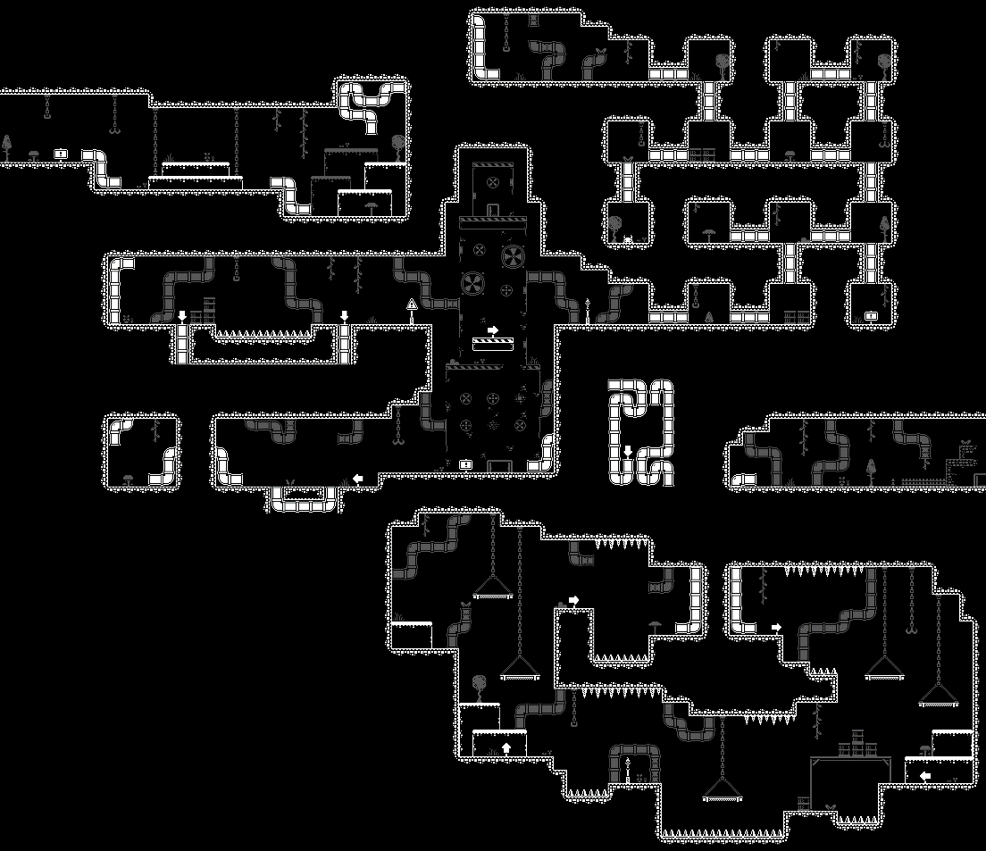
Level 2 Tilemap
Regarding level 3, this served as both a tutorial of the armor and launch mechanics, as well as an application of all the mechanics learned so far. The level starts with a spiked floor to show the player that the knight armor is able to walk on hazards right away. This is followed by a challenge that aims to show three new mechanics including the ‘switch’ to jump out of the knight armor as light, the ‘recall’ ability to fly back to the armor, and the knight’s lower jump height. This is done by making the player switch back to light to reach a higher platform in order to unlock a door so the knight armor can go around the section and continue with the light. At the end of this first section, there’s a spiked floor that requires the armor to navigate across, followed by a vent that takes the player to the second section.
The second section of level 3 starts with a path blocked by a door with a spikes floor in the other direction. After the knight reaches the other side of the spikes, the player has to switch back to light to trigger a lamp, making a door descend to form a step. In the next part, there’s some knight platforming on spikes, ending on a door blocking the exit and foreshadowing a room on the ceiling. Right next to the door, there’s a vent that takes the light to a narrow room that requires the player to switch between heights and triggering a lamp at the end revealing a vent that takes the player to the third and last section.
The third section starts with the launch unlock room with the launch unlock object on a platform similar to the knight armor. After unlocking the launch mechanic, the player has to launch the light up to a higher floor where they’ll find a checkpoint that will teleport the armor to it. The following challenges stop trying to tutorialize mechanics and follow the level design concepts of expansions and evolutions, with these challenges working more as actual challenges that combine different mechanics. Some challenges in this part are reminiscent of previous level mechanics. At the end, there’s a challenge that forces the player to launch the light to the end and leave the armor behind.
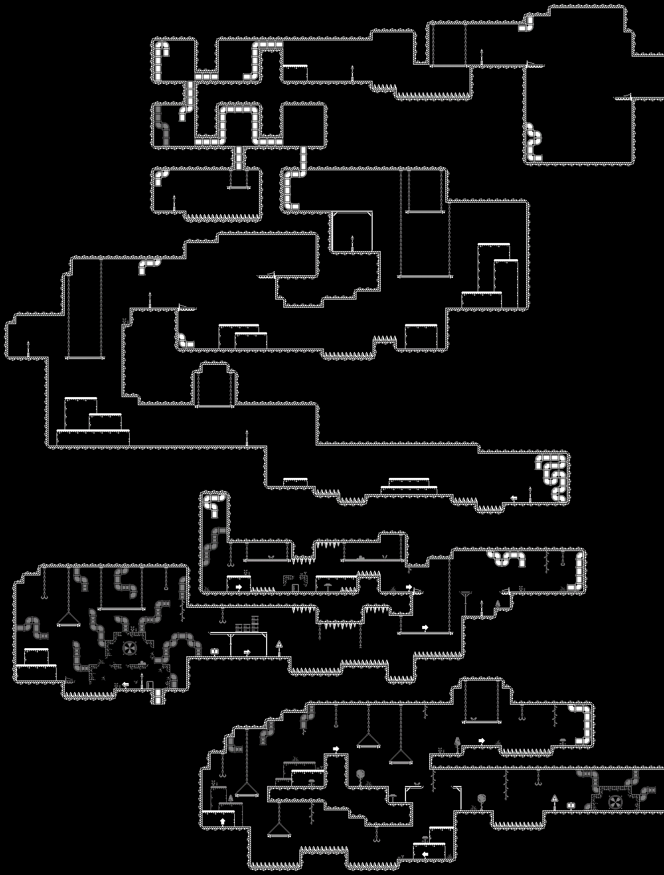
Level 3 Tilemap
Method of testing
This playtest session was structured similarly to previous playtests where playtesters would play through a build of our game while the researcher takes notes on their behavior and comments of the game in order to make observations for later analysis. After this, subjects get interviewed by the researcher with questions regarding their overall experience with the game. Finally, playtesters get asked to share feedback including what they liked or disliked about the experience.

Methodology
All three of the playtest sessions were performed in-person with playtesters playing the game on the researcher’s device. These were all performed from March 9th to March 10th, 2024. The average playtest session length was 30.6 minutes including gameplay, feedback sharing, and debriefing. All three participants were DigiPen BAGDs around the age of 20. The designers playtested had no previous relationship with the researcher other than being class peers. No ethical considerations to be made regarding the experience. All playtesters consented to having their data collected and analyzed to form conclusions and recommendations for our game design.

Participants
Playtester A
Name: Nolan Parker
Identity: DigiPen BAGD Student
Place: Edison
Date: 04/09/24
Session length: 34 minutes
First Time User: Yes

Playtester B
Name: Jake DeLuise
Identity: DigiPen BAGD Student
Place: Edison
Date: 04/09/24
Session length: 29 minutes
First Time User: Yes

Playtester C
Name: Jean Pate
Identity: DigiPen BAGD Student
Place: Edison
Date: 04/10/24
Session length: 29 minutes
First Time User: Yes

Limitations
While choosing the sample, we wanted all playtesters to be first time users to test the tutorialization of our game mechanics more successfully, without previous knowledge or any kind of bias. We also wanted all playtesters to be game designers in order to get more technical feedback on our design as it’s really useful in this stage of development since we’re getting closer to shipping and having our game graded. Regarding the designers playtested, their only relationship between them and the researcher is academic peers.

Observations
Participant A
This playtester started the game normally, making it through the first couple platforms. He reached the left click sprite prompt as it appeared and performed the flashbang successfully revealing the path on the other side as intended. Right before the second checkpoint, he tried seeing what’s inside one pocket on the right of the wall, but it was empty. After lighting up the lamp and seeing the door opening, he tried to go up to the door, and immediately noticed the backtracking path. As the playtester kept playing, he didn’t seem to notice the corner bug which made the player get stuck on a corner and build up velocity downwards. On the last part, the playtester missed the last checkpoint and had to walk back from the second checkpoint when he died. Nonetheless, he was able to finish the short puzzle and proceed to the end of the level.
On his way to level 2, as he collected a signiflyer, he mentioned he still didn’t know what they were for. After finishing the first platforming part, he reached the reworked section, missing the first checkpoint. On the second challenge, he saw the lamp above the spike floor, but since the flashbang range didn’t hit the lamp, he decided to jump into the spikes and try to light it up as he fell, which he accomplished as the flashbang triggered as he died. Since he missed the checkpoint, he respawned all the way back in the first part and went the wrong way since he didn’t remember how to navigate this part. After noticing and going back the right way, he continued to the maze where he liked on the small jokes written on a sign. After finishing this part, he headed to the last part of the level where he found the armor, and gasped amusedly at the light emitted by the armor once he got inside it.
In level 3, he liked walking on spikes as he also showed amusement after hesitating whether to jump on the spikes and finally jumping to walk on them. After completing the first puzzle, he headed to the second part where he completed the puzzle with ease and immediately knew he had to use the door as a step to reach the next part. As he headed to the end of the hall, he tried to see what’s in the ceiling pocket used to foreshadow the short light puzzle. After exploring a bit further, he found the vent on the ceiling leading him to the light puzzle, which he completed and headed to the second half of the level. In this next section, he found the launch unlock and touched it but since it had no feedback, he didn’t know if it did anything. After learning how to use the launch, he ran into the challenge that requires the player to jump and launch to reach a higher place. However, he took advantage of a platform at the bottom of the pit and was able to reach the platform by jumping and launching from up there. On the next challenge, he didn’t see the higher lamp on the ceiling, but he did notice it after looking around for a second. In the next challenge, he ran into a bug with one of the vent colliders which made the player disappear, and after trying to reload the scene, we ran into another bug that saved the scene on release mode, making the player unable to reset since it’s nowhere to be seen. After trying to fix this bug unsuccessfully, we decided to let the playtester finish the game in debug mode since there wasn’t much left anyways. And in the last challenge, he couldn’t see much of his surroundings and even tried to go up on the ceiling vent, though he ended up launching the light through the level transition, finishing the level.
When asked to share feedback regarding the game, he said he liked it overall, and that it felt like a platforming puzzle and not a puzzle platforming, which he clarified he meant it in a good way. He expanded on this statement and mentioned that you constantly move from one place to another instead of staying in place solving a puzzle. He mentioned that the backtracking reminded him of metroidvanias. Mentioned that he had problem trying to see the jump height difference between both knight and light, but he still ended up catching on to it in the end. He said he really liked the recalling mechanic as it allows you to try again instead of walking back after failing a challenge. However, one problem he had with this mechanic was that recalling back when you’re next to your armor takes too long, and that it should be instant like the ‘switch’ mechanic. Another problem he had was that he was trying to press space to jump, as well as trying to use the same key for throw and recall since the name ‘switch’ implied that one key is used to switch between states. He also added that arrows worked well on the level, but he would’ve liked more around spawn points or checkpoint. In addition, signiflyers had no use, and he didn’t care if he missed any. Not to mention, tooltip signs were underutilized for tutorialization, but they could be used more for narrative or general guidance. He also mentioned that he didn’t know why you had to interact with checkpoints, until the knight armor mechanic was introduced. He suggested that we should have the characters feel more solid, and added another suggestion to help signiflyers feel more rewarding like playing some fireworks when you collect one or playing fireworks in the win screen when you collect all of them. Some final feedback given was that he liked that the tutorials were fast and they didn’t slow him down at any time. He added that backtracking only took a second and that it didn’t feel too monotonous. Finally, he said that he wished the game were a bit longer, and that the last level was missing that last big puzzle where everything learned is put to use.
Participant B
This playtester started the game by analyzing the main menu, asking which font was used for the game and recognizing it from one of our previous games. He proceeded to point out the cognitive fluency in the order of the buttons in the main menu with ‘play’ at the top and ‘quit’ at the bottom. When he clicked on the credits button, it wasn’t working correctly and not all text was rendered, but he went back to the menu using the escape key.
Once he loaded in the first level, he rapidly learned the controls and mentioned how he loved the jump sound effect. After some more platforming, he added that he liked that you don’t just go right, you go up and left, too. Right before the second checkpoint, he also tried looking into the pocket but noticed there was nothing inside it. As he did this, he mentioned he loved exploring every corner of the map. As he triggered the first lamp, he said the UX on the door opening sequence was brilliant. Once he dropped down, he said he felt like he’d been there before and immediately remembered the way to continue. As he made his way back, he fell through a gap next to the jump through, having to backtrack again. As he backtracked, he died on purpose since the checkpoint would take them closer to their objective. He mentioned liking these strategies that make it faster to progress through the game. Finally, in the last puzzle with multiple lamps, he said it's cool finding out how to open doors.
In level 2, not much flashbang use was shown. As he continued through the level, he said he liked the checkpoint pacing and how they are spread evenly between challenges. He mentioned liking a section specifically, the small section where the player is surrounded by vents since it reminded him of a narrow or packed space. On the lamp over the spike floor, he also had some problems with reaching the lamp in the middle, but instead of dying on purpose, he had to get really close to the edge. Finally, he mentioned that it’s cool that you can move during door cutscene.
In level 3, in the first challenge, he didn’t notice the lamp used to open the door until he used flashbang close to it, but he ended up being able to complete the puzzle. On the next part, he liked the placeholder sign and requested to leave it in the game since it was funny. When he died as light after jumping out of the armor, he ran into a bug that makes the screen very dim and anything can barely be seen, but it was fixed shortly after. In the last part, he tried going up the vents that are meant to help get you back up after failing a challenge. In the jump and launch section, he kept being close to reaching it, but he ended up getting up there from the bottom which was not intended. In the vent section he ran into a bug with the vent collider width which made the player disappear. As we switched the game to debug mode, he mentioned he liked the level design, and how he knows when to get in and leave the armor. Finally, he reached the end of the level and finished the game.
When asked to share feedback, he mentioned that WASD feels nice, but the game was very left hand heavy, and that not much was done with the mouse. He added that it was very hard to criticize since there were very few bugs for so many mechanics. Some things he’d like to see in the future are less parts to fall down from, levels that head to the bottom instead of to the top, and a new idea, automated launchers.

Participant C
This playtester mentioned liking the game title and started exploring the main menu. When they clicked on the credits button, they couldn’t see much as it didn’t work as intended. After loading in the first level, they continued normally through the first couple platforming obstacles, and successfully used left click on the left click prompt to light up the path on the other side. However, as they jumped to the other side, they said they were wondering what was at the bottom of the pit. At the first checkpoint, they tried to light it up using the flashbang ability, before realizing that you had to interact with it. After triggering the first lamp, they dropped and almost fell further. Then, right before the door opened, they fell back down. After this, they ran into the compute shader bug which made the game crash. As the game was reloaded in debug mode, the cursor seemed too distracting to the player during gameplay and they seemed to think the mouse position impacted their gameplay. On the third lamp of the puzzle, they died to a ceiling hazard due to its collider’s end being on the edge. Not to mention, they struggled to find a path to the last lamp. Once they solved the puzzle, they headed to the end of the level and decided to share some feedback. They mentioned that there were not many signifiers for player weight, and that for a puzzle it’s ok, but for a platformer it’s not. They also suggested that we should add squish and stretch to the player when moving and jumping.
In level 2, they didn’t seem to like having to wait before the flashbang could be used again. In the maze section, they knew exactly where the lamp was after running into the door blocking the exit. They mentioned this was because they thought it’d be in a corner and because of the branching leading the player to the right with the exit being on the left. Finally, when they reached the ending room, they jumped into the knight and said it looked cool and so different to light.
In level 3, they rapidly noticed the jump height between both knight and light. And in the first puzzle, they were looking for secrets in the knight section. In the second part, in the light section, they mentioned liking the part where you have to fall through the platform to a lower level. In this part, there were multiple physics bugs like the knight clipping through hazard colliders or the player falling through colliders. In the next part, in the jump and launch section, they also tried to launch from the bottom floor and also made it to the lamp this way. As they made it to the last part, they mentioned liking the red light from the hazards blending with the background. In the maze in this part, they wanted to see the end first before continuing with the puzzle. And once they reached the room in the middle of the maze, they liked the pipe going around explaining the gap between the vents at the start.
When asked to share some feedback, they mentioned that the ‘F’ and ‘R’ keys are too close to each other and were repeatedly pressing the wrong keys. They said they thought the level design was good, and there were parts where they had to climb back up which were pretty fun. They said they liked how pretty the game was starting from the main menu. They added that the arrow that appears when launching looked off because of its red color. They also wished the armor was a permanent upgrade instead of something you switch modes with. Finally, they mentioned that the flashlight was cool but didn’t end up being that useful.

Conclusions
After making all these observations based on the playtesters’ experience, these are the main takeaways:
- Left click prompts work as intended showing up when the player needs to perform an action and the player does it.
- Players try to see what’s in every corner of the map, even if it’s empty space or there are no secrets hidden.
- There’s a bug that occurs on corners that gets the player stuck on a corner and builds up velocity downwards.
- Checkpoints don’t have a clear signifier, ending up in some players missing them.
- Signiflyers don’t have any use and players don’t mind missing one of them.
- The lamp above the spike floor challenge is too far for the player to trigger within a safe distance.
- Players often forget where to navigate after being respawned.
- Players find the armor light and ability to walk on spikes cool.
- Challenges were doors used in more different ways than just blocking a from one end to the other can be quickly understood by players.
- Ceiling vents weren’t as easy to find as vents that start on the ground.
- The launch unlock archetype had no feedback when collected.
- The jump and launch challenge didn’t work as intended since players are able to just launch from the bottom.
- Elements in the ceiling are less noticeable and require further exploration by the player.
- There’s a bug with vent colliders where the player would disappear if they jumped directly into a 0-pixel wide collider.
- There’s a bug that saved the current scene on release, soft locking the player if they tried to restart the scene after getting bugged.
- In the last challenge, the player can barely see their surroundings.
- Players like that the game feels like a puzzle platforming, constantly moving around instead of staying in place solving a puzzle.
- The backtracking in our game is reminiscent of metroidvanias.
- Some players have trouble noticing the difference in jump height between knight and light, though they end up noticing it.
- Players really like the recall mechanic because it allows them to try again instantly.
- Recalling takes too long even when you’re next to the armor.
- Players were trying to press ‘space’ to jump, and they got confused by the different keys for switch, recall, and launch.
- The arrows around levels work well, but some were missing around checkpoints.
- Tooltip signs can be used more for narrative purposes and general guidance, instead of just tutorialization.
- Interacting with checkpoints was confusing.
- The game tutorials are fast and don’t slow the player down.
- The backtracking didn’t take too long, and it didn’t feel monotonous.
- Players wished the game had more level content or it ended in a big puzzle.
- The menu button order matches the players’ cognitive fluency.
- The credits menu doesn’t render all text.
- Players love the jumping sound effect.
- The level design moves the player up and left, in addition to just right.
- Players liked the door opening sequence.
- Older sections can be remembered by players with enough guidance.
- Players fall through gaps between jumping through platforms and terrain.
- Checkpoint positioning can be used by players to save time.
- Players didn’t use the flashbang mechanic a lot after level 1.
- There’s good checkpoint pacing between challenges.
- Players like the section where they are surrounded by vents.
- Players like being able to move while a cutscene is playing.
- Some lamps are too hidden and not too noticeable.
- There’s a bug when dying as light after unlocking the knight armor that makes the screen light very dim.
- Players try to go through ceiling vents which are generally used for the player to return to a safe zone.
- Players feel like the game is very left hand heavy, and that not much is controlled with the mouse.
- Players want less parts they can fall down from.
- Players like the game title.
- Some players tried to trigger the checkpoint using the flashbang ability instead of interacting with the prompt.
- There’s a bug with compute shader that makes the game crash.
- The cursor isn’t relevant to gameplay, and it can be too distracting for players.
- The ceiling hazards colliders kill the player when they only touch the edge.
- There are no signifiers for the light player weight or hitbox.
- Players would like the light player to have squish and stretch animations when moving and jumping.
- The flashbang cooldown seems to be a bit too long.
- There were multiple physics bugs like the player clipping through colliders.
- Players like the hazard light signifiers blending with the background.
- The ‘F’ and ‘R’ keys are too close to each other to be keybinds.
- Players felt like the arrow that shows up when they use the launch ability looked off.
- Players thought the flashlight wasn’t as useful as the flashbang.

Recommendations
Based on the conclusions, the following solutions or features can be implemented to the game
- We can add more proximity prompts in places where we want the players to perform an action.
- We can create hidden sections that reward the player with collectibles.
- The programmer in charge of physics has been notified of the corner bug.
- We need to add signifiers to the checkpoints, so they stand out to players like a dim light.
- We need to add a purpose to signiflyers other than simple guidance like a simple counter.
- We’re changing the lamp above spike floor challenge so the player can reach it without trying to jump into the spikes.
- We need to add arrows around the respawn points so players that die know where to head after respawning.
- We could consider adding a different sound effect for when the knight walks on spikes.
- We can come up with more puzzles where doors are used as platforms the player can walk on.
- We should make all vents easy to access by the player.
- We need to add visual and sound feedback to the launch unlock archetype that tells players they unlocked a new ability.
- We’ll reduce the height of the bottom platforms in the jump and launch challenge.
- We’ll make elements the player is not supposed to interact with more hidden.
- We’ll make the width of the vent colliders thicker, so players don’t run into bugs.
- The programmer that caused the save on release bug has already fixed this issue.
- Decorations will be added to the last challenge so players can see their surroundings better.
- We’ll avoid designing challenges where the player isn’t moving.
- We’ll be keeping the same kind of backtracking consistent throughout our levels.
- More feedback will be added to both types of players’ jump so players notice their jump height difference.
- The recall mechanic will play a fitting sound effect to improve its feedback, we’ll also make it feel more responsive.
- The recall ability will be faster with even faster recall speed when closer to the knight armor.
- The jump keybind will be changed from ‘W’ to the spacebar.
- More arrows will be added around respawn points, so players know where to head towards after respawning.
- More tooltip signs and NPCs will be added to further expand the narrative.
- The signifier for checkpoints will be changed so it’s clearer to players and harder to miss.
- We’ll keep the same structure with mechanic tutorials and some challenges that apply said mechanic between them.
- We’ll be careful with backtracking and make sure it isn’t too long and that it has purpose.
- In the future, we’ll design more challenges and implement them in the game.
- The main menu buttons will stay in their current order since it makes sense to players.
- The programmer in charge of the credits scene has detected the bug that doesn’t render children text and has worked on a solution.
- We’ll keep the player sound effect and play with pitch to not play the same sound effect when jumping all the time.
- We’ll consider adding sections that make the player move to different directions.
- The door opening sequence will not be modified further since players liked the panning, screen shake, and sound effect.
- More decorations will be added to backtracking sections so it’s easier for players to remember them.
- Jump through platforms with gaps around them will be expanded to go up to the walls.
- Some checkpoints will be moved to places where it makes it easier for the player to backtrack.
- Flashbang use during light sections will be more encouraged.
- Checkpoints will be added after every challenge.
- More sections that are not challenges but fit with the level’s aesthetic can be added.
- Player movement will never be disabled during short cutscenes.
- More guidance elements will be placed around lamps, so players don’t miss them.
- The programmer in charge of the player has fixed the bug when dying after hopping out of the knight armor.
- Vents that help the player retry a challenge will be more hidden.
- More actions will be moved to the mouse instead of just the keyboard.
- Pits will be easier to recover from.
- The game title will be improved further with a new animation and more particles.
- Checkpoints will keep the interaction prompt, but they will have another signifier, so players understand better how to trigger them.
- The compute shader bug that makes the game crash has been solved.
- The cursors will be removed during gameplay, and it will be brought back on the scenes without it.
- The colliders of ceiling hazards will be reduced so players don’t accidentally collide with them.
- We’ll make the light player sprite have higher opacity so players can see its hitbox better.
- We’ll consider adding squish and stretch, though since the light player doesn’t have a sprite, this might be a bit complicated.
- The flashbang cooldown will be slightly reduced.
- The programmer in charge of physics is currently solving multiple physics bugs.
- The hazard proximity lights are a good signifier for hazards.
- We’ll avoid using the ‘F’ and ‘R’ keys for keybinds since players get them confused.
- The arrow sprite for the launch ability will be changed.
- More decoration elements will be added to the third level, so players are encouraged to use their flashlights.

