Jared Callupe Lopez
GAM200
Team Luminosity
Game KnightLight
Playtest Report 3
Level Design Playtesting
Subject
One of the rooms designed for our game’s level design planned to be implemented in the game.

Executive Summary
Our GAM200 team’s game, KnightLight, is currently under development. The team’s designers have prepared a Unity prototype but would like to have it playtested with the purpose of seeing what changes need to be made to the different design elements such as systems, level design, user experience, etc. The build consists of a big room that has multiple doors and enemies scattered throughout it. The player must use their flashlight to trigger the lamps and defeat the enemies they’ll find on their way to the exit. Each designer recruited three playtesters each to play through the experience and collect qualitative data from participant observation. Playtesters will be instructed to play while sharing their thoughts and feedback about the game while the researcher takes notes as qualitative data. These data will later be cleaned and coded into categories and analyzed to form conclusions and ultimately form recommendations our team should follow to make the game better.

Purpose
“What changes should we make to this room’s level design before implementing it in the game?”
The purpose of this playtest was to find potential changes that could be made to the current room we’re planning on implementing in the game, based on both playtester feedback and our own observations. As it’s been stated before in previous playtest reports, playtesting is one of the core parts of level design between the block out and polish stage. It is important to repeat this part of the process in order to deliver the best possible design once it’s time to ship the game.

Method of testing
The way the game was tested was by making playtesters play through the current Unity build of our game. This build consists of a big room with multiple doors that the player has to open in order to progress through them by lighting up their respective triggers with their flashlights. There will be enemies scattered and hidden in the dark which the player can kill by focusing and shining their flashlight on them making them grow bigger and ultimately explode. Finally, coins and a secret chest can be found around the map as incentives for the player to collect.
The only instructions given to the players was to narrate their experience and share their thoughts while playing through it. Players will not be instructed on any of the controls or mechanics unless needed.
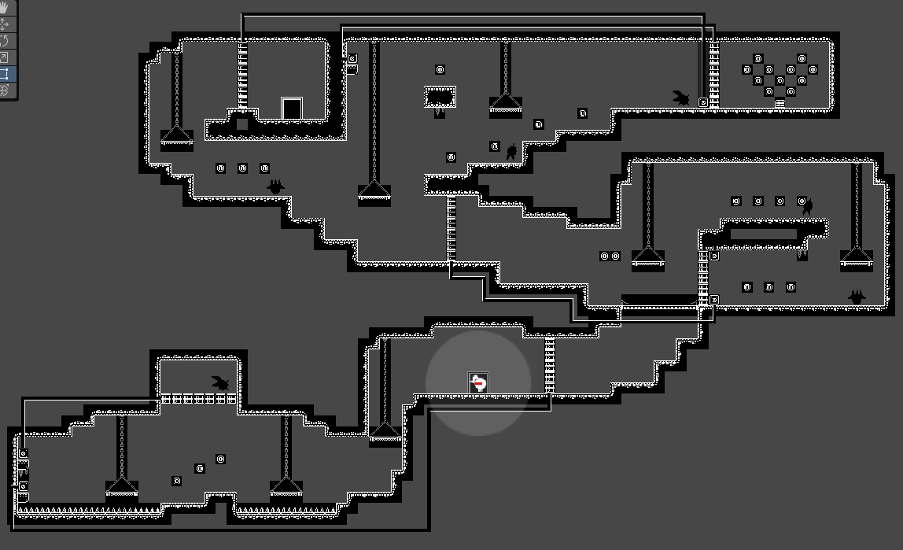
Room in the Unity editor

Extra Playtesting
In addition to the original purpose of this playtest, some more observations will be made in regard to systems, enemies, and user experience in general. This will be done in order to assist the other team’s designer get additional observations that could potentially help with their own research and changes to be made in their design.

Limitations
While choosing my sample, I made sure none of the participants were DigiPen students and had little to no experience in game design. Additionally, I prioritized people who were not that proficient in platformer games, as well as those who might not play games too often. The only limitations that could be found are regarding the playtesters’ relationship with the researcher as all of them have playtested previous game I have worked on and are familiar with being tested in participant observation.

Methodology
The playtests sessions were all done online over Discord with playtesters streaming what they saw on screen using the screen share feature on October 18th, 2023. The average playtest session time was about 16.5 minutes counting debriefing and feedback sharing. All participants recruited were non-DigiPen college students around the age of 20. The only relationship with the researcher is being regular subjects for playtesting. No ethical considerations to be made regarding the experience. All playtesters consented to having their data collected and displayed on this playtest report anonymously.

Participants
Due to the anonymizing process during data clean up and coding required for the DES270 course, for which this bigger scale playtesting was done, qualitative data collected from all playtesters has been merged. However, the GAM200 syllabus requires playtest reports to include information regarding playtesters and their playtesting sessions.
In no particular order, these were the subjects for this playtest:
- Samuel Gadbois on October 18th for 14 minutes.
- Michael Okamoto on October 18th for 22 minutes.
- Angel Bautista on October 18th for 14 minutes.

Observations
At the start of the experience, all playtesters had different thoughts. Among some of these comments we can find feeling trapped, feeling like they’re playing a mobile game, or the player character being a “hippie with a ponytail”. Playtesters would then go to the right to check the wall and realize there’s no way to progress, so they’d go down the left side to a new area, some even showing amusement as they went down through the jump-through platform. In this new area, they’d find their first coins which one playtester mentioned felt satisfying to collect because of its sound effect. Then, playtesters were presented with trigger lamps which opened their respective doors, but players didn’t know how to trigger them. One, for example, tried to find a key on their keyboard to see if anything happened. Another playtester jumped into the spikes to physically touch the lamp then went back to check if the door opened, but nothing had happened. After some deaths, playtesters mentioned liking the slow-motion effect as well as the enemy getting darker and fading out of existence. Once they were instructed how the flashlight focus and shine work, they triggered both lamps, opening the first door, but letting a ‘chaser’ enemy drop on their heads, to which they were shocked and learned how to kill it with the flashlight. Continuing with their path, they ran back to the start and noticed the open door and on the other side, there was a heal lamp which they lit up and ignored, until later. Once playtester tested it and thought it “overhealed” as you can only get to 3 HP with the player’s healing over time, and to 4 HP with the heal lamp, though this wasn’t clear to the playtesters. One playtester suggested adding some kind of particles when the player healed.
On the second part of the room, playtesters were presented with two new enemy types: the ‘coward’ and the ‘patroller’. One of the playtesters screamed when they saw the ‘coward’ running away from them in the dark. Once they reached the loop section, one of the playtesters liked to mock the enemies that were found at the bottom. Once this section was cleared, the players continued to the last section, going to the left first and seeing the exit door blocked by a door so they went to the opposite to find how to trigger it. On their way uphill, some playtesters got jumpscared by both a ‘coward’ and ‘chaser’ enemy at the top, which they ended up killing, even one who had just started being a pacifist and tried not to kill any remaining enemies. By this time, all playtesters had learned how the health system and aura work. In the same way, all playtesters showed their discomfort toward having to hold both mouse clicks to shine the flashlight. When explained how this system works, playtesters mentioned thinking the explosion when killing an enemy was what dealt damage to them instead of the flashlight overheating, which they thought didn’t make sense, and one added how it was counterintuitive. To this, some playtesters suggested adding a way to see your energy and to make killing an enemy not reduce your health. Additionally, one playtester commented on the lamps’ auras feeling unnatural with the level rest of the level design, but they couldn’t really tell what felt wrong with them. While another playtester said how the aesthetic of the level felt creepy with all the monsters going around.
After all of the playtesters finished the game, they replayed the level while sharing their thoughts and feedback. One that everyone mentioned being adding some kind of tutorial teaching the controls of the flashlight. Another comment was how the coins lead the way and how cool it was. While one of the playtesters was speedrunning the game on their second playthrough, they started repeatedly rotating their flashlight around their player character, which ended up in them finding a bug where a ‘coward’ enemy was frozen on the last frame of the animation right before exploding. One playtester even added their own level idea where there would be multiple ‘coward’ enemies you have to chase down and kill to find the exit. A comment all playtesters made was how scary enemies were as you cannot see them until you aim your flashlight at them. Nonetheless, a playtester mentioned how their silly looks matched the game’s style, while another one mentioned how they’re “sick and terrifying”. Another comment that came up regarding enemies was how it was unfair that enemies didn’t die when they touched spikes. Regarding the chest prop, some playtesters mentioned how underwhelming it was to open the chest and not receive much, some even showed confusion when they opened it for the first time. Another observation was how it was possible to “snipe” triggers from across the room with the flashlight. Another bug found was how enemies can trigger and collect coins for the player making them able to get hundreds of coins by guiding the enemies to the coin room and moving them around to collect as many coins as possible. Another small bug was how the highest jump-through platform in the level didn’t work consistently and players could hit their head on it. One final piece of feedback by one of the playtesters was how the heal lamps felt weird in their current spots and how it should be recharged after it’s used by the player to heal.

Conclusions
After collecting these observations and playtester feedback, we can identify the flaws and strengths of our current level design which will later help us identify the appropriate changes to be made to the game:
- Players feel trapped in an environment where there’s no visible exit or the space is too tight.
- Players cannot really tell that the player character is supposed to be a knight.
- Players like the current prototyped jump-through interaction.
- Players like satisfying collectible sound effects.
- Players didn’t know how to use the flashlight initially.
- Players liked the dying animation’s fading and slow-motion feel.
- Players’ engagement went up when they got ‘jumpscared’
- Players didn’t end up fully understanding the health/energy system.
- Players barely used the healing lamps and didn’t like their placements.
- Players liked enemies hiding in the dark.
- Players dislike having to hold both mouse clicks to kill enemies.
- Players like diegetic signifiers like the aura on the player.
- Players didn’t find the heal lamp aura fitting in the environment.
- Players find getting damaged for killing an enemy nonsensical.
- Players would like to see a way to track their energy on their flashlight before it overheats.
- Players like coins leading their path.
- Players found a bug that makes enemies freeze in their exploding animation.
- Players don’t like how the enemies can’t die to spikes/hazards.
- Players found the chest opening underwhelming and expecting more than just coins.
- Players found a bug where enemies can also trigger coins and collect them for the player.
- Players don’t like jump-throughs not working inconsistently.

Recommendations
Based on these conclusions, the following solutions and changes can be implemented to the game:
- We can use tighter spaces to make the player feel trapped.
- The player sprite could be revised, though it’s not a priority currently.
- We should implement jump-through physics similar to the prototype’s in the custom engine.
- Experiment and try to find an even better coin sound effect.
- A tutorial or some kind of signifier for teaching the basic mechanics should be implemented.
- The current dying animation can be further polished.
- More ‘jumpscares’ can keep the player engaged for longer times.
- A clearer way to show the health/energy system should be found, preferably diegetic.
- Healing lamps should be moved to safer points in the level.
- Keep enemies hidden in the dark as they make for great shocks for the player, increasing engagement and encouraging flashlight use.
- Different buttons can be found to control the flashlight.
- Polish diegetic signifiers like the player aura.
- The healing lamp aura can be adjusted to look more like light.
- The player getting hit for killing an enemy is an interaction that should be removed.
- A bar or diegetic signifier can be added for the player to see the energy on their flashlight.
- More coins pointing to the right way to go in the level should be added.
- A bug in the enemy script when they’re about to explode should be fixed.
- We should test if enemies the level design would benefit from letting enemies die to hazards.
- A particle system with coins could be added to the chest to make it feel more rewarding.
- A bug with the coins being able to be picked up by enemies should be fixed.
- All jump-through platforms should be working consistently.

