Jared Callupe Lopez
GAM200
Team Luminosity
Game KnightLight
Playtest Report 2
Level Bit Testing
Subject
Different level bits, which include challenges planned to be implemented in the game.

Executive Summary
In order to start testing possible level sections for our game, we came up with multiple level designs for the game. We made a build that contained three level bits the player has to go through before restarting the scene. The player has the same movement variables as the ones found over the last playtest. The player is also equipped with a flashlight which they can use to defeat enemies scattered around the level bits. These enemies will start following the player when it gets in their range to add difficulty to the experience. From this playtest, the main conclusions formed were that the players need to learn how to use the main mechanic with some kind of instruction or tutorial before going directly to the level. Another conclusion was that enemies liked getting collateral eliminations and defeating multiple enemies at once. Finally, one of the most important conclusions was that the health system needs to be revised as it’s currently being playtested and this build’s version is not the official one. Based on these conclusions, some of the recommendations were to find a way to encourage players to get closer to the enemy as they would simply slow down and defeat enemies from outside their range. Another recommendation was to make the player aura and flashlight out of raycasts instead of sprites for more realistic physics. Finally, background elements should have lower opacity to differentiate them from foreground elements. Following these recommendations can help us make better level designs and a more enjoyable experience overall.
Build
The playtest was made in a Unity build in a scene with three different rooms made in Tiled for ease of the players to test instead of explicitly showing the final map in the game. The first challenge features some platforms on top on a longer one above some spikes. The second one follows a more vertical approach going with platforms that guide the player from left to right as they go up and ends in a small room with the exit. And the third and last room features an elevator flat surface which leads to a pipe players can jump from to reach some floating platforms which guide the player to the exit above the start door.
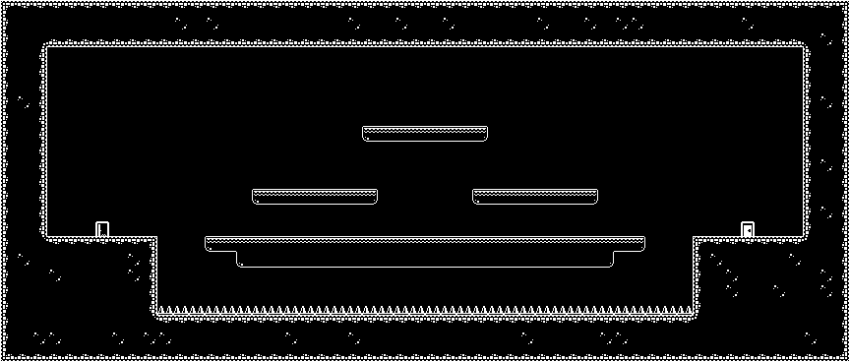1st room
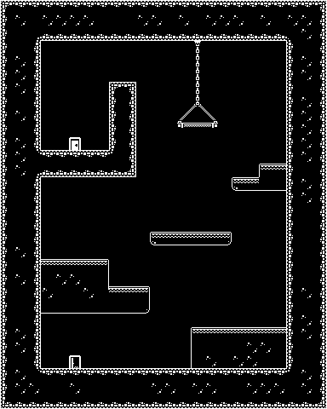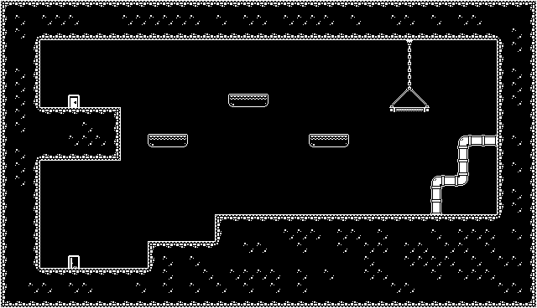
2nd and 3rd room

Purpose
“What changes should we make to these challenges before implementing them in the game?”
The purpose of this playtest was to find potential changes we could make to these previously designed challenges before implementing them in the game. Playtesting is one of the core parts of the level design process found right after the prototyping/block out stage. It is important to perform multiple iterations of playtesting before getting to the polish stage, and ultimately shipping the game.

Method
The way these levels were tested was by making the player go through each room until they reached the exit which would teleport them to the entrance of the next room. A dark mask around the player was implemented with a slightly lower opacity based on previous playtest. Additionally, some enemies were added and spread throughout the map. The player can defeat the enemies by aiming at them and holding left click which will make them get increasingly bigger until they explode. Finally, the playtesters’ feedback will be collected, and the appropriate changes will be implemented on the level bits. The only quantitative data collected was ‘deaths without flashlight’ and ‘deaths with flashlight’ for playtesters who took multiple tries to find out about the flashlight mechanic, though this variable would end up being irrelevant and was not used for further analysis.
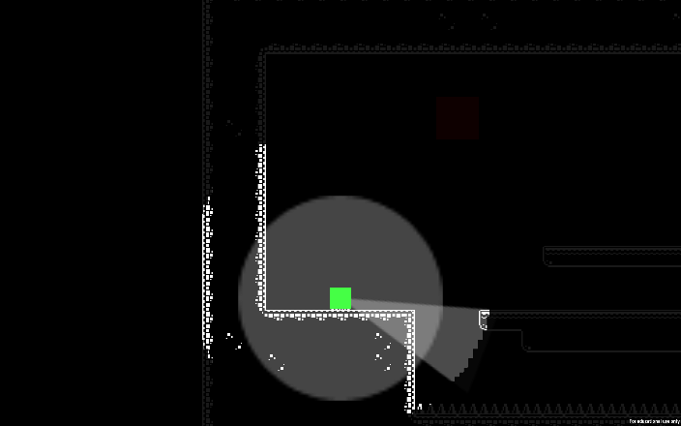
Start of the experience

Extra playtesting
In addition, player behavior will be observed to see how long it takes them to find out about the flashlight mechanic, or whether they find out about it at all, whether the new opacity for the mask allows them to barely see outside the ring, whether they kill all enemies or only kill those needed to progress, etc.
In order to add some difficulty to the experience, the enemies were modified to chase the player when they’re in range. With this modification, enemies were carefully placed in locations where they barely hit the player if they tried to just run towards the door. Additionally, both evolution and expansion changes were applied to make each room increasingly harder.
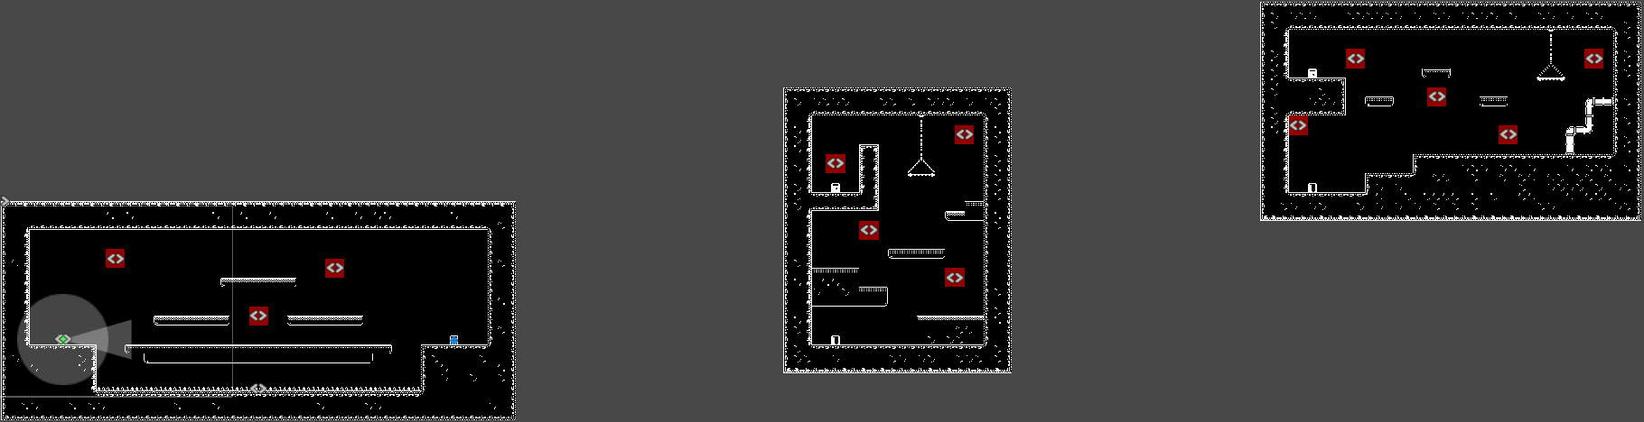

Observations
All playtests were performed online over Discord with the playtesters sharing their screen while sharing their thoughts as they progressed through the different rooms.
First Playtester
- Name: Richard Nagao (Non-DigiPen Mechatronics Student)
- Date: 09/28/23
- Session length: 15 minutes
- First Time User: No
Since this was a previous playtester, his first comment was how he could actually see what’s around him now that the opacity of the mask was slightly decreased. He didn’t use the flashlight initially. And he got hit multiple times by enemies that were specifically placed in tricky locations. After multiple deaths, he mentioned going in without carefully avoiding the enemies was probably a better idea, at the same time he figured out the light around him represented his health and added that it was “clever” to have the player resist 4 hits before dying. He also mentioned it being “annoying” that you can barely jump over the enemies without taking a hit.
Before instructing him to press left click to damage the enemies, he tried pointing the flashlight at them with no effect mentioning it was useless. After he experimented with the flashlight on spawn, he pointed it at an enemy that was approaching him and killed him. Immediately after, he started killing all enemies and finally getting to the final exit door, restarting the experience. With this new mechanic learned, he proceeded to try and speedrun all rooms.
While I let him go around killing enemies, I asked him questions regarding the experience so far. When asked where he was, he said he was in some kind of Limbo haunted by all the souls he killed in his past life (the enemies). When asked regarding the flashlight mechanic, he said the flashlight made it way easier to progress through the levels. Without it, it felt like an interesting challenge nonetheless, he mentioned, almost like a precision jumping game like Super Meat Boy, or Celeste. He also called whoever the level designer was a “sadist” as he felt most of the jumps and platforming required getting hit.

Second Playtester
- Name: Angel Bautista (Non-DigiPen Communications Student)
- Date: 9/28/23
- Session length: 17 minutes
- First Time User: Yes
This playtester discovered the flashlight mechanic almost immediately. Though, he didn’t know he had to use it on the enemies yet, so he made a run for it to the end, which didn’t work. After dying a couple times, he tried pointing the flashlight at the enemies and successfully killed one. After using his flashlight for a while, he realized it could overheat and it had a cooldown. He panicked and hid from the multiple enemies following him. When it went back to normal, he killed them from behind a wall and mentioned it was too broken that you it goes through walls. Once he found this out. He killed all enemies from spawn in the last room and finished the experience. After this, he went back to using no flashlight and tried to finish the game without it. This required him to perform some precise jumps and platforming. He even purposely died to restart his health.
Regarding the feedback shared, the playtester shared his thoughts from a more technical point of view. He mentioned liking the light around the player being the HP but regarding the system itself, it could be a two hit HP system where the HP point lost can slowly recover over time until it goes back to 2 HP. In addition, he suggested making the enemies unkillable when they are outside the ring, in other words, disabling their triggers when they are not in range, so they don’t get killed by the flashlight in the dark. Finally, the playtester mentioned the jump not working sometimes which could mean the jump check on the player movement script could be only working sometimes.

Third Playtester
- Name: Samuel Gadbois (Non-DigiPen Art Student)
- Date: 09/29/23
- Session length: 21 minutes
- First Time User: No
This playtester’s first action when entering the experience was noticing how the flashlight followed the player’s mouse and started spinning it around. The playtester commented on the new tilemap aesthetic, and said it looked more like a cave with rocks all around in comparison to the last playtest where they said it was like a grassy valley. He also mentioned the player character having both a flashlight and a lamp (the aura around them). When they started progressing through the first room, they noticed the enemies chased them and immediately realized the aura was their HP when they got hit by one of the enemies. And once they lost too much HP, they died on purpose to reset the HP. Once respawned, they tried to make a no hit run immediately, still not knowing about the flashlight mechanic.
When they were told to click, they spammed clicked but nothing happened as they needed to hold on the enemies for it to deal damage. After some testing, they realized they had to hold it and gasped when they found out how to kill enemies. When the flashlight overheated, they mentioned having a “timer”. After dying a couple more times, the playtester said they were going to get their mouse as they were not using one, but their laptop trackpad instead.
Regarding the feedback shared, the playtester mentioned liking the aura around representing health. One feature that they mentioned would be cool is making the mask smaller too when the player gets hit to increase difficulty. Regarding the level design itself, they mentioned the enemy placement was genius as they could feel they were placed just right to hit them. In the third room, they said they liked how the exit door was shown from the start and how “you know you have to go there”. One complaint the playtester expressed was how the hanging platform didn’t let them go through from below, and that it’d make sense if it did because of the difference in shape with other floating platforms. Another complaint they made when they didn’t know about the flashlight was how they were too fat to jump around. Finally, one observation they made was how the pipe platforms were good variation, but they didn’t know if it was really a platform or prop.
Conclusions
After collecting all the playtesters’ feedback, we can identify the flaws and strength of our level designs, and make the appropriate changes based on them.
General Conclusions:
- Players need to learn how to use the main mechanic with their mouse
- Players liked the new aesthetic
- Players like killing all enemies and fun ways to do so like collateral
- Players find it too overpowered that the flashlight goes through walls
- Players liked enemy placement and expansion
- Players need encouragement to move around faster
- Player health system could be revised
- Player likes the aura health signifier
- Players need to be told to use a mouse preferably
- Make hanging platforms jump through platforms
- Make platforms and props visibly different

Reflections
Based on the conclusions, the following solutions or features can be implemented in the prototype build:
- Making some kind of signifier to show the player how to use the flashlight. Though, if we want to go for a more diegetic approach, we could go with the tutorial idea we had where a player will be instructed to kill an enemy at the start of the game.
- The new aesthetic of the maps works well and makes players think they’re actually in a cave. More rocky tiles could be used to add more variation.
- Players like to find more ways of killing enemies, placing them in locations where multiple enemies can die at the same time by one single left click hold can help enhance this feeling and increase engagement.
- The current flashlight that uses a sprite and polygon collider can be replaced with a raycast flashlight to make it not go through walls.
- More enemy iterations where they barely hit the player encourage the players to kill more. In addition, the more enemies appear in later challenges, the more engaged the player remains.
- There needs to be a way to encourage the player to go for the objective instead of slowing down and killing enemies one by one. One solution could be adding a timer that either goes down to make the player hurry, or up to encourage the player to get the fastest time. Though this wouldn’t work for two reasons, one being that this is not the type of game that encourages speedrunning but rather discovery, and the other that we want as little UI as possible. Which brings us to the other solution being to add enemy spawners which will spawn enemies in the dark to create more unpredictable enemy patterns and make rooms less empty.
- The player health system is currently being playtested and will be applied to future builds.
- Since players like the aura around the player signifying health, animations could be worked on to make the feeling of losing health and getting health back in the future, more impactful and satisfying, respectively.
- At the start of the game, we should let players know a mouse is recommended to enjoy the experience.
- Hanging platforms will be made jump through, as one of the programmers was able to get jump through platforms to work recently. And additionally, floating platforms and hanging platforms will be used correctly and more consistently.
- In order to help the player differentiate between platforms they can walk on and background or other prop elements, these will be covered by another layer of dark tiles with lower opacity to still make them visible but making it clear the player cannot collide with them.

