Jared Callupe Lopez
GAM250
Team Luminosity
Game KnightLight
Playtest Report 4
Level 2 Playtest
Subject
KnightLight’s second level

Executive Summary
After testing our first level in the custom engine, the designers have decided to keep testing more levels in the custom engine, implementing new mechanics in each instance. For this playtest, the second level of the game was designed to test the new vent mechanic which teleports the player to other parts of the map, as well as other aspects like some changes made based on the last playtest, some UI elements like the finished pause menu and the main menu, etc. Overall, this playtest would focus mainly on the level design for the second level as well as player behavior around the new vent mechanic. Some of the main findings of this playtest were how players would like to see more vent focused challenges instead of repeating some of the hazard challenges we’ve been using. Another takeaway was how we need more feedback for every mechanic that we have in the game like lamps, doors, flashbang, checkpoints, etc. in order to help players understand when they have made use of a mechanic. Finally, we also took notes on some of the unintended behaviors that happened in the build during playtest. Some bugs were the ‘tile scrambling’ bug which only happened once the first time the game was opened, as well as another bug that didn’t check for time scale when a tooltip and the pause menu were instantiated allowing players to create multiple UI elements on a level. Overall, this playtest allowed designers to see what changes need to be made to our level design and what changes we can implement to enhance our UX.

Purpose
“What changes should we make to our second level?”
The purpose of this playtest was to see how playtesters played through the second level of our game. After being able to import our first level to the custom engine and playtest it, we decided to implement our second level by introducing a new mechanic in the game. Since the first level focused on both movement, and the lamp and door mechanic, we decided our second level will introduce the ‘vent’ mechanic which will teleport the player from one place from either side of the vent. The level contains mechanics from the previous level including the ‘flashbang’ ability and a door. This playtest focuses on player behavior when using the vents, as well as level design aspects such as exploration and a small secret that encourages it, not to mention some psychological concepts like cognitive maps.

Additional Playtesting
In addition to the new mechanic and the level design, some UI elements were analyzed, too. Elements like the main menu, pause menu and how tooltips are used throughout the second level. In addition to this, some questions were asked during the feedback and debriefing sections of the playtest. Questions like whether they thought the level was smaller or bigger in relation to the first level, if they have played it, or how they think the level layout was structured as the level can end up being very disorienting. Not to mention that notes were taken regarding any bugs or unintended behaviors in the build.

The Build
Just like the last playtest, this wasn’t a Unity build, but rather the current Release build of the game. The build consists of three scenes: the new main menu, credits menu and level 2. The new main menu replaced the old placeholder menu, which was only functional to open the first level, but now it’s been replaced with an improved version of our old Unity main menu prototype. This main menu consists of the following elements:
- Title Screen: This screen starts with a knight sprite fading in right after the splash screen sequence is over, with some slow particles in the back. Then after a couple seconds, a prompt asking the player to left click shows up and loops between fading in and out to catch the player’s attention. Once the player left clicks the start sequence plays, lighting up the knight sprite and revealing the game title along with the ‘Play’, ‘Options’, ‘Credits’ and ‘Quit’ buttons. In addition, some faster and brighter particles appear, too.
- Options Menu: This menu simply lets the player switch between fullscreen and windowed mode, as well as change the master volume or the ‘BGM’ or ‘SFX’ groups.
- Controls Menu: This menu is placed as a placeholder until we implement changing key binds which the programmers are working on.
- Start Menu: This menu allows the player to select their save file which is another feature the programmers are working on. This menu is more immersive as it showcases the knight falling to the underground as the screen shakes.
- Save File Info Menu: This menu displays the selected safe file information. It also moves the falling knight sprite so it follows the player’s current location in the menu.
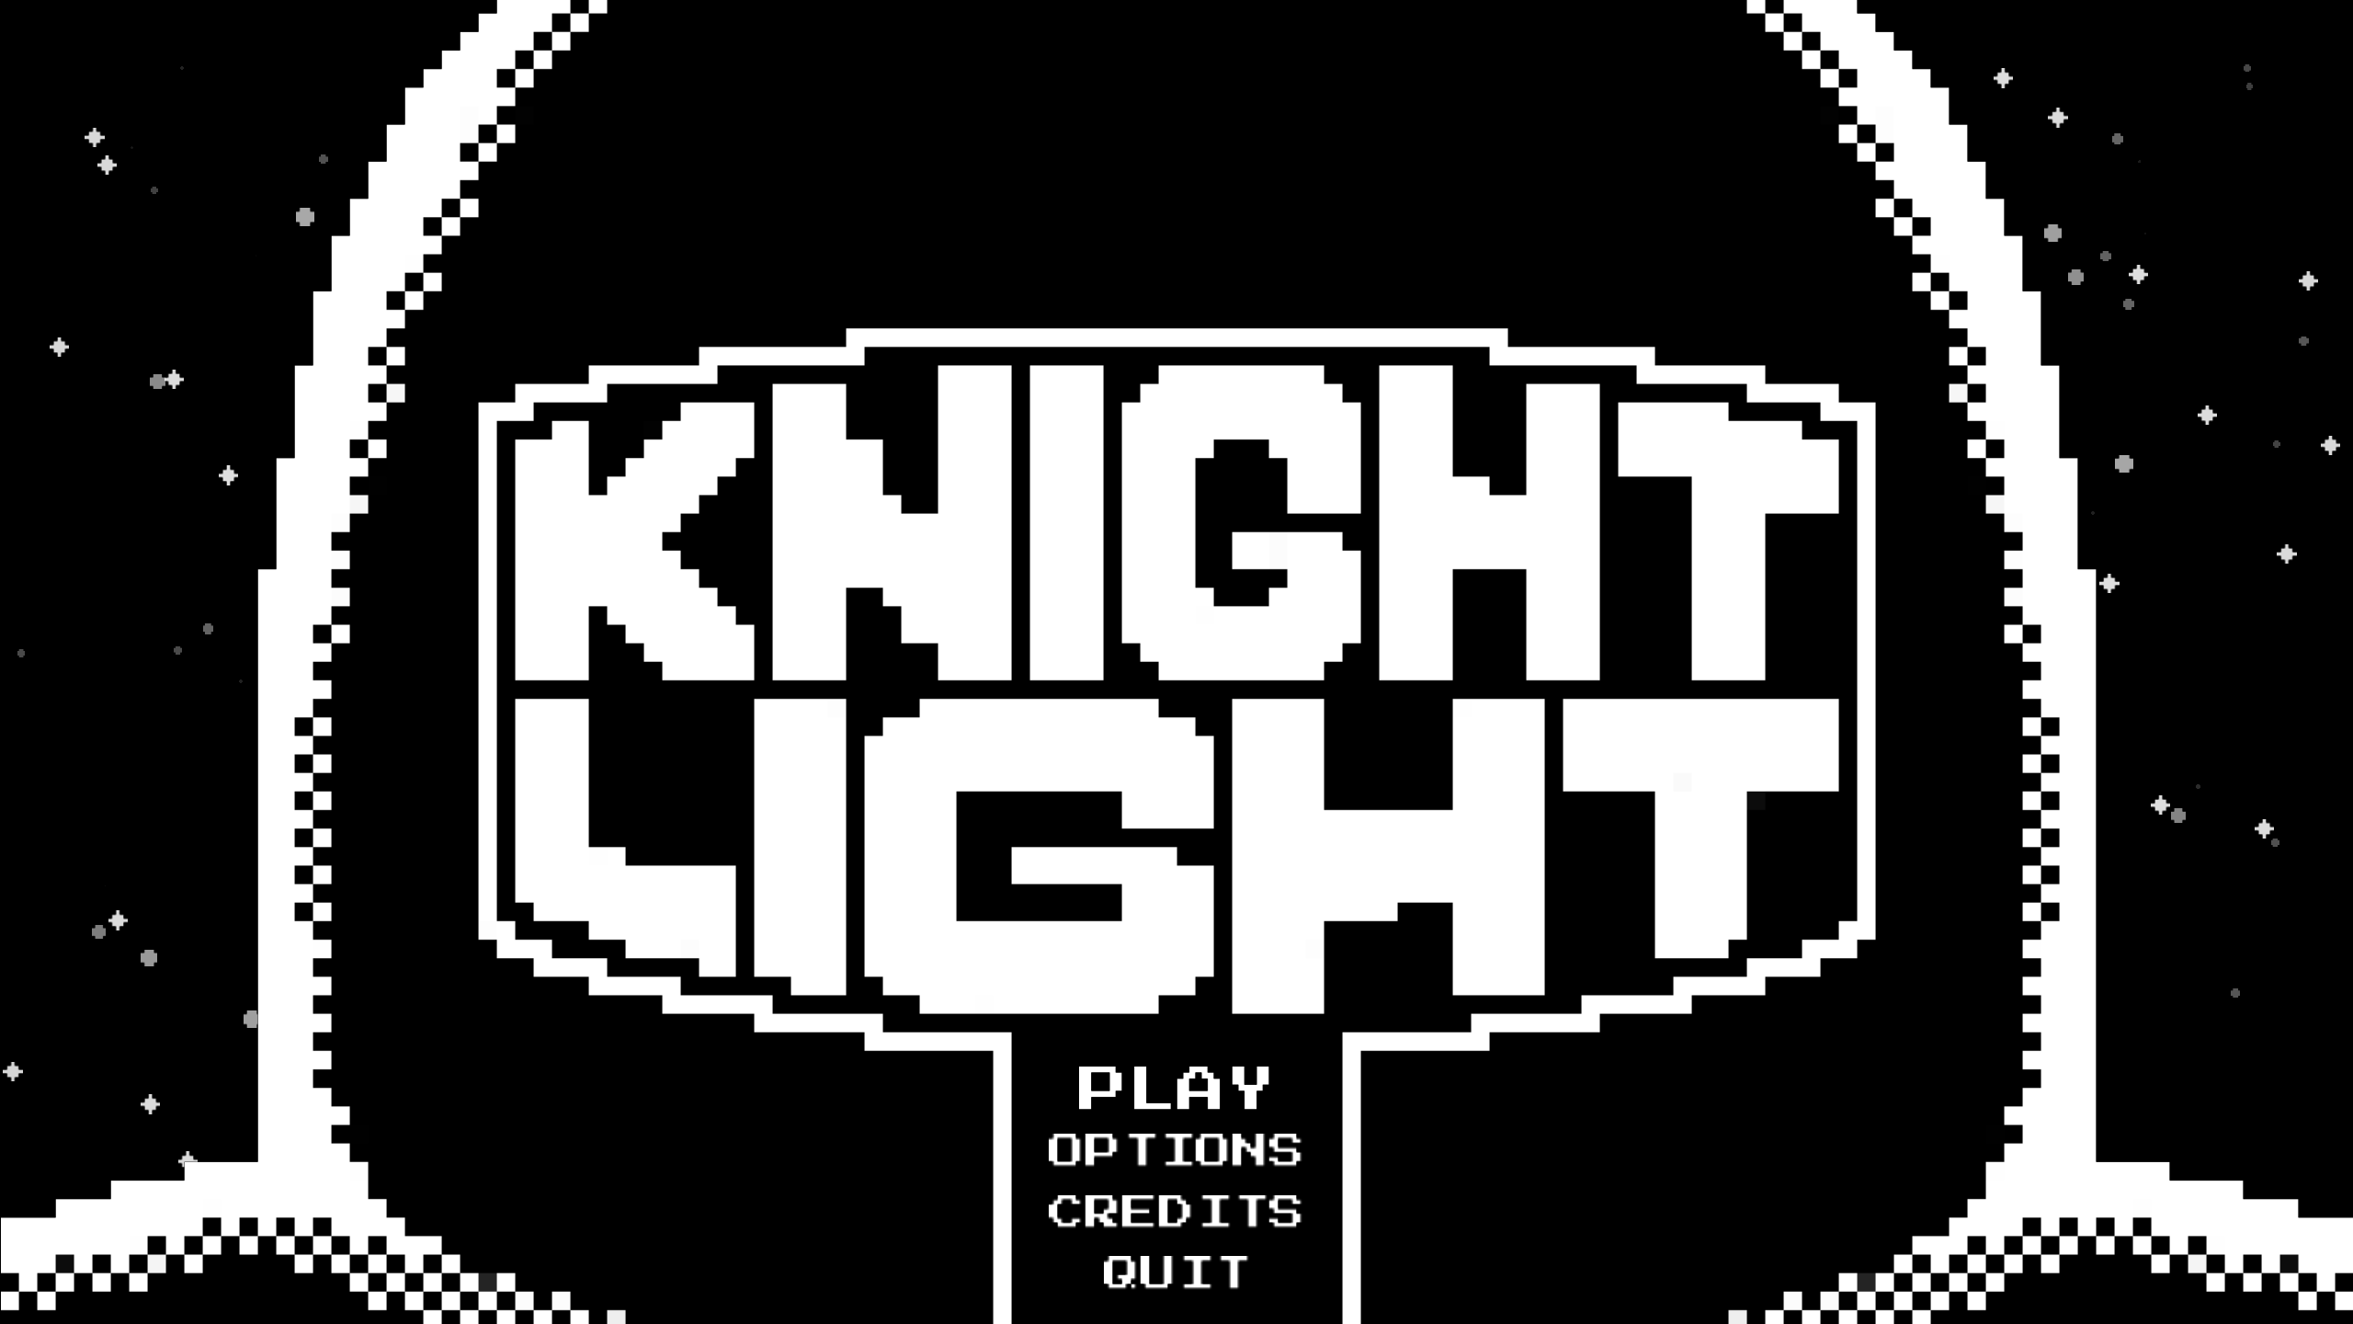
New Main Menu
The credits menu is a different scene as it was being worked on by a programmer. It shows our team members’ names and roles, and it allows the player to scroll up and down to show more credits. It is currently being worked on to further improve the UX.
Regarding level 2, the tilemap consists of two main sections: the transition between this level and the previous one, and the vertical section. The transition section starts with the vent that teleported the player from the first level, continue by the first vent which teleports the player to a short platforming section with vents in the background to introduce this theme to the player, as well as a checkpoint at the end. After this, the player takes a couple vents to reach the next main vertical section. In this following section, the player has to take vents to reach a higher floor while avoiding some hazard challenges. After making it to the third floor, players can choose to finish the level, or if they explore a bit further, they’ll find a door with a small secret behind it. The lamp that opens the door is located on one of the pits on the third challenge which drops the player down to a small pocket with a vent that brings them back up. Once the door is opened, the player can find an NPC sleeping on the other side. The idea of this was to hide a collectible that the player can retrieve behind this sleeping NPC, but since the collectibles haven’t been implemented, only the NPC was placed. This section also features a background full of vents that go around the environment to match the level theme.

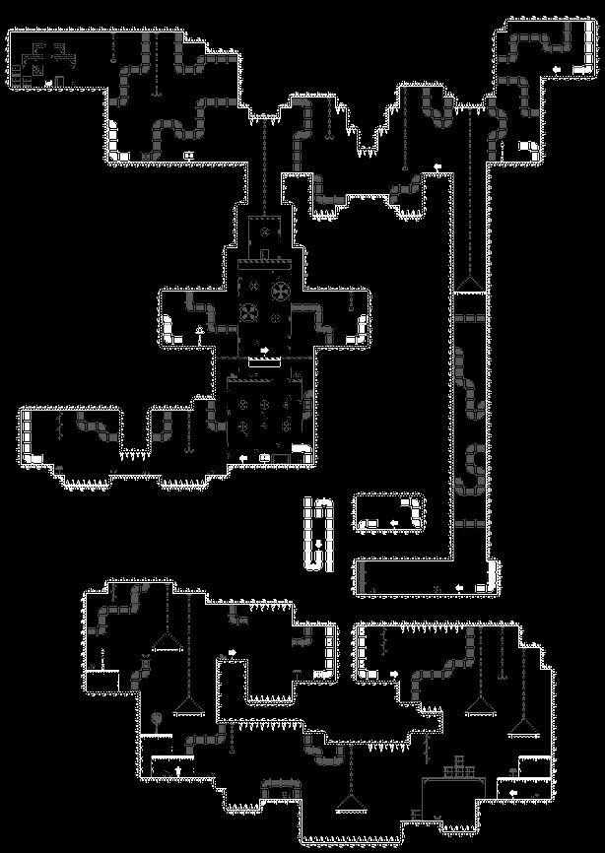
Level 2 Playtest Tilemap
Method of testing
This playtest session was structured similarly to previous playtests where playtesters would play through a build of our game while the researcher takes notes on their behavior and comments of the game in order to make observations for later analysis. After this, subjects get interviewed by the researcher with questions regarding their overall experience with the game. Finally, playtesters get asked to share feedback including what they liked or disliked about the experience and sharing what they’d like to see in the future.

Methodology
All three of the playtest sessions were done online over Discord with playtesters streaming what they saw on screen using the screen share feature. These were all performed on and March 17th, 2024. The average playtest session was about 19 minutes including installation guidance, gameplay, feedback sharing, and debriefing. All three participants were non-DigiPen college students around the age of 21. Two of the subjects’ relationship with the researcher is being regular subjects for playtesting, while the other one is the researcher’s sibling. No ethical considerations to be made regarding the experience. All playtesters consented to having their data collected and analyzed to form recommendations for our game design.

Participants
Playtester A
Name: Michael Okamoto
Identity: Non-DigiPen Community College Student
Place: Discord
Date: 03/17/24
Session length: 18 minutes
First Time User: No

Playtester B
Name: Carlos Callupe Lopez
Identity: Non-DigiPen Film and Media Studies Student
Place: Discord
Date: 03/17/24
Session length: 22 minutes
First Time User: No

Playtester C
Name: Angel Bautista
Identity: Non-DigiPen Student
Place: Discord
Date: 03/17/24
Session length: 17 minutes
First Time User: No

Limitations
While choosing the sample, regular playtesters were chosen due to convenience and availability, meaning all of them were familiar with the playtesting process. Another consideration made while picking subjects was choosing the same players that played through level 1 as they’re familiar with the mechanics and can form comparations between this and the previous build. The only limitation to consider is the relationship between the researcher and one of the subjects who was the researcher’s sibling which might create some bias and make them avoid making comments that might be too critical of the game’s design. Additionally, one downside of choosing to perform these playtest sessions exclusively online is that the researcher cannot see playtesters’ physical reactions to the game, such as facial expressions in response to game stimuli. However, this information was not considered relevant in this research.

Observations
Participant A
This playtester started by mentioning how they liked the splash screen and start sequence, then he went to the options menu just to go around exploring the main menu and asked what “BGM” meant as they weren’t aware of the term. He then went back to the title screen and clicked ‘Play’. He pointed out the screen shake and on the save file info menu he mentioned it was so hard to read with all the screen shake. Once the level loaded, the ‘tile scrambling’ bug occurred which made the tilemap look weird. He used the pause menu to quit the game and reopened it. However, once the level loaded again, the pause menu still showed up as if it was saved on the scene when the player quit the game. After reopening the game again to confirm that it was saving the scene on quit, I asked him to reinstall the game. Once reinstalled, the player continued with the level normally.
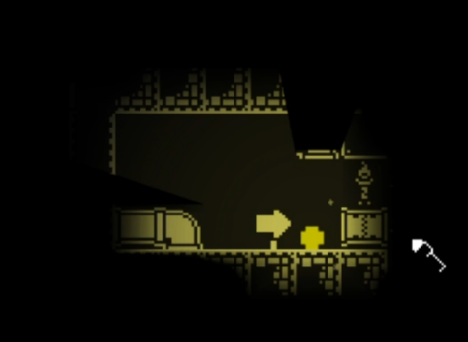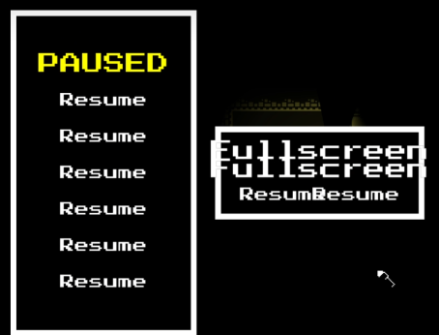
Tile scrambling and scene saving on quit bugs
At the end of the platforming section, he tried lighting up the checkpoint, but he showed confusion as no feedback happened. After dying, he then realized those were checkpoints as he respawned on the first one. While making his way to the third floor he fell from the second floor to the first one and asked where he was. After going through some vents, he recognized the section he was just at and started becoming familiar with the environment. On the third floor, he recognized the pit with the secret and went through it. He triggered the lamp and went back up using the vent. He showed confusion as he thought was just there, but it was actually the small pocket on top of the vent that leads to the third floor. He jumped down and realized that was the third floor. As he jumped to avoid the ceiling hazards, he died and respawned at the checkpoint but as he jumped, he jumped down to the secret pit on accident multiple times due to the positioning of the checkpoint, showing frustration. Finally, he finished the hazard section and made his way to the end of the level and saw the NPC.
When asked whether this level felt bigger or smaller than the first one, he said it was bigger and longer due to the vents that make the map feel large. He also added that the minimap in level one made it easier to navigate and that he actually liked feeling lost in this level. Some other feedback given was how there were a good number of checkpoints for the length of the level and the floating specs were cool, but he’d like to explore the building inside, as well as some sound effects for the different objects, especially the checkpoints. Regarding the lamps, he mentioned they were better because they’re not blending with the background anymore, while doors are even cooler now with the screen shake. Some things he’d like to see are more puzzle-based challenges especially with the vents as learning where they take you is fun. Regarding the main menu, he said he would’ve liked the start sequence to make a flash like it does in game.

Participant B
This playtester started the game normally and questioned why the camera was shaking we he pressed play and selected a save file. Once he loaded in the level, he tried to go through the first vent which didn’t work as it’s only there to show that’s where the player came from. After getting to the first checkpoint, he didn’t realize that’s what it was, so he went back there when he died. As he got to the third floor, he knew there was something in the pit as he had been lighting up his path. When he went down and fell on the two-way platform, he asked if it was a trap and that he couldn’t leave until he tried pressing ‘S’ to fall through it. As he was looking for the door that he opened, he had already reached the end and found the NPC sleeping.
When asked to share feedback, he said that not much happened compared to the first level. When asked to explain, he said that vents aren’t that impactful of a mechanic since they simply move you around and that we could solve this by making more challenges around them. Regarding the overall level, he said that it felt more like a transition between two levels instead of an actual level, and that there needs to be an incentive to explore like coins to form a sense of progress. He added that the only thing that stood out in the whole level was the NPC and that he wanted to know more about it. Another comment regarding the vent mechanic was how they can become very disorienting and that if that was the objective, then it was achieved. Another thing mentioned was how the last floor challenge should be more difficult or different if possible, and that we should encourage the player to make use of the flashbang more. One thing this playtester would like to see is simple enemies that just move left and right and can be defeated by using the flashbang on them.

Participant C
This playtester started by mentioning how he liked the splash screen and start sequence. Once he loaded in the level, he noticed the first vent and pointed out how it was the continuation of the first level. Once again, when he reached the first checkpoint, he mentioned that he didn’t know whether he activated it or not and that there should be a sound effect for that. On the first floor, he thought he saw something so he went back and ended up dying to ceiling spikes even though he didn’t touch them and mentioned how their hitbox shouldn’t go up to the edge. Even though there’s no sound, he said that he’d imagine a sewer ambience for this level. On the second floor, he fell back to the first one and landed on a checkpoint and added that we could make the checkpoint flame light up. Once back up, he made his way to the end of the level and explored a bit more, finding the closed door. He went back to explore until he finally found the pit with the secret. As he was doing this, he mentioned the vent lighting looked weird. After lighting up the lamp, he went back up and realized that was how you got up there in the small pocket on top of the third level vent. He went up to the NPC behind the door and interacted with it. Before closing the dialog, he pressed pause and then closed the dialog which made the pause menu stay instantiated on the level, making the player able to instantiate infinite pause menus.
When asked to share feedback, he mentioned this level seemed shorter than the other one because the first level had more platforming. He also mentioned he still didn’t know what the knight part is about and how everything is related to it yet. Finally, he repeated some of the things he wanted from the last playtest like a health bar with varying damage sources, more puzzles with doors and vents.

Conclusions
After making all these observations based on the playtesters’ experience, these are the main takeaways:
- Players like the splash screen and main menu start sequence.
- Not all users know what ‘BGM’ means.
- The screen shake makes the save file info hard to read.
- The ‘tile scrambling’ bug occurred once when the game was opened for the first time.
- A bug that saves the scene on quit occurred allowing the player to create multiple pause menus instantiated on the level.
- The checkpoint lacks feedback and confuses players.
- Players can get confused when falling from another section to a previous one.
- Some checkpoints would punish the player for moving after respawning.
- Players felt like this level was bigger than the first one due to the number of vents making it feel like a big map.
- Players like the sense of feeling lost in the environment, rather than having a minimap to help navigate it.
- The number of checkpoints was good for the length of the level.
- Players like the environment particles.
- Players would like to explore the buildings in the background of the levels.
- Players like lamps not blending in the environment, as well as the new door screen shake.
- The main menu start sequence should make the knight do a flash like the flashbang mechanic in game.
- Some players tried to go through the first vent which didn’t work.
- Some players didn’t know you could fall through platforms and thought they were trapped.
- Not much happened in the second level compared to the first level.
- Players want coins or some kind of currency.
- The NPC at the end made players curious about the level’s narrative.
- The third floor was too easy and didn’t feel like a challenge.
- The flashbang mechanic wasn’t used that much on this level.
- Some players died to the ceiling spikes even though they didn’t touch them.
- The theme of the level made players think the level was themed after a sewer.
- Some players thought the vent lighting looked weird.
- There’s a bug that allows players to pause the game while using a tooltip.
- Players didn’t know how the game is related to a knight so far.

Recommendations
Based on the conclusions, the following solutions or features can be implemented to the game
- We should polish our menus even further to enhance our UX.
- We’ll change some of the technical terms like ‘BGM’ and ‘SFX’ to more colloquial words like ‘Music’ and ‘Sound’.
- We can reduce or ultimately remove the screen shake from the menu and only enable it once the start sequence occurs.
- The programmer in charge of tile behavior will be notified of the tile scrambling bug even though it was already fixed in debug mode.
- The programmer in charge of saving a scene will be notified of the bug that saves on quit.
- We need to add both visual and audio feedback to the checkpoints.
- We can add background elements the players can easily recognize to previous sections the player can backtrack to.
- We need to move checkpoints to safe zones where the player cannot die or lose progress after respawning.
- We can use vents to make our players think a level is bigger than it is.
- We should not implement a minimap as players enjoy having to explore.
- We should be generous with the number of checkpoints we implement in the level, but also not put one after every challenge.
- We can improve our environment particles now that we have even more customization options for particle emitters.
- We can consider adding small rooms the player can access by interacting with the background buildings.
- We can change the previous lamps, so they are clearly visible and make the player learn how they look as they play, as well as keep the door screen shake.
- We’ll polish the main menu start sequence with better sprites and particles.
- We’ll make it so players can backtrack to a previous level using vents.
- We need to teach players how to fall through platforms using ‘S’ in the first level.
- We’ll replace some of the platforming challenges with new vent challenges in the second level as they didn’t feel like an impactful mechanic.
- We’ll add currency items that will help to both form a sense of progress in the player and guide the player in the environment.
- We’ll add a better narrative to the level making use of more NPCs and environmental storytelling.
- We’ll completely replace the third floor challenge with a vent challenge to fit the level’s theme.
- We’ll add more lamps and doors so the players will use their flashbang even more. In the future, we can add simple enemies the player can defeat by using their flashbang.
- We’ll make the ceiling spike colliders less wide so players don’t accidentally collide with them when they walk on their side.
- We’ll add sewer ambience to this level so players can become more immersed in the environment.
- We’ll ask the programmer in charge of lighting how we can improve the lighting when the player comes out of the pipe.
- We’ll add a time scale check before letting the player use the pause menu or interact with a tooltip.
- We are planning on introducing the knight armor on the next level, these first two are mainly to introduce simple mechanics.

