Jared Callupe Lopez
GAM250
Team Luminosity
Game KnightLight
Playtest Report 3
Level 1 Playtest
Subject
KnightLight’s first level

Executive Summary
KnightLight has reached the testing stage in the custom engine. This means that playtesters are now able to install and play through an early instance of the official version of the game. For this playtest, the first level of the game was prepared to test the player movement made for the engine, the main mechanics, some UI elements, the level design, and its environment itself. Altogether, the level focused on the tutorialization of the ‘light’ player including both the movement feel and the main mechanic: the ‘flashbang’ ability which is used to trigger doors and open the player’s path. Simultaneously, the level design elements were separated into two main sections: the movement with short challenges, and a puzzle bit with multiple lamps, with a short backtracking part in their intersection. Some of the main observations were that playtesters felt lost after dying and respawning due to the change of position in the dark being too sudden, or that players were expecting enemies even though there weren’t any, which is something we could play with, as well as the multiple bugs that occurred which were communicated to the programmers so they can get them fixed soon. Overall, this playtest allowed the designers to see what changes should be made to our design and what changes we can implement to it to enhance the players’ experience.

Purpose
“What changes should we make to our first level?”
The purpose of this playtest was to see how playtesters behaved in the first level of our game. Since we, the designers, started working in the custom engine, we’ve been moving all our previous work from our Unity prototype to the engine. Now that C# scripting has been implemented, we’ve been able to implement our movement and other elements that make movement smoother to the player. In addition to this, multiple levels were designed to be implemented in the game, each one of them having a purpose in the progression of the game. This playtest will contain the first level which encompasses the light form tutorialization, meaning the knight armor will be unlockable later in the game. This tutorial teaches the main movement mechanics, as well as the main light mechanic itself: the ‘flashbang’ ability which can open doors that block the player’s path. This playtest focuses on the movement variables and the feel of it, as well as level design aspects like evolutions, expansions, backtracking, and the lamp-door puzzle sections.

Additional Playtesting
In addition to movement, some secondary level and UX elements were analyzed, too. Elements like background environment and user contrast sensitivity. The ‘flashbang’ ability range, brightness, and overall feel. In addition to this, some questions were asked during the feedback and debriefing sections of the playtest. Questions like where they think they are, or what’s going on in the environment narratively, among other things. Not to mention that notes were taken regarding any bugs or unintended behaviors in the build.

The Build
Unlike previous playtests, this instance of the game wasn’t a Unity build, but rather the Release build of the game, meaning that this will be the official version of the game once we get more elements added. This build consists of two scenes: the main menu, and level 1. The menu is a simple placeholder used to load the level 1 scene while this other one contains actual gameplay. The level 1 scene consists of a player controller which uses ‘A’ and ‘D’ to move left and right, ‘W’ to jump, ‘S’ to fall through one-way platforms, ‘E’ to interact with tooltip signs, and left click to use the ‘flashbang’ ability which creates a flash where the player triggered the ability and lights up the player’s surroundings, helping them navigate the environment.
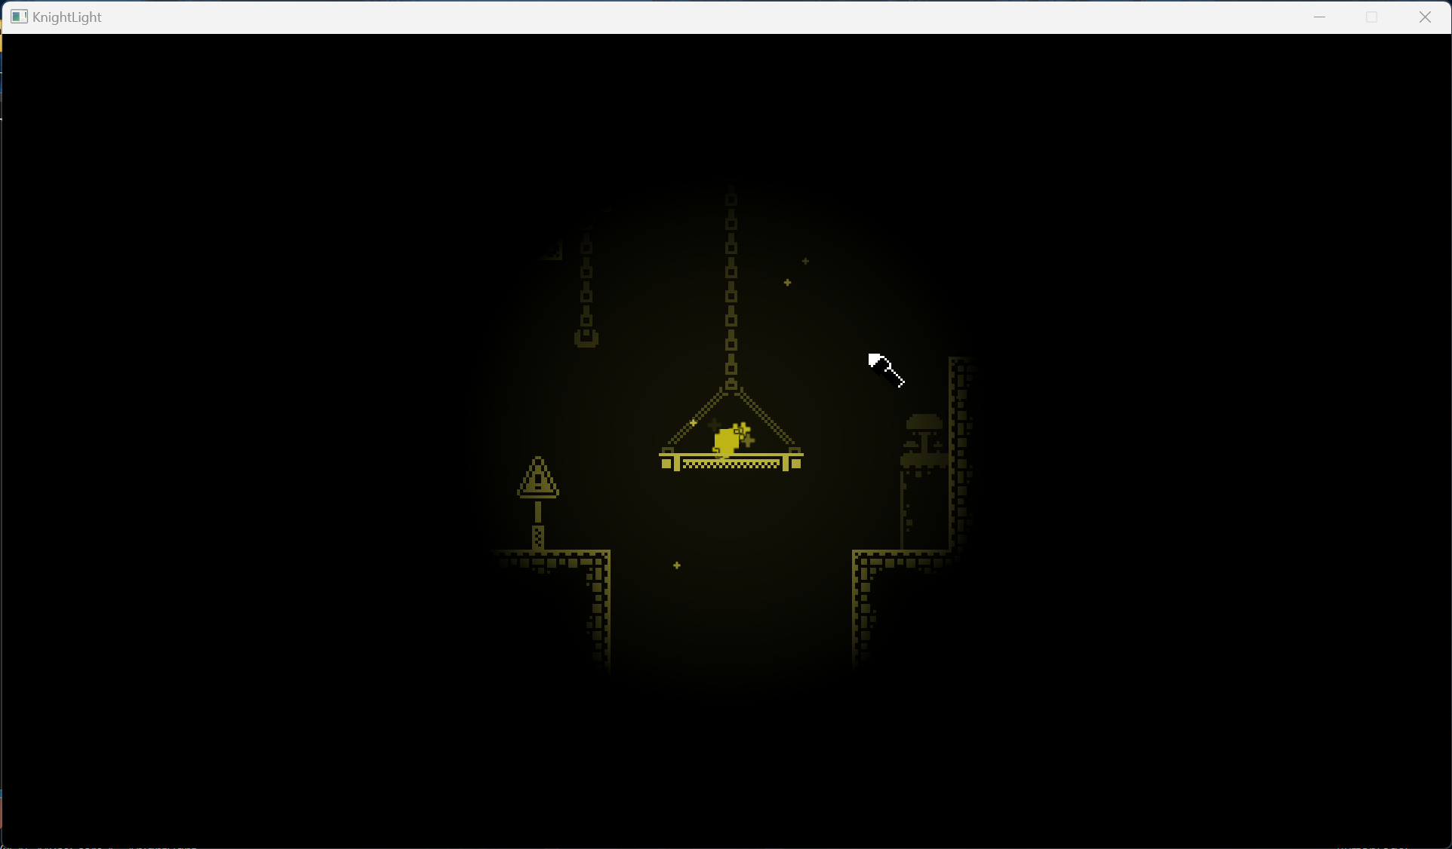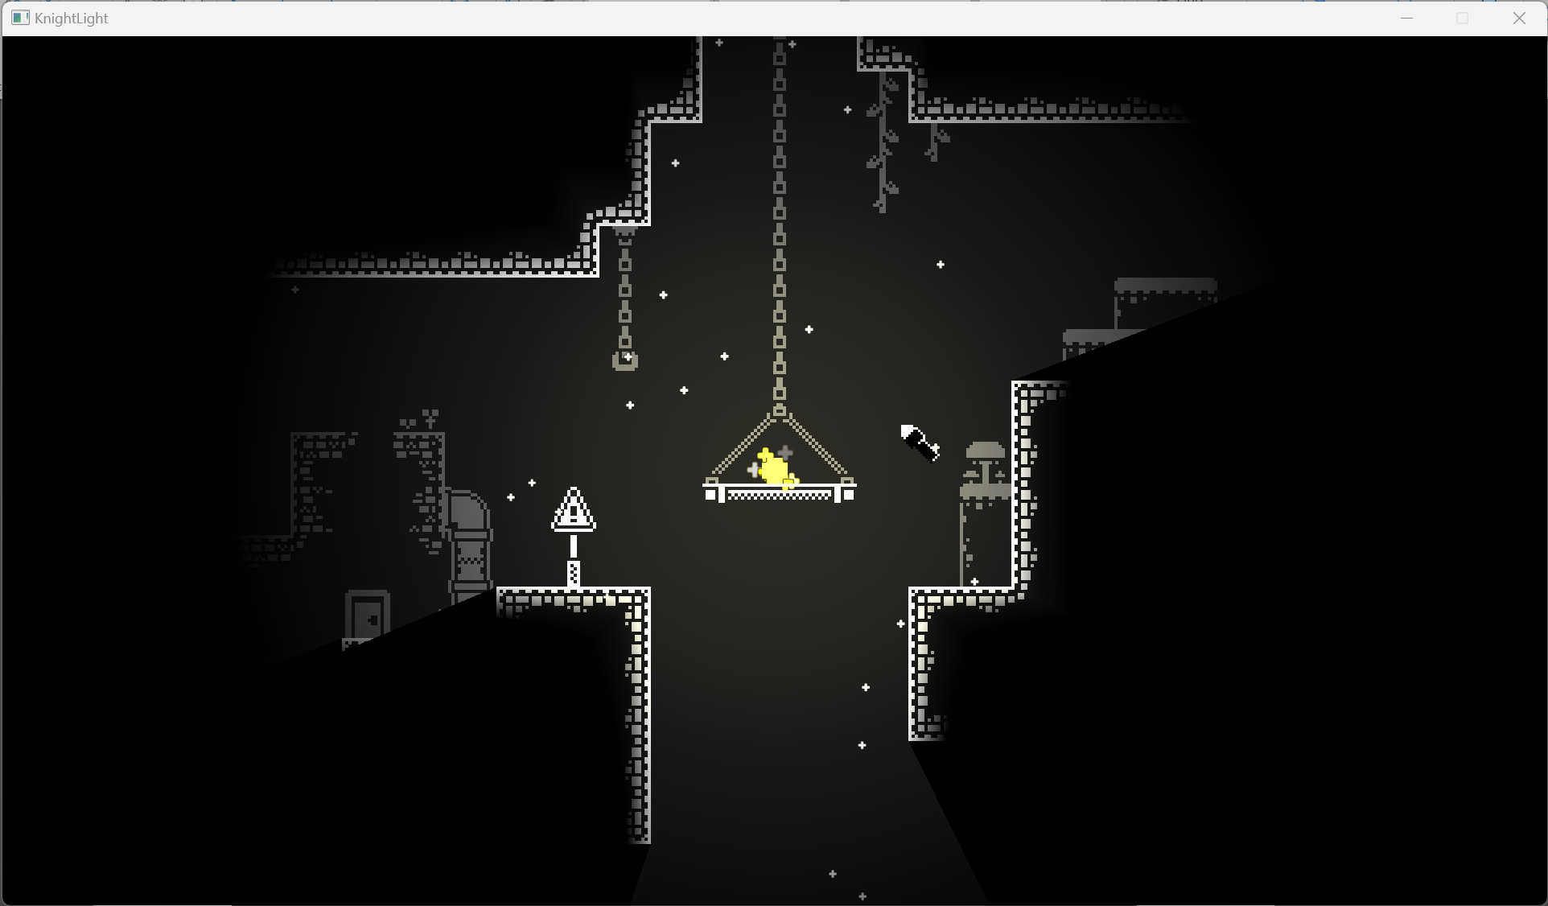
Flashbang ability
The tilemap consists of two main sections: platforming section up to the first door, and the lamp puzzle with a checkpoint between them. The platforming section applies the concepts of evolutions and expansions with the initial challenge being a small jump expanding in depth and length and evolving with spikes and hanging platform jumps as the level goes on. This first section contains tooltips that explain to them how the player can jump through one-way platforms, use their flashbang to light up their surroundings, and activate lamps with it. This section also features a short backtracking section after they light up the first lamp which allows them to see the first lamp behind a wall as they go around it. The second section features a small puzzle with lamps behind doors where the player has to open the respective lamp to open a door an be able to light up another lamp, which ultimately would open the last door and let them proceed and finish the level. This section makes use of looping, so the player has to go around this section at least once more to light up all the lamps. At the end, there’s a pipe that teleports the player to the following section.
Both sections have background decorations that fit the “underground abandoned city” aesthetic since narratively this was the place where villagers used to live before, at the bottom of the underground. It features overgrown destroyed buildings, abandoned mine-like structures with barrels to signify those were used for work-related activities, destroyed bridges, hanging platforms and chains, among other elements that add to the aesthetic. All of these have a lower opacity so the player is able to tell them apart from the regular tilemap they can interact with.

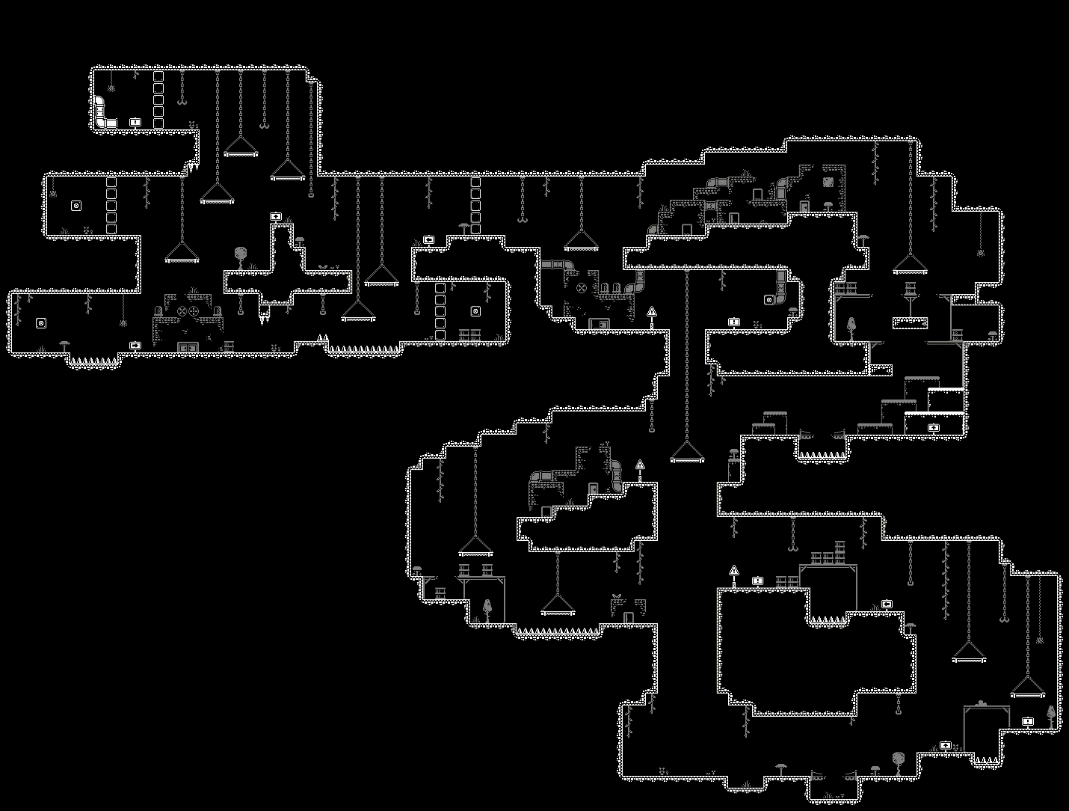
Level 1 Playtest Tilemap

Method of testing
This playtest session was structured similarly to previous playtests where playtesters would play through a build of our game while the researcher takes notes on their behavior and comments of the game in order to make observations for later analysis. After this, subjects get interviewed by the researcher with questions regarding their overall experience with the game. Finally, playtesters get asked to share feedback including what they liked or disliked about the experience and sharing what they’d like to see in the future.

Methodology
All three of the playtest sessions were done online over Discord with playtesters streaming what they saw on screen using the screen share feature. These were all performed between March 2nd and March 3rd, 2024. The average playtest session was about 16.6 minutes including installation guidance, gameplay, feedback sharing, and debriefing. All three participants were non-DigiPen college students around the age of 21. Two of the subjects’ relationship with the researcher is being regular subjects for playtesting, while the other one is the researcher’s sibling. No ethical considerations to be made regarding the experience. All playtesters consented to having their data collected and analyzed to form recommendations for our game design.

Participants
Playtester A
Name: Michael Okamoto
Identity: Non-DigiPen Community College Student
Place: Discord
Date: 03/02/24
Session length: 15 minutes
First Time User: Yes

Playtester B
Name: Carlos Callupe Lopez
Identity: Non-DigiPen Film and Media Studies Student
Place: Discord
Date: 03/03/24
Session length: 21 minutes
First Time User: No

Playtester C
Name: Angel Bautista
Identity: Non-DigiPen Student
Place: Discord
Date: 03/03/24
Session length: 14 minutes
First Time User: No

Limitations
While choosing the sample, regular playtesters were chosen due to convenience and availability, meaning all of them were familiar with the playtesting process. Another consideration made while picking subjects was making sure their experience in games was varied and not limited to one single genre to avoid biases between experiences and have a broader range of potential ideas the playtesters can share. The only limitations to consider is the relationship between the researcher and one of the subjects who was the researcher’s sibling which might create some bias and make them avoid making comments that might be too critical of the game’s design. Additionally, one downside of choosing to perform these playtest sessions exclusively online is that the researcher cannot see playtesters’ physical reactions to the game, such as facial expressions in response to game stimuli. However, this information was not considered relevant in this research.

Observations
Participant A
This playtester started the game by spamming left-click after focusing the game window as they saw clicking triggered the ‘flashbang’ ability. After moving around and figuring out the controls by pressing the WASD keys, he processed with the level while questioning whether the light wall mask debug render was a functional minimap and got confused by it. Regardless of that, he mentioned the game looked like a cool horror game so far due to the dimness of the light which is caused by a bug that only happens the first time the game is opened after installing it. After making it to the lamp tooltip saying to trigger the lamp, he asked if the ‘lamp’ next to it was a lamp and, once he triggered it, the cutscene played and he showed displeasure at not being able to move for a short moment after the cutscene played. During the backtracking section, he mentioned how cool it was that that light is blocked by the environment and proceeded to show how the flashbang stayed in its initial position even when the player was moving. On the last section of the level, while looking around the map with the flashbang ability, he accidentally triggered the first one across a hazard floor due to its proximity to the player. He then continued to the narrow path with hazards and activated the next lamp. After making his way to the third lamp, he died to the ceiling hazards, and he questioned what he died to. Once respawned, he was also confused where he had respawned, he then went back to the section where he died and noticed the hazards on the ceiling. Finally, he triggered the last lamp and made his way to the last door with the vent, finishing the level.
After asking to share feedback on his experience, he mentioned he kept waiting for monsters to jump at him as he thought it was a horror game. He also mentioned the game feeling mysterious and that he’d like more lore elements that explain what the player character is and what they’re doing there. He mentioned liking the abandoned aesthetic with spiders, barrels, and buildings where humans lived, and that they had to abandon their underground city due to a landslide or a similar catastrophe. Regarding the lighting, he mentioned that the lamps looked like background elements, and that darker and lighter objects were a bit hard to tell apart. He mentioned that we should make it, so the lamps have a small light around them and it increases it’s radius when you light them up. He added that the minimap needs to show where the player is in the environment. Additionally, he mentioned how there were no collectibles or coins to collect on the map which made it feel empty. Finally, one idea he gave me was a collectible menu where you can display all your collectibles on a shelf or in some kind of environment.

Participant B
This playtester started the game by using their flashbang and immediately continued with the first platforming challenges. After the first tooltip saying to use the flashbang to see around them, he fell as he thought the pit was tighter and the platform across was closer. While jumping around looking for secrets in the dark, he noticed a small inaccessible pocket in the map and tried to get in there. He achieved this by jumping midair due to a bug that allowed the player to jump midair after falling off a platform. Once he got to the first lamp, it wasn’t lighting up when he used the flashbang ability right next to it, but once he moved away and used the flashbang it did work, and it opened the door. This bug only happened the first time the game launched as he reopened it later and the flashbang interacted correctly with the lamps. While backtracking, he died and respawned all the way back at the start of the level. This time, he was more careful with jumps and got to the last section where he accidentally triggered the first lamp just like the first playtester. He then headed to the second door and triggered the third lamp. Since he had checked the last door first, he thought this one was that door and he headed to the end, but he realized that the door wasn’t open, so he looked around and found the actual door with the last lamp. Finally, he went around the section and finished the level.
After this, he was asked to share feedback, for this he reopened the game and noticed the lighting being brighter due to the bug. He mentioned liking the background because of the different storytelling elements and that it makes the game feel livelier, but he also said that it should be clearer that you cannot interact with the background. Another aspect he said we should change was how we should use the spacebar for jumping as that’s what most platformers do and that we should change the flashbang key bind because platformers don’t normally use the mouse. One great idea shared by this playtester was how doors can be more diegetic and make use of the environment to create more interactive environments. He also mentioned how the lamp tile didn’t look like a lamp and that he confused it with a background tile. Another good point made by this playtester was how you can just spam the flashbang ability and that it’d be better if there were a meter or bar of some kind that showed your stamina or energy. He also added that there should be a narrative element that explains why the player can just summon a flashbang. Other design elements he liked were the door colors, hazard signifiers, and player particles, as well as the factory buildings in the background. He added that he’d like to see more narrative explaining the environment and enemies that hide in the dark. While some elements he disliked were the small time after the cutscene and the jump and ability key binds. In addition, he mentioned liking the bug that allows the player to jump midair.

Participant C
This playtester started the game by asking how does the player jumps, and shortly after he found out the ‘W’ key was used for jumping. As he made progress, he asked whether the footsteps audio was coming from the player, and he asked to remove that looping audio. He then continued up the hanging platforms and asked if there were any enemies. On the pit jump, he asked whether you needed to go down the pit until he realized using the flashbang revealed the other end of the pit. As he continued through the level, he asked if the main mechanic of the game was to light up the environment before every jump. Once he made it to the first door, he questioned what the blue light was for and then proceeded to try and light it up. He then dropped and found the first lamp unlocking the next section. On the last section, he found multiple doors and showed confusion. He asked whether everything was blocked, and he didn’t look in the second lamp across the hazard floor. After this, he completed the level normally without any problems other than accidentally performing a midair jump which he didn’t notice, and a bug that instantly killed him out of nowhere which we couldn’t replicate.
When sharing feedback, he said the minimap should have a border as it can get confused with the actual level. He also said he was looking for collectibles but there weren’t any. At the end of the level, he was also expecting the vent to suck the player. Another bug found by the playtester was how the cursor offset was not accurate, possibly due to the resolution of the playtester’s monitor. He also mentioned not liking the sound effects and said we should remove the footsteps sound effect and replace the jumping one with a ‘swoosh’. Some ideas shared were adding coins and collectible cosmetics. He also said how the cursor could play a bigger role in the gameplay and that if enemies were added, you could click on them to create a flashbang on them. Finally, he mentioned wanting a life system with different hazards decreasing a certain percentage of health.

Conclusions
After making all these observations based on the playtesters’ experience, these are the main takeaways:
- The light wall mask debug render was confused by an in-game minimap.
- A bug that made lighting dimmer happens only the first time the game is opened after installing it, making playtesters think it was a horror game.
- Playtesters couldn’t tell lamps apart from the background and they didn’t really understand the lamp tile sprite in general.
- The time the player’s movement is disabled during a door opening cutscene is too long.
- Players like the way light is blocked by the environment and how the flashbang ability stays in the position where it was triggered.
- Players were confused after dying to the ceiling spikes.
- Checkpoints are confusing as players suddenly get moved to a different place.
- Players were expecting enemies to surprise them.
- More narrative elements are wanted to explain the context of the game.
- Players like the abandoned aesthetic of the first level.
- The lamps looked like background elements as darker and lighter objects were a bit hard to tell apart.
- The minimap needs to show where the player is in the environment.
- There were no collectibles or coins, which made the game feel empty.
- Players want a collectibles submenu to display all the collectibles once they get added.
- The pit gap seems smaller than it was before using the flashbang to reveal it.
- There’s a bug that allows the player to jump midair after falling off a platform.
- There’s a bug that made the flashbang ability does not work when used close to a lamp but it did work once the player was far enough, and it only happened the first time it was opened after installation.
- We should avoid placing lamps in places where the player normally uses their flashbang ability without much thought.
- Players can confuse doors that are arranged in similar ways to others.
- Players want the spacebar to be the default jump key bind and they want to make the flashbang key bind not in the mouse but in the keyboard.
- Doors should be more diegetic, and the environments need to be used more creatively.
- The flashbang can be repeatedly spammed with no downside.
- A narrative element could be added to explain the player’s abilities.
- Some players liked the midair jump bug.
- Players didn’t like the looping footsteps sound effect and the jumping sound effect didn’t fit.
- Players can’t tell the blue light belongs to the door.
- Too many doors can cause confusion.
- Players ignored the second lamp because of the sign pointing in the opposite direction.
- There’s a bug that instantly kills players in the last section that can’t be replicated.
- There’s a bug with the mouse cursor offset showing incorrectly with different screen resolutions.
- Players want the cursor to play a bigger role in the game if it’s going to be kept on the screen.
- Players don’t like getting instakilled so a health system is required.

Recommendations
Based on the conclusions, the following solutions or features can be implemented to the game
- While we have plans to add a map sometime in the future of the game, the debug render that resembles a minimap isn’t part of the game so we should remove it from release builds.
- We should fix the bug that makes the light darker the first time the game is opened to avoid players playing with an unintended light setting.
- Lamps should stand out among other tiles. One solution is making them emit a small ring of light on their idle state and make it get bigger when they get triggered.
- We should re-enable the player controller earlier than its current setting.
- We should play more with the way lighting works with the environment and also keep how the flashbang stays in its place.
- Ceiling spikes will be removed and moved back to their own proper challenge as their essentially an evolution of the regular spikes.
- Checkpoints will have both a visual signifier like a sprite and feedback like particles getting activated and a sound effect to make it clearer for players that those are the checkpoints they will respawn at.
- While programming enemy AI is too complicated currently, we can add static enemies the players can defeat using their flashbang giving it more utility.
- Short cutscenes and/or text panels can be shown to tell the game’s story. Additionally, the environment storytelling can be expanded on even further.
- Adding more decorations that fit the current level’s aesthetic is a good idea.
- We should decrease the opacity of background tiles even more so players can tell which tiles they can interact with. We could even make this a setting later on.
- When we implement a map, the player should be able to tell where in the map they’re located currently.
- We should add collectibles and/or coins for the player to collect. These don’t necessarily have to be used for a shop but simply for collection and guidance.
- We should move the second tooltip closer to the edge so players stop and read it so they know they have to use their flashbang ability there.
- The midair jump bug should be fixed, it should be related to the coyote jumping in the player movement script.
- We should fix the bug that made the flashbang inconsistent.
- We can make the challenges to get to lamps longer or with bigger safe zones in between them.
- We should make all doors have different environments or structures if they’re in the same puzzle bit at least.
- We should change the default jump key bind and get the key bind options menu working soon.
- We can still use the regular door boxes to make doors, but we could also combine these with more diegetic approaches and use decorations to further enhance these doors.
- A stamina or energy bar can be used to regulate the use of the flashbang ability.
- We already have explanations for the player’s abilities.
- While we’re not keeping the midair jump bug, we can consider a similar mechanic later on.
- We could make the whole door emit light instead of just having a light source next to it.
- In puzzles that require multiple doors to be opened, we should make sure all of them seem different and that the player is able to navigate between them with ease.
- We should make the second lamp more visible.
- We should fix the bug that kills the player out of nowhere. Though it’s extremely rare, the only because I can think of it occurring is the hazard collider on the right moving to the left for some reason since hazards are the only thing that can kill the player.
- We can make it so the cursor following the mouse supports other resolutions.
- We’re not planning on implementing the cursor as a mechanic, but it might be an idea if we decide to add more abilities later on.
- We can add a health system like our previous Unity prototype.

