Jared Callupe Lopez
GAM200
Team Luminosity
Game KnightLight
Playtest Report 5
KnightLight UX Playtest
Subject
KnightLight’s different UX elements.

Executive Summary
In summary, the current build’s tutorial requires some more work in its UX and level design. Some of the recurring issues were that we forgot to change the Knight’s sprite in the main menu of this build, how the game was missing an option to restart the level, or how playtesters were trying to light up the already lit up healing lamp. Despite all of this, the positive takeaways outnumbered the issues. Some of the positive aspects pointed out by playtesters were how good the sound design was, and the amount of sound effects made the game feel more responsive and smoother, or the way the player vision is limited using tiles. As well as some witty intentional design choices like setting the default volume settings to ‘69’. Ultimately, the game requires some minor fixes and adjustments before implementing certain elements to the custom engine and shipping.

Purpose
“What changes should we make to our game’s UX elements before implementing them?”
The purpose of this playtest was to find potential changes that could be made to our current game build’s user experience elements such as collectibles, door triggering sequence, and player behavior in general, based on both playtester feedback and our own observations. Playtesting user experience is essential to understand player behavior and get feedback regarding our game feel. As well as to find bugs that might have been overlooked during the development stage. All these aspects aim to make the game design even better, which leads to a better experience overall.

Extra playtesting
In addition, some level design aspects will be observed and written down to analyze them and make the appropriate changes to the tilemap or game object positioning. As well as, some observations regarding player interaction with the UI.

Method of testing
The way this playtest session was structured was by making playtesters play through the current Unity build of our game. This build consisted of three different scenes:
- Main Menu: A simple main menu with 4 different buttons. The ‘Start’ button plays an animation where the Knight character gets dropped into the abyss. The ‘Options’ button opens an options menu where the player can set their master volume, background music volume, sound effects volume, toggle fullscreen, and choose their resolution. The ‘Credits’ opens up a panel with the team members list and their respective team roles. The ‘Quit’ button opens up a confirmation of destructive action panel where the player can choose to stay or quit the game. Finally, there’s a flashlight on the top right corner of the screen that follows the player’s mouse position, so players know about this in-game mechanic before they even start playing the game.
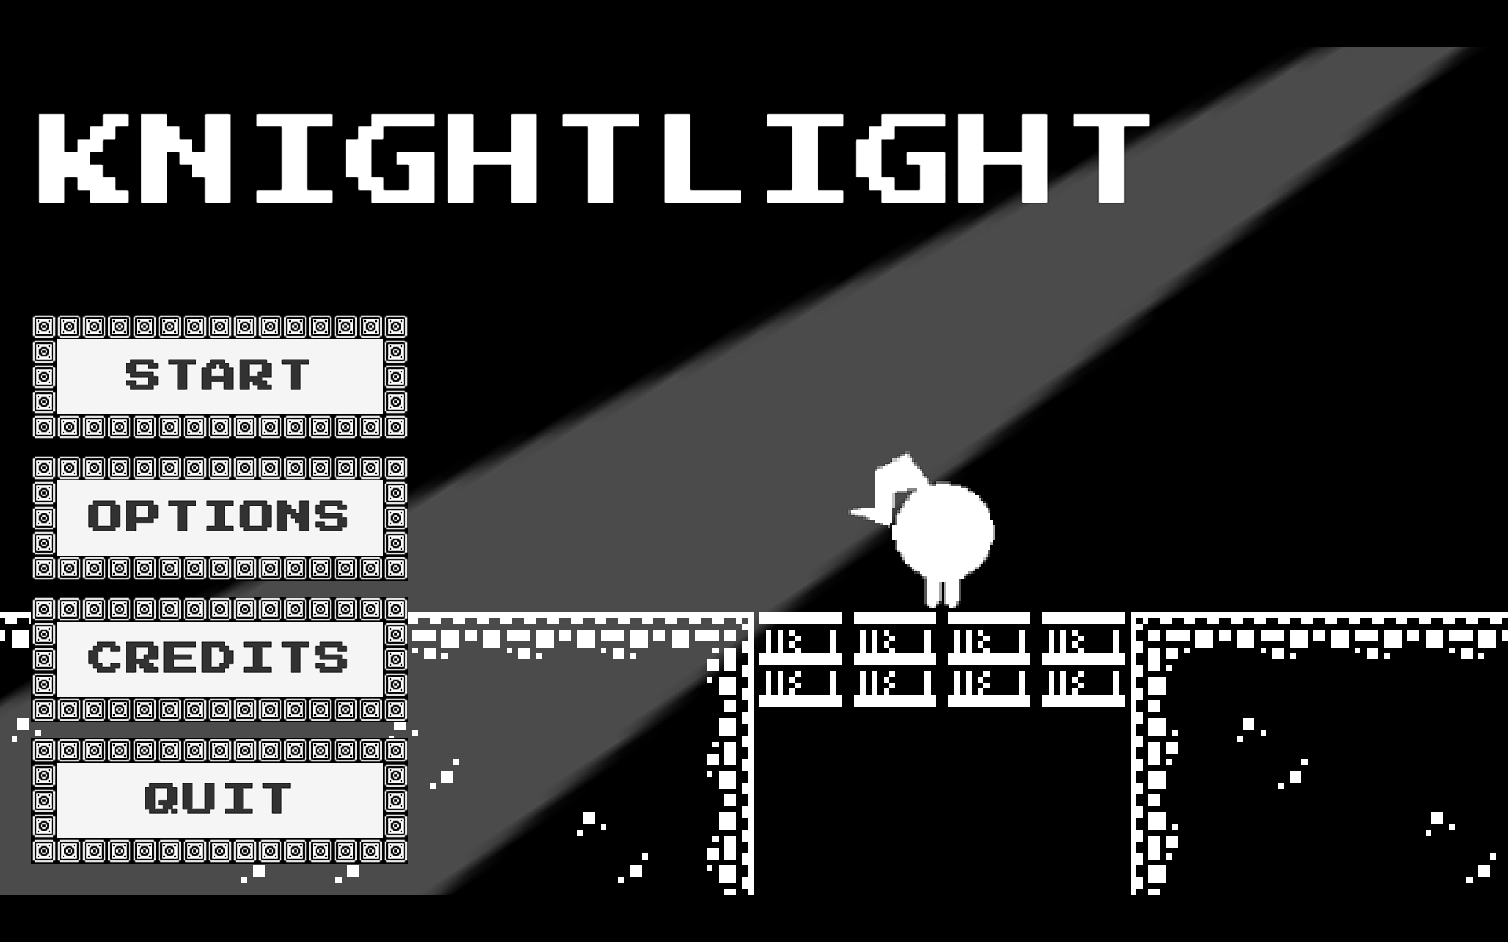
Main Menu
- Tutorial: The tutorial scene contains the tutorial tilemap mocked up by our design lead and implemented and edited by our level designer. The purpose of this tutorial is to teach the player all the mechanics in our game including: player movement, flashlight usage, health/energy system, jump through platforms, collectibles, door-triggering lamps, healing lamps, static hazards, and a basic patrol enemy. All of these mechanics are what we want the player to learn from the start. In contrast to previous builds, the Knight character has and updated sprite and animations as previous recommendations suggested. Additionally, there’s a panel in world space at the start of the level that shows the player how to use the flashlight using mouse controls.
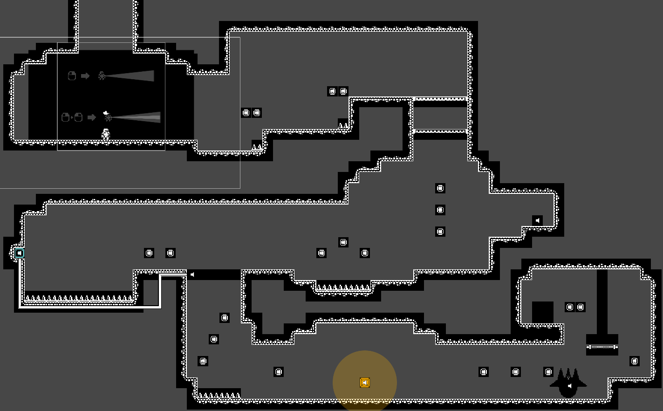
Tutorial Tilemap Layout
- Victory: The victory screen plays starts with an expressive color-changing victory message to catch the player’s attention, followed by a plain sound effect that reveals a ‘(this time)’ message letting the player know there’s more ahead or inviting for replayability. Finally, it plays another less plain sound effect that reveals two buttons inviting the player to make a choice.
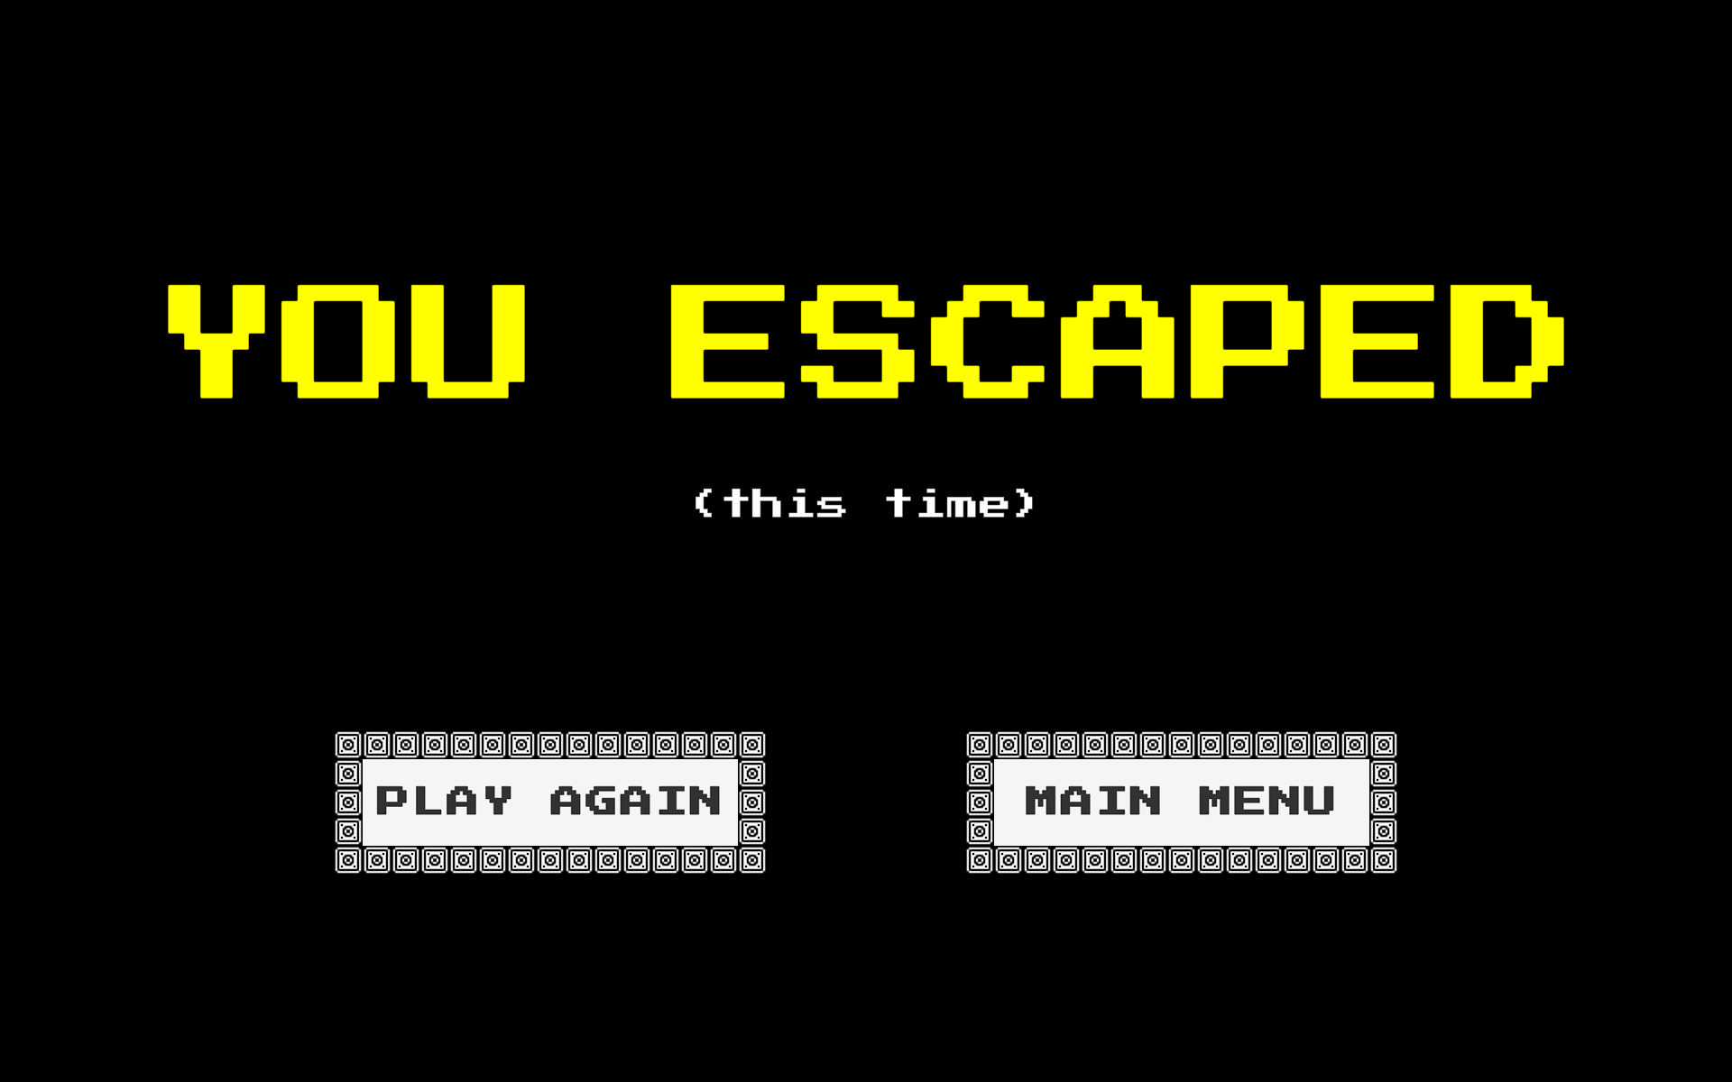
Victory Screen
The only instructions given to the playtesters was to share their thoughts as they played through the experience. Playtesters were not instructed or shown any of the game controls or mechanics before the experience.

Methodology
Two of the playtest sessions were done online over Discord with playtesters streaming what they saw on screen using the screen share feature, while another one was done in-person along with our design lead performing a pair playtesting using participant observation on another team’s designer. These were performed on different dates throughout November 16th to November 19th, 2023. The average playtest session was about 13.3 minutes including gameplay, feedback sharing, and debriefing. Two of the participants were non-DigiPen college students around the age of 20, while the other one was a 19-year-old DigiPen BAGD. For the two non-DigiPen students, the relationship with the researcher is being regular subjects for playtesting, while the DigiPen student has worked previously with our current team’s designers in GAM120 and over summer for our game’s Steam release. No ethical considerations to be made regarding the experience. All playtesters consented to having their data collected and analyzed to form recommendations to our game design.

Participants
Playtester A
Name: Michael Okamoto
Identity: Non-DigiPen Community College Student
Place: Discord
Date: 11/16/23
Session length: 11 minutes
First Time User: No

Playtester B
Name: Jake DeLuise
Identity: DigiPen BAGD Student
Place: Edison Lab Space
Date: 11/17/23
Session length: 15 minutes
First Time User: Yes

Playtester C
Name: Samuel Gadbois
Identity: Non-DigiPen Art Student
Place: Discord
Date: 11/19/23
Session length: 14 minutes
First Time User: No

Limitations
While choosing the sample, we didn’t have any requirements for the participants. Though one thing we wanted to do for this playtest report was to have at least one BAGD to get more technical feedback on our design, as well as perform a pair playtesting. We managed to do both at once and got useful feedback. The only limitations to consider regarding the playtesters’ relationship with the researcher is that the two non-DigiPen students are regular playtesters for the researcher and have played previous builds of the game and previous games too, meaning they’re familiar with the process of participant observation. Additionally, the DigiPen BAGD has worked with both designers previously, which might create some bias and ignore certain elements or could even create expectations of an already existing game for our current game.

Observations
Participant A
My first thought when Participant A opened the build was how we forgot to change the Knight sprite in the main menu to the new one. This would end up causing some confusion later on. The playtester saw the mechanics and quickly relearned the mechanics and mentioned how good the new sound effects were for the flashlight. As the playtester was testing the flashlight, they ended up overheating and lost one HP to it. He remembered overheating the flashlight damaged you and went on. As he was jumping around the first obstacles, he mentioned the ‘spacebar’ would be a good key to bind to jumping in addition to the ‘W’ key. As he descended through the jump through platforms, he missed the first coin at the start of the drop which he tried to collect again by jumping on a platform nearby, but it wasn’t possible. By doing this, he discovered that there was a hidden chest on the right side which he opened and asked what was inside of it. He wasn’t expecting the small creature to jump out as the last instance of the game didn’t have them in the chest. After this, he jumped over another obstacle and made it to the door-triggering lamp bit. Here, he immediately knew he had to light up the lamp with his flashlight, which he did. Then he proceeded to look at the door and jump in, falling into the spikes at the end. He went back and tried to collect the coins that he couldn’t get when he fell. After that, he walked up to the lit healing lamp and tried to light it up, which ended up in him getting hurt from the overheating. While he was inspecting the healing lamp, he saw the enemy peek in the dark and he mentioned how both cool and scary it was. Once defeated the enemy, he continued to the exit door and seemed excited when he saw the animation, pronouncing “Hell yeah!”. When presented with playing the tutorial again or going back to the main menu, he clicked on returning to the main menu and asked whether the character at the start was a princess we have to save.
When asked for his thoughts or feedback, he mentioned how cool it was that only some of the squares light up, presenting a hanging jump through platform as an example of the limited vision. One complaint he had was how there was no way to restart the level. He mentioned there should either be a button in the pause menu that allows you to restart the level, or you should be able to restart with the ‘R’ key. He also asked questions regarding the creature in the chest to which I replied it was a collectible for each level, he then mentioned how he thought it was a ghost and that there should be some kind of UI that shows you when you get it.
Participant B
This was an unplanned session we came up with after I playtested Jake DeLuise’s game. He offered to exchange playtests and I called our design lead to perform a pair playtesting on Jake, another designer, and get more technical feedback regarding our design.
When Jake opened our build, he didn’t have a mouse which we wouldn’t notice just yet. When he saw the menu, the first thing he saw was the flashlight following the mouse position. He also mentioned liking the asymmetrical design of the menu. He then proceeded to go through the different menus. When he opened the options menu, he laughed and said how good it was that the default values for volume were all 69, a funny number. After looking at the different buttons, he pressed play and his first thought once the tutorial scene was loaded was how evocative the theme is already with all the darkness around the player. He jumped over the first obstacle and after dropping from the jump through platforms, he looked at the coins on the left and seemed tempted to go that way, but then he turned around and went to check what was on the right side, finding the chest. He liked the chest animation but didn’t question what the thing that jumped out of it was. He then headed to the left and mentioned how fluid the WASD controls were as he jumped over the long spike obstacle. In the door-triggering lamp bit, he was physically amused at how the door opened after lighting up the lamp. Before jumping onto the next floor, he got scared at the animation the Knight made (falling animation) on the edge of the floor. Once he made it down, he got surprised by the spikes and called them ‘punishing’. It wasn’t until here that he mentioned ‘spacebar’ would also be a good key to bind to jumping. After this, he continued through the level ignoring the lit healing lamp, this didn’t give him enough time to see the healing effect. One thing I noticed here was how the healing lamp light clipped through the floor. He killed the enemy at the end and proceeded to the exit door.

When asked to share feedback, they mentioned liking how it hurts you when you hold for too long for balance. He also realized the color of the Knight gets darker as their health goes down signifying the health system. Another thing he pointed out was how the door-triggering lamp and healing lamp complemented each other since they had opposite colors. When asked about the healing lamp function, he couldn’t figure it out until he was instructed to take damage and come back to the lamp. He then realized that it makes the aura grow, healing the player. He then proceeded to play around with the audio settings. One question he was asked here was what he thought the chest was for. He said it was some kind of goblin or friend which was what we were going for. He also called them friendly and creative. Finally, he finished another playthrough and mentioned he really liked the “(this time)” popping up after the “You escaped” text in the victory screen, giving it some personality.

Participant C
The first thing this playtester did when opening the build was going to the settings menu, and immediately noticed the default values being ‘69’ which made them laugh. After looking at the credits, they pressed ‘Play’ and sounded amused when the Knight fell into the abyss. This playtester had a hard time understanding how to use the flashlight on their last playtest and were so thankful that there’s instructions right at the beginning in this build. They mentioned liking the squares lighting up when they looked around. Since a new type of tile was used for jump throughs, they didn’t recognize it and tried lighting it up, but after seeing there was a wall they learned it was a jump through platform. Once they dropped, they immediately went left and didn’t check right. They then got to the door-triggering lamp bit and jumped into the spikes but made it back up. They triggered the lamp, but they didn’t get to see the door animation as it was too close to the spot where you triggered the lamp from. On their way down they hit the spikes and didn’t like them at all. They passed through the healing lamp and noticed it healed them. They were intrigued by the enemy that passed through the coins ahead. Once they killed it, they went to the exit door and really liked the victory sequence as they celebrated while it was playing. They played again and enabled the sound as they had it really low initially. This time, they actually checked the right after dropping from the jump through platform. After triggering the chest, they mentioned how cute the creature inside it was. On the lamp bit, they fell on the spike pit again and lost health twice.
When asked for feedback, they mentioned liking that there’s instructions now as it was impossible to decipher how to play before. One thing they pointed out was how the chest zone was hidden and didn’t “load” (referring to the tiles lighting up), which is how they didn’t notice it the first time. One thing they noticed after playing again was how it gave you 10 coins, but they wish there was so kind of signifier for it. They also mentioned liking how the coins lead the player and liked following and collecting them. Once they got back to the main menu, they pointed out how the Knight sprite was the old one and not the one in the tutorial scene. One final thing they wanted to mention was how there were so many sound effects and how stimulating they were to the ear.

Conclusions
After making all these observations based on the playtesters’ experience, these are the main takeaways:
- Main menu Knight sprite should be updated.
- Flashlight mechanics are quick to learn.
- Players don’t know what happens when you overheat your flashlight at the start.
- We should allow players to jump with both ‘W’ key and ‘spacebar’.
- Spikes at the end of the opening door path are too hard to avoid.
- Players like getting all the coins.
- Players try to light up the already lit up lamp.
- Players like the enemies’ multiple sound effects.
- Players like limited vision.
- Players want means to restart the level.
- Players want to see all their collectibles on the UI.
- Players need to know they need a mouse before starting the experience.
- Players like the flashlight in the menu.
- Players like the asymmetrical layout of the menu.
- Players like the default volume values being 69.
- Players like the darkness theme of the game.
- Players like the fluid movement.
- Players like the door-triggering lamp feedback.
- Players think the spikes at the end of a jump can be too punishing.
- Players don’t know what to do with the lit healing lamp.
- The healing lamp light clips through the floor.
- Players like the lamps’ complementary colors.
- Players like the chest creature.
- Players like the instructions at the beginning of the tutorial.
- Players like consistent tile usage.
- Players like to see what’s in front of them.
- Players couldn’t notice the door animation.
- Players didn’t like intentionally jumping into the spikes.
- Players like hidden areas to find.
- Players would like more signifiers for collectibles.
- Players like the amount and harmony of sound effects.

Recommendations
Based on the conclusions, the following solutions or features can be implemented to the custom engine.
- We should replace the Knight sprite in the main menu with the new one.
- Instructions at the start of the tutorial are a good way for the player to learn mechanics quickly.
- We should teach the player that overheating the flashlight damages them.
- We should have both ‘W’ and ‘spacebar’ as keybinds for jumping.
- We should add better signifiers for where the player needs to land when making blind jumps.
- We should make all coins available to be collected again even after the player misses them.
- We should keep the healing lamp unlit as players will try to interact with it when they find it.
- We should make enemies’ sound effects more impactful.
- We should keep it so players have limited vision and are surrounded by darkness.
- We should add a button on the pause menu that restarts the scene and make it so the scene restarts when you press the ‘R’ key.
- We should add a collectible panel to the already existing coin panel.
- We should mention the game should be played with a mouse for a smoother experience.
- We should find a way to implement that main menu flashlight on the custom engine.
- We should keep the asymmetrical layout of the main menu and improve it.
- We should set all default values that allow it to be 69.
- We should keep developing the game’s theme.
- We should match the Unity build’s movement with the custom engine’s.
- We should keep improving the feedback of all interactable game elements.
- We should make the blind jump spikes more forgiving by extending the ground without spikes.
- We should make the healing lamp start unlit.
- We should cover up the light that clips through the floor with dark tiles or we could rework the light into raycasts.
- We should keep using colors that match or work well with each other.
- We could add more types of creatures for the chest as the tileset has multiple.
- We should keep and add more instructions on how to play at the start of the tutorial scene.
- We should be consistent with the tiles we use for the levels and their purpose.
- We should add a lip on the corner of floors before pits, so players know what’s in front or whether it’s safe to land or not.
- We should add a small timer when the player focuses their light on the door when it can be triggered to give them time to notice the animation.
- We should add signifiers for where it’s safer to land clearer on blind jump sections.
- We should add more hidden areas that only load or are visible when the player finds them.
- We should add more signifiers for when the player collects a collectible to make them more satisfying to pick up.
- We should keep developing the audio feedback of different elements in our game.

