Jared Callupe Lopez
GAM200
Team Luminosity
Game KnightLight
Playtest Report 1
Player Movement
Subject
The subject of this playtest is Player Movement, which includes both Move Speed and Jump Force.

Executive Summary
In order to find the best and most comfortable player movement settings for our game, a playtest was performed on this subject. The build playtested contained an environment for the player to freely explore, as well as a HUD which displayed the current values for movement variables: move speed and jump force. Playtesters were able to change these values in increments of +-0.5. Once playtesters found a movement setting that they felt comfortable with, these values were recorded to later be compared and analyzed. We found the average values and ended up with 4u for the Move Speed and 9u for the Jump Force. Other takeaways we got from this playtest were how players tend to go to the path that offers a challenge first when a path splits. We also found out the ceilings were too low and blocked some of the players’ height when jumping. Finally, some tile changes to fit the cave style of the game. Based on these conclusions, we’ll set the default value of the movement variables to 4 and 9 respectively. We’ll also be creating level designs based around splitting paths. Finally, we’ll raise the ceiling height so the player can perform a full jump at all times. With these changes, we’ll create a comfortable experience for the players in our game.

Build
The playtest was made in a Unity build in a scene with a map specifically made for player movement testing in Tiled. It features jumps across cliffs that get increasingly longer and platforms that lead to a higher ground on the opposite side of the map, with the player starting in the middle where they’re presented with two arrow signs pointing left and right.
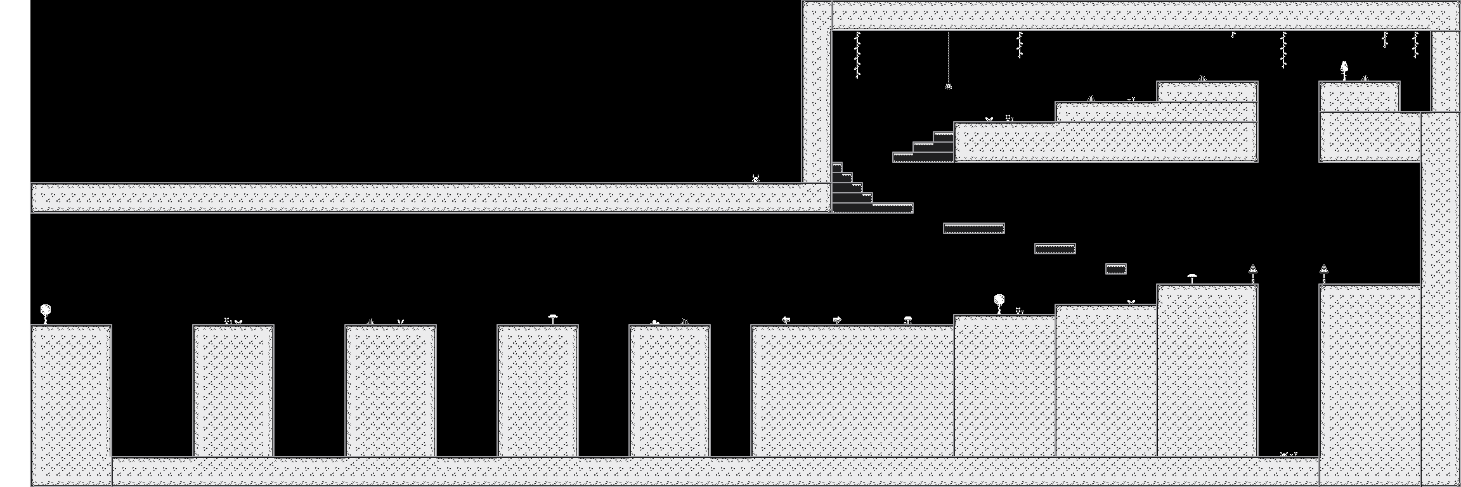

Purpose
“What’s the player movement setting that most players will be comfortable with?”
The purpose of this playtest was to find a Move Speed and Jump Force setting that players feel comfortable with. It is important to have consistent platforming measurements before the level design starts being worked on, in order to avoid jumps being either too easy or impossible, gameplay time being too short or too long, and to have set metrics in general, building up patterns in the player’s brain and promoting intuitive play.

Method
The way this subject was tested was by firstly letting the player move around the map with the default settings (Move Speed = 4 and Jump Force = 9). Then, the participant will be told to change the values of their movement variables by pressing the keys shown on their UI, allowing them to modify these variables in increments of ±0.5. Finally, all playtesters’ final values will be recorded and used to form an average of both variables to find a setting that the majority of players can find comfortable.
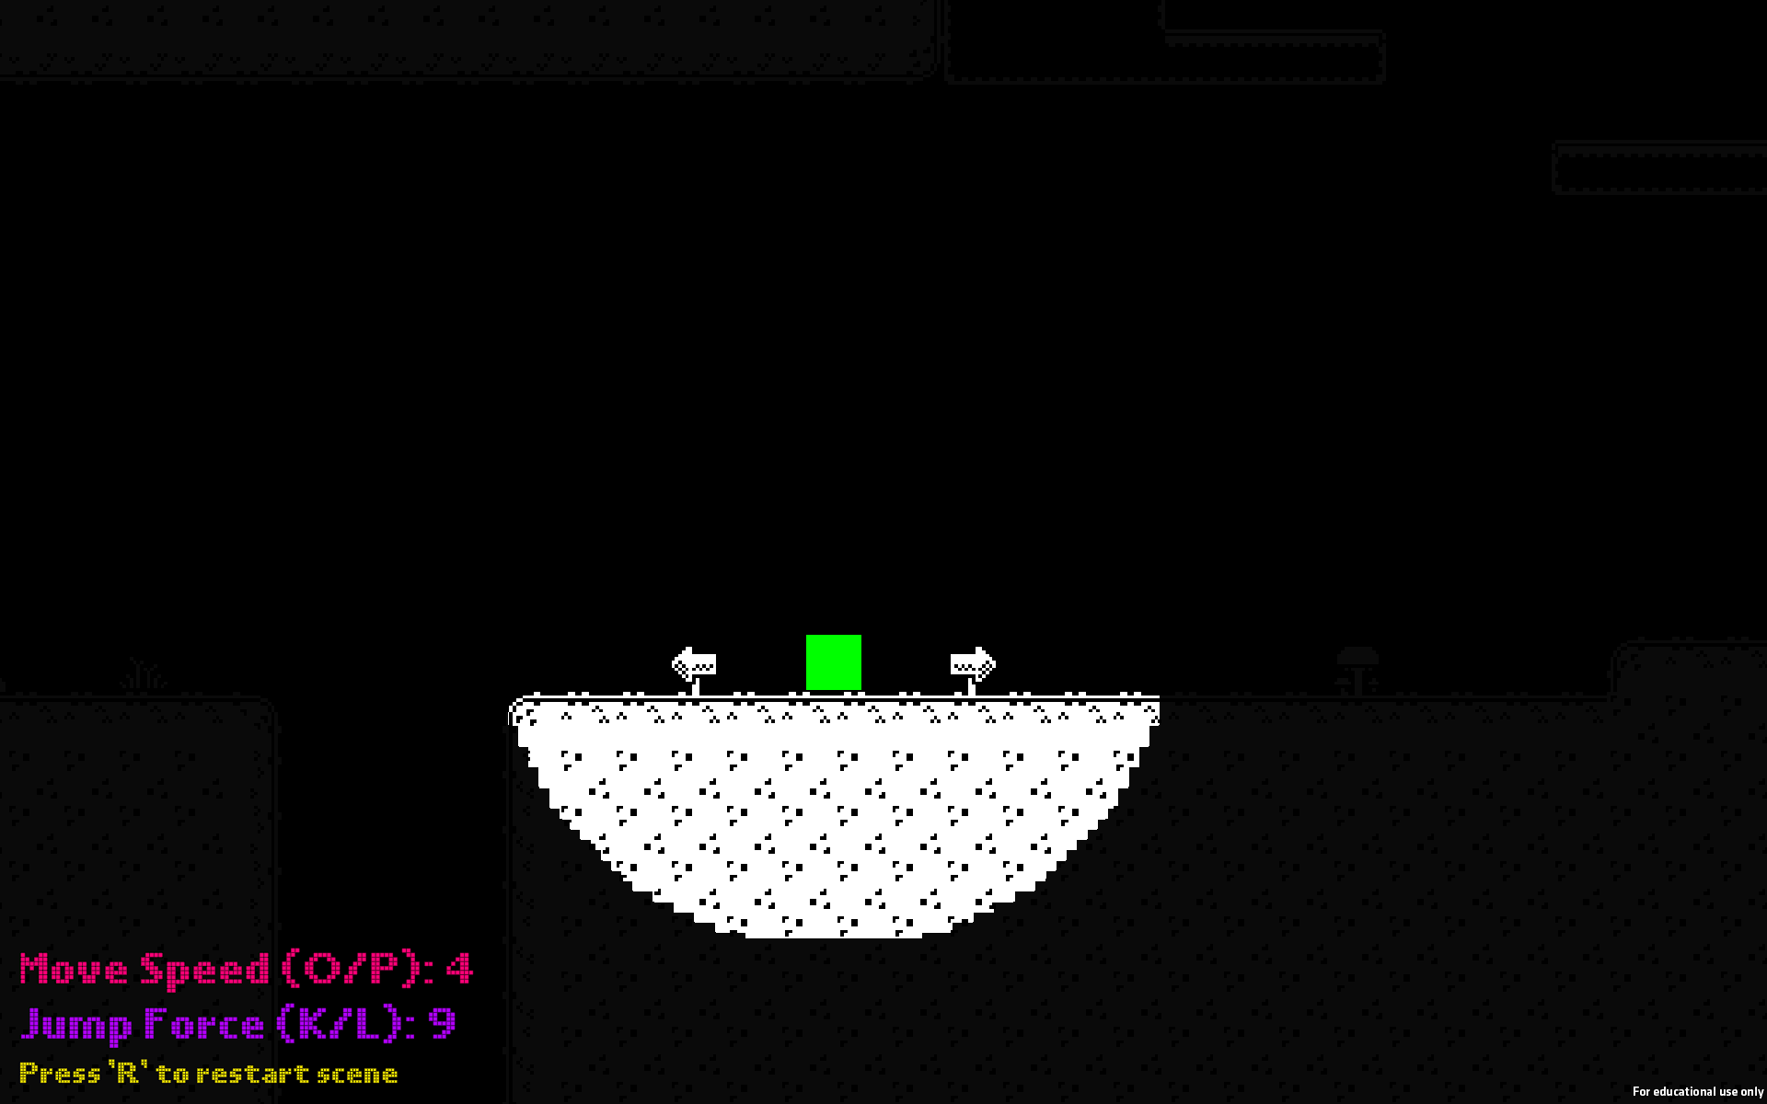
Start of the experience

Extra playtesting
In addition, some observations regarding User Experience were made including player behavior, map scale, tile coherence, etc. As well as some additional questions being asked like: Where are you? Why is everything dark? Why is there light? Can you see what’s in the darkness? And others.

Observations
All playtests were performed online over Discord with the playtesters sharing their screen while sharing their thoughts as they moved around in the experience.
First Playtester
- Name: Samuel Gadbois (Non-DigiPen Art Student)
- Date: 09/20/23
- Session length: 21 minutes
- First Time User: Yes
This playtester’s first action as soon as they opened the game was jumping over the cliff on the left trying to make all the jumps while commenting on how dark the environment was, which they described as a dark valley reminding them of Mario and Terraria. They also commented on the default movement being ok but there wasn’t much going on so they couldn’t tell whether it was too fast or too slow. Once they realized the last jump was impossible, they moved to the right side of the scene and climbed the platforms, and mentioned they looked off almost reminding them of a conveyor platform from Mario. Despite this, they complimented the small details and props around the map. After they were instructed to change their Movement Speed and Jump Force to try and find one they’re comfortable with, their final results were 2.5 for MS and 9 for JF. Their justification being it felt like a scary game and those are usually slower, and it makes it easier to appreciate the details around the map.
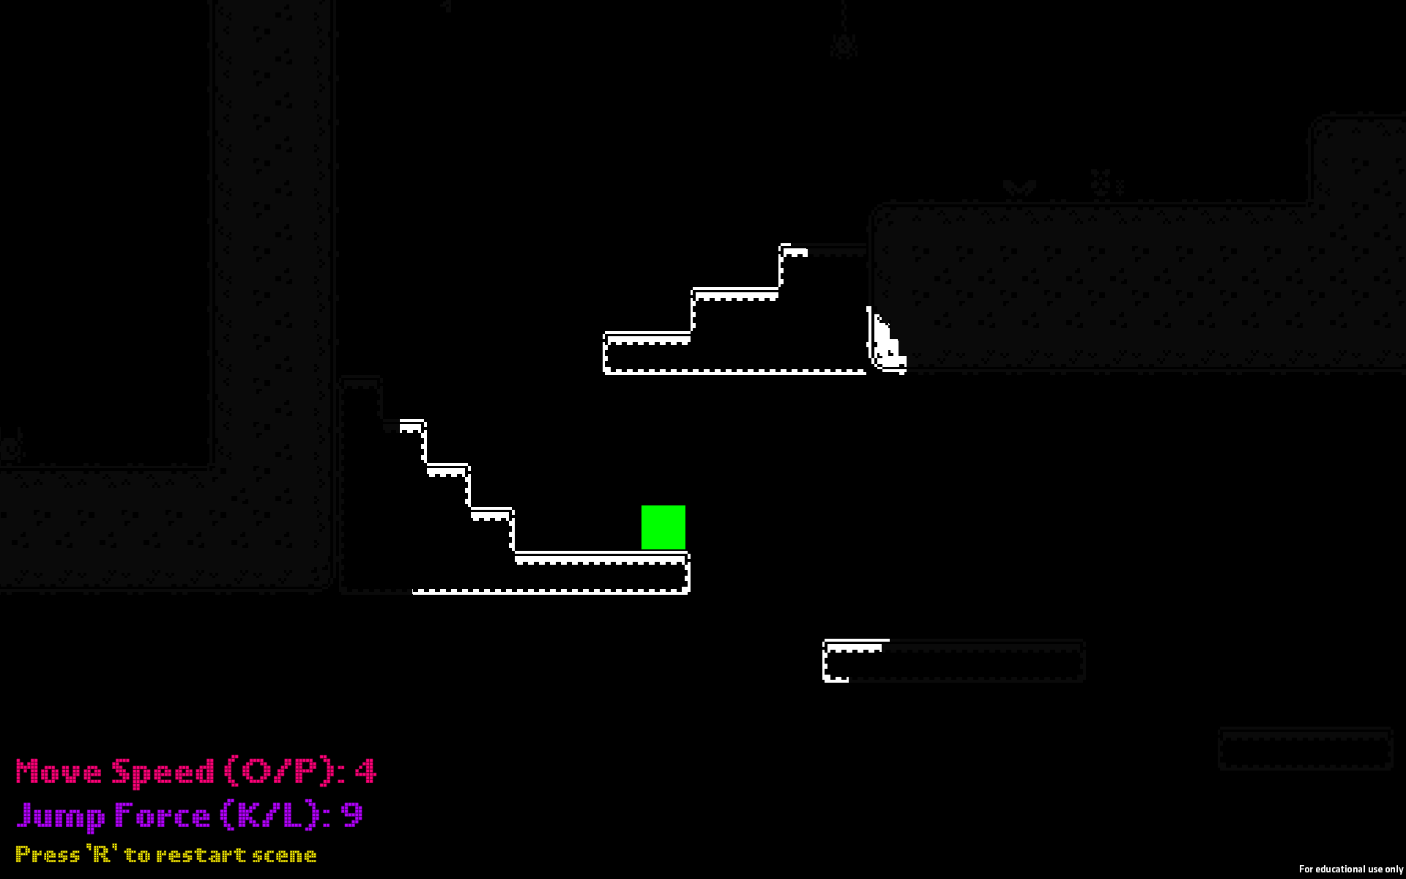
Off-looking platforms
Second Playtester
- Name: Michael Okamoto (Non-DigiPen Community College Student)
- Date: 09/21/23
- Session length: 16 minutes
- First Time User: Yes
The playtester’s first action upon entering the experience was also trying to jump over all the cliffs on the left side of the scene. While he did this, he mentioned he was in some kind of meadow at night with some kind of spotlight on him. Before he realized he couldn’t make the last jump, he also mentioned the player looked weird in comparison to the props around him.
After this, the playtester moved on to the right side going over the cliff and back, then climbing the platforms which, he also mentioned, looked weird and scary in nature. This even led him to theorize the player was some kind of alien unfamiliar with the environment. The playtester also seemed curious about the props and even tried interacting with some of them like the spider and mushroom. When asked about the darkness, he mentioned it was perfect as he could barely see what’s outside the spotlight.
When he was told to change his variable values, he went for a higher MS and JF at 5 and 10.5. Mentioning he could see himself speedrunning the game and collecting all the coins (there were no coins planned or in the scene at all). Then, he proceeded to finish all the jumps on the left side and even went outside of the map by climbing the ceiling.

Third Playtester
- Name: Richard Nagao (Non-DigiPen Mechatronics Student)
- Date: 09/23/23
- Session length: 18 minutes
- First Time User: Yes
This playtester’s first action when loading in the scene was going to the right exploring the higher part of the map first. When questioned about this, he mentioned it is common in platformers for players to keep going in that direction. Surprisingly, the playtester never went back to jump over the cliffs on the left. While doing this, the playtester mentioned being in a valley or desert with train tracks (the black with white outline platforms), with the player being an explorer and having some kind of lamp.
While platforming around, the playtester showed frustration on the jump with a lower ceiling as they fell to the pit at the bottom. As he climbed back, he said the game reminded him of old minimalist games. When asked about the darkness opacity, he mentioned it was way too dark and he didn’t notice the platforms outside the light were visible at all until he turned his brightness up to max.
When asked to change his MS and JF, he chose 4.5 and 8 respectively. The lower JF would help with jumps in narrow spaces or lower ceilings. As for the MS, he mentioned that if it were a game like Metroid, where you need to aim and move around constantly, it would go a bit higher.
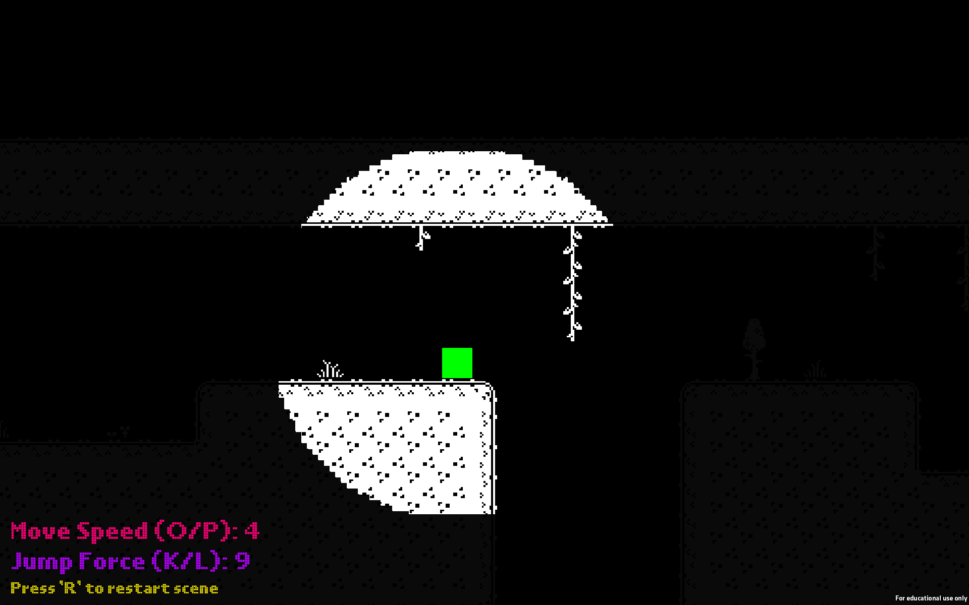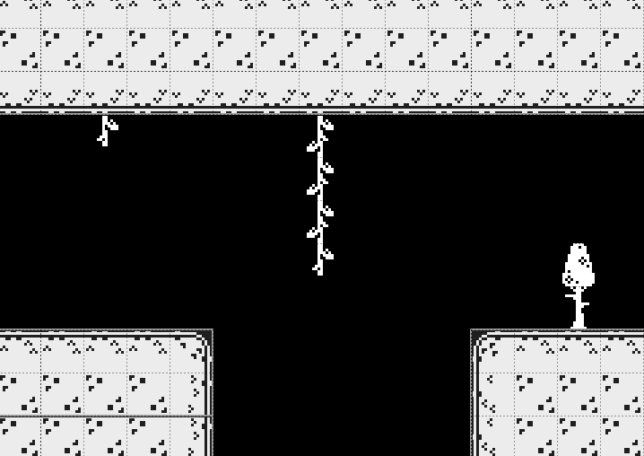
Platform across the cliff wasn’t visible in the playtester’s screen

Conclusions
After collecting all these data, the final values for Move Speed and Jump Force are:
Move Speed = 2.5, 5, 4.5 Σ = 12
μ = $\frac{12}{3}$ = 4
Jump Force = 9, 10.5, 8 Σ = 27.5
μ = $\frac{27.5}{3}$ = 9.167
Since the results don’t vary too much or don’t change at all from both the default values and the playtesters’ chosen values, we can assume 4 Move Speed and 9 (rounded up from 9.167) Jump Force are values that most players can feel comfortable with.

Other conclusions:
- When running into two paths in different directions, players tend to go for either the one that offers a challenge first, or the one on the right side.
- The grassy tiles remind the player of nature and open spaces such as valleys and meadows.
- The black tiles with white dotted outlines feel out of place in the environment.
- The prop scaling is not proportionate in relation to other props and the player themself.
- Some ceilings are too low for some jumps.
- The opacity can be too low in some systems at max brightness

Reflections
Based on the conclusions, the following solutions or features can be implemented in the prototype build:
- Since the game starts with two paths, one being closed and the other being open but leading to the trigger for the closed path, it’d be better to place the closed path on the right and with an obstacle players can easily pass, like a simple jump. This will make sure most players check the closed path first, then they’ll look for a way to open it on the other side.
- The tiles used for the terrain will be changed to fit the cave/dark dungeon aesthetic.
- Platform tiles will be changed to be less confusing and more coherent with the terrain tiles.
- Some props will appear bigger, and trees will be removed to both fit the aesthetic and get rid of the player size inconsistencies.
- Ceilings will be high enough to let the player make a full jump. Though, some obstacles may still require the ceiling to be lower than usual.
- The darkness opacity will be lowered to make the objects behind it barely visible.

